Research Poster

Aligning Educational Learning Theories and Educational Philosophies

Mike Martin
125 Gentry Hall
Columbia, MO 65211
217-653-0085
mjmgg7@mail.missouri.edu

Dr. Tracy Kitchel
124 Gentry Hall
Columbia, MO 65211

Aligning Educational Learning Theories and Educational Philosophies

Introduction

Theoretical frameworks have become essential components of school-based agriculture research (Roberts et al., in press). Contemporary researchers have identified educational theories and concepts that apply to agricultural education, such as the project method (Roberts & Harlin, 2007), experiential learning (Knobloch, 2003; Terry & Briers, 2010), and educational learning theories such as cognitive and social constructivism (Doolittle & Camp, 2001; Roberts & Ball, 2009). The philosophy of school-based agricultural education has also been recently defined. Wardlow and Osborne (2010) identified the educational philosophies of realism (knowledge-based program) and pragmatism (student-centered and Deweyian program) within school-based agricultural education. Yet, no study within agricultural education research has attempted to broadly conceptualize educational learning theories and philosophies within the discipline. This clarification can help guide research and has been expressed in the National Research Agenda (Osborne, 2007, p. 21). The goal of this study was to align educational theories and educational philosophies along a single continuum to facilitate research frameworks and discussions.

Conceptual/Theoretical Framework

The researchers understood the need to precisely conceptualize educational philosophies and learning theories. The researchers conceptualized an educational philosophy as a broad and abstract explanation of teaching and learning. The five philosophies identified were idealism, realism, pragmatism, existentialism, and postmodernism and grounded in the work of Gutek (2004). The researchers acknowledged that there were a variety of educational theories, such as experiential education and problem-solving, which helped explain the processes occurring in education, but only grand educational theories fully explained the processes of teaching and learning. The researchers identified behaviorism, informational processing, social cognitive, cognitive constructivism, and social constructivism as grand educational learning theories (Bruning, Schraw, & Ronning, 1999; Schunk, 2008). The researchers utilized a conceptual model developed by D.C. Phillips (1995) to align the educational learning theories and educational philosophies. Phillips developed a continuum model explaining how knowledge was either created or transformed and who has the power to transform the knowledge

Purpose

The purpose of this study was to position educational learning theories and educational philosophies along a continuum of how knowledge is created and transformed.

Methodology

Qualitative research methods were utilized. The researchers examined multiple definitions of educational theories and educational philosophies, synthesized the definitions, and placed them along Phillip’s (1995) continuum of knowledge (Patton, 2002). Credibility was built through a consensus by peer debriefing and the control of researchers’ bias through reflexivity activities. Dependability and conformability was developed through a detailed audit trail and triangulation of each definition and conceptualization of how the philosophies and theories operate (Ary, Jacobs, & Razavieh, 2002).

Findings/Conclusions

The researchers found that the both educational learning theories and philosophies can be aligned within a framework of how humans conceived knowledge. When knowledge was conceived to be created outside of the human consciousness, then an idealist or realist philosophies and behaviorist learning theory was present. When knowledge was conceived to be created by human consciousness then realist or pragmatist philosophies and social cognitive or information processing learning theories was present. Finally, when knowledge was conceived to be transformed by human consciousness, then postmodernist or existentialist philosophies and social or cognitive constructivist learning theories was present. Figure 1 outlined these findings.

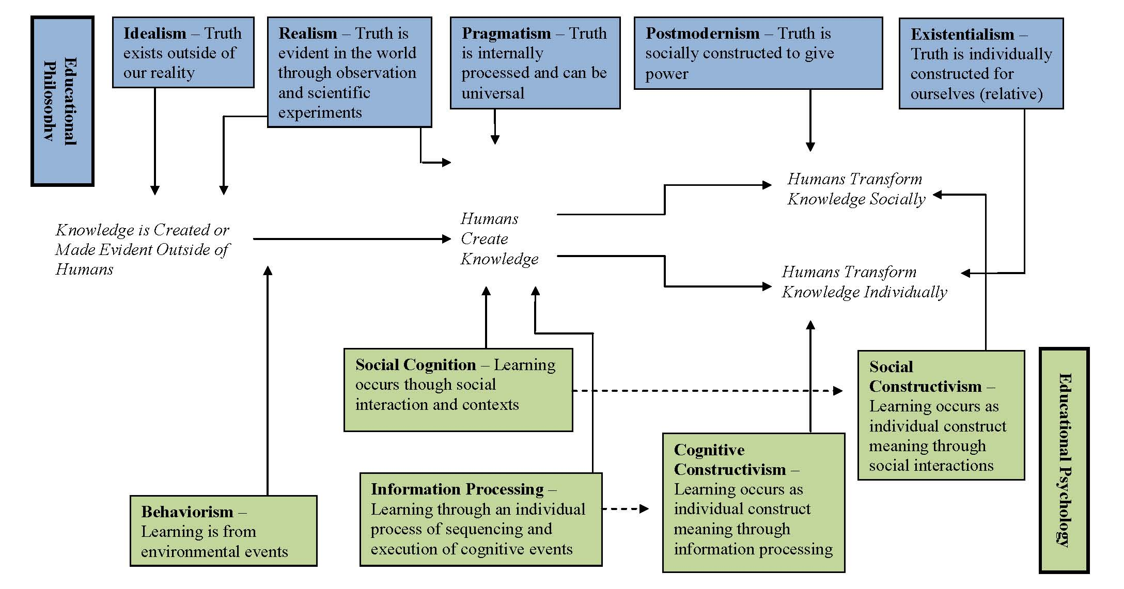
Figure 1. A framework for aligning educational learning theories and educational philosophies.

Implications/Recommendations

The findings of this study have implications for the current status of school-based agricultural education research. Roberts and Ball (2009) reported that school-based agriculture “oscillates between cognitive and social constructive” (pg. 87), which would suggest that school-based agriculture would tend to operate under the philosophies of postmodernism and existentialism. But, Wardlow and Osborne (2010) argued that the philosophy of school-based agriculture was either realism or pragmatism, which would suggest that school-based agriculture operates optimally within informational processing and social cognition learning theories. The researchers do not claim to know who is right, but recommend that philosophical, theoretical, and experimental research be conducted on school-based agricultural education to explore possible contradictory thoughts. A clear philosophical and theoretical foundation can accurately dictate research and policy for the profession.
References

Ary, D., Jacobs, L. C., & Razavieh, A. (2002). Introduction to research in education. Belmont, CA: Wadsworth/Thompson Learning.

Bruning, R. H., Schraw, G. J., & Ronning, R. R. (1999). Cognitive psychology and instruction. Upper Saddle River, NJ: Merrill.

Doolittle, P. E. & Camp, W. G. (1999). Constructivism: The career and technical education perspective. Journal Vocational and Technical Education, 16(1). Retrieved from http://scholar.lib.vt.edu/ejournals/JVTE/v16n1/doolittle.html.

Gutek, G. (2004). Philosophical and ideological voices in education. Boston: Allyn and Bacon.

Knobloch, N. A. (2003). Is experiential learning authentic? Journal of Agricultural Education, 44(4), 22-34. doi: 10.5032/jae.2003.04022

Osborne, E. W. (Ed.) (2007). National research agenda: Agricultural education and communication, 2007-2010. Gainesville, FL: University of Florida, Department of Agricultural Education and Communication.

Patton, M. Q. (2002). Qualitative research and evaluation methods. Thousand Oaks, CA: Sage.

Phillips, D. C. (1995). The good, the bad, and the ugly: The many faces of constructivism. Educational Researcher, 24(7), 5-12. doi:10.3102/0013189X024007005

Roberts, T. G., Barrick, R. K., Dooley, K. E., Kelsey, K. D., Raven, M. R., & Wigenbach, G. J. (in press). Enhancing the quality of manuscripts submitted to the Journal of Agricultural Education: Perceptions of experienced reviewers. Accepted for publication in JAE.

Roberts, T. G. & Ball, A. (2009). Secondary agricultural science as content and context for teaching. Journal of Agricultural Education, 50(1), 81-91. doi: 10.5032/jae.2009.01081

Roberts, T. G. & Harlin, J. F. (2007). The project method in agricultural education: Then and now. Journal of Agriculture, 48(3), 56-56. doi: 10.5032/jae.2007.03046

Schunk, D. E. (2008). Learning theories. Upper Saddle River, NJ: Pearson.

Terry, R. Jr. & Briers, G. E. (2010). Roles of the secondary agriculture teacher. In R. M. Torres, T. Kitchel, & A. L. Ball (Eds.) Preparing and advancing teachings in agricultural education (pp 87-98). Columbus, OH: Curriculum Materials, The Ohio State University.

Wardlow, G. W. & Osborne, E. W. (2010). Philosophical underpinnings in agricultural education. In R. M. Torres, T. Kitchel, & A. L. Ball (Eds.) Preparing and advancing teachings in agricultural education (pp 17-29). Columbus, OH: Curriculum Materials, The Ohio State University.

