Innovative Poster
Using Text Messages to Increase Student Engagement in the College Classroom

Nathan W. Conner
Graduate Assistant
nathan.conner@ufl.edu

Jessica M. Blythe Graduate Assistant jmblythe@ufl.edu

T. Grady Roberts
Associate Professor
groberts@ufl.edu

Department of Agricultural Education and Communication
University of Florida
310 Rolfs Hall
PO Box 110540
Gainesville, FL 32611-0540
352-273-2614

Using Text Messages to Increase Student Engagement in the College Classroom
Introduction/need for innovation or idea
Today’s college students are different than past generations (Carlson, 2005). The millennials are intelligent and ready to learn, however they expect learning to be on their terms and to encompass today’s technology (Carlson, 2005). Millennials are more interested in interactive media and controlling their learning than past generations (Berk, 2009). They may not be interested in sitting passively in a lecture style classroom and taking notes (Carlson, 2005). Millennials often prefer active learning and expect immediate feedback (Nelson & Litzenberg, 2011). In response to the millennials needs, Nelson and Litzenberg (2011) utilize a personal response system (PSR) in their classrooms. This technology allows students to engage in the learning by providing answers to proposed questions and then receive immediate feedback (Nelson & Litzenberg, 2011). However, there is a substantial monetary cost associated with implementing PSR or other clicker systems (Nelson & Litzenberg, 2011).
In order to encourage active learning in the classroom and engage students through interactive media, an online text message polling system was incorporated into a course. Polleverywhere was the audience response system chosen because it is easily accessed through the Internet and students only needed a cell phone capable of sending text messages in order to engage in the activity.
How it works/methodology/program phases/steps
The following steps were taken to create the texting poll through polleverywhere.com (2011):
- Once on the polleverywhere website, you may choose to continue without an account, register for a free account, or you may purchase a subscription account. A free account will allow for up to 30 responses. If more responses are needed, a subscription account would be needed.
- Click on create a new poll.
- Type your multiple choice or open-ended questions into the text box and click on the preview icon and then click continue.
- Follow the provided instructions to download the question into a PowerPoint slide.
- Insert the slide in to your PowerPoint presentation (see Figure 1).
- Conduct you class session as you would normally do. When you reach the point of your class that you wish to ask the question, instruct students to take out their cell phones and follow the instructions on the screen.
- Student responses will appear instantly. You can use student response to give students immediate feedback as well as to provide feedback for yourself.

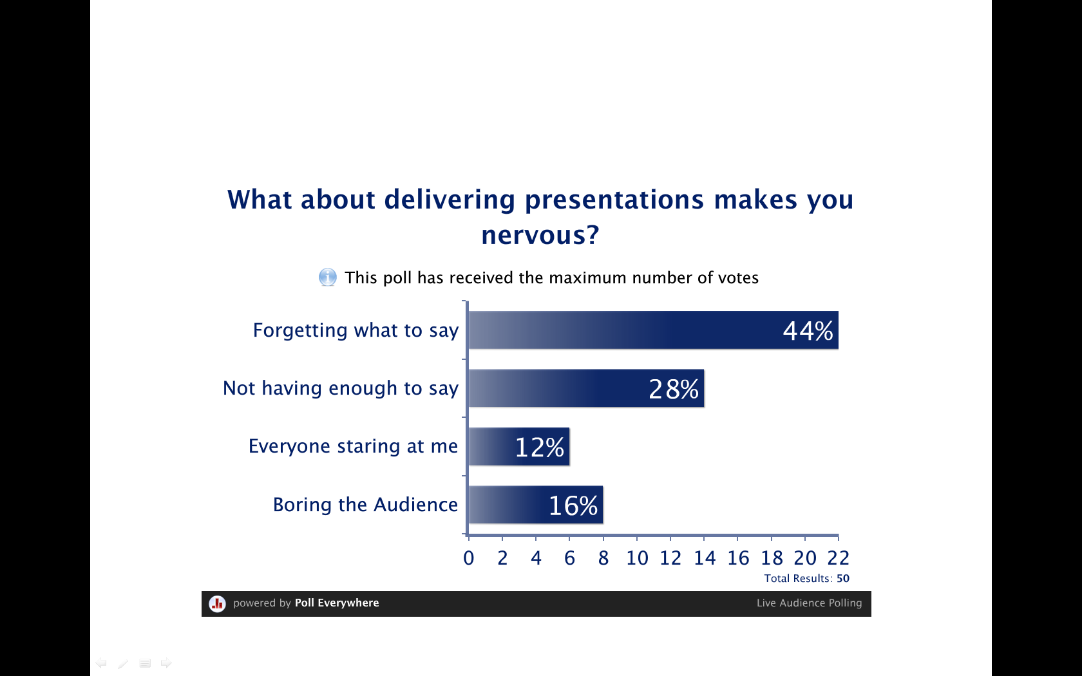
Figure 1. Screen Capture of a Texting Poll on PowerPoint
Results to date/implications
The audience response system polleverywhere has been utilized in an undergraduate course since the Fall 2010 semester. Student feedback has been positive and has indicated that students welcome the opportunity to use cell phone technology in the classroom. Students have indicated that they are more likely to answer questions through a texting poll because it feels less threatening than answering the question out loud in front of the entire class. Many students have chosen to incorporate texting polls into their required presentations for the course. Polleverywhere seems to be an effective way to engage the students and encourage active learning.
Future plans/advice to others
Future Plans
Polleverywhere texting polls will be incorporated into additional PowerPoint’s to engage students and to encourage active learning. Students will also have the opportunity to create and propose questions about the content or assignments through Polleverywhere.com. This will give students some control over what is discussed in class.
Advice to Others
Start by creating and implementing 1 texting poll in the class. Then talk to your students about their experience and decide if this technology is appropriate for students in the class. If texting polls enhance the educational quality of your class, increase the amount of texting polls that you use overtime.
Costs/resources needed
To utilize polleverywhere texting polls, minimal resources and costs are needed. Internet access and PowerPoint software is needed to display the poll. Students will need to have cell phones with texting capabilities. Free subscriptions are available, but the subscription is limited and only works for an audience of up to 30 students. Options to poll larger audiences can be purchased for an additional monthly fee that increases based on the size of the audience. There is a $15.00 monthly fee for an audience of up to 50 students. An individual instructor plan may be purchased for $699.00 per year and offers more options such as grade reporting and response moderation.
References
Berk, R. A. (2009). Teaching strategies for the net generation. Transformative Dialogues: Teaching & Learning Journal, 3(2), 1-24.
Carlson, S. (2005, October 7). The net generation goes to college. The Chronicle of Higher Education, pp. A34.
Nelson, A. G., & Litzenberg, K. K. (2011, June & July). Enhancing learning in the classroom–One click@ a time. Paper presented at the meeting of Canadian Agricultural Economics Society/Western Agricultural Economics Association, Banff, Alberta.
Polleverywhere.com. (2011). Retrieved from http://www.polleverywhere.com

