Innovative Poster

Conversation Starters: Helping Extension Professionals Incorporate Public Policy

Laura Bernheim
Media Specialist
Center for Public Issues Education
University of Florida
121F Bryant Hall
P.O. Box 112060
Gainesville, FL 32611
352-273-0793
bernheim@ufl.edu

Dr. Alexa J. Lamm
Policy Research and Evaluation Specialist
National Public Policy Evaluation Center
University of Florida
G086A McCarty Hall
P.O. Box 110180
Gainesville, FL 32611
352-392-6545
alamm@ufl.edu

Dr. Tracy Irani
Development Director
Center for Public Issues Education
University of Florida
220 Rolfs Hall
P.O. Box 110540
Gainesville, FL 32611
352-273-2588
irani@ufl.edu

Conversation Starters: Helping Extension Professionals Incorporate Public Policy

Introduction
During the past 20 years, the land-grant university system has refocused efforts to include greater participation from those involved in agriculture and natural resource (ANR) management, as well as attempted to empower clientele through extension programs by providing access to a wider range of resources when making decisions (McDowell, 2001; Spanier, 1999). Research has shown extension professionals are a trusted source of information for producers, serving as opinion leaders within their communities (Rogers, 2003). In order to be effective opinion leaders, extension professionals must understand their stakeholders and the communities in which they reside (Scheer, Cochran, Harder, & Place, 2011) including the challenges they face.

Federal public policies set the required processes, regulations, and conservation efforts that impact those working within ANR management as well as consumers. As such, federal public policies impact extension clientele on multiple levels. For example, agricultural producers and growers must understand and meet required regulations so their products can be sold. The information in these policies is critical to the ANR industry, but the education tools designed to ensure policy comprehension and informed decision-making is difficult to find. Extension professionals are in positions of leadership within their communities and relied upon for research-based information, but are rarely prepared to converse about public policy, as they must remain unbiased and cannot appear as advocates.

How it works
To facilitate these crucial conversations, two interdisciplinary centers at the [University] have collaborated to create an online environment (Conversation Starters) that provides extension professionals an easy way to stay up-to-date on current federal public policy. Conversation Starters offers information and tools to assist in incorporating policy into everyday conversations with volunteers, customers and clients. The [Center #1] measures the perceptions and communication of public policy by finding tested, research-based solutions to agriculture and natural resources issues, resulting in effective communication and proactive education strategies. The [Center #2] examines how current and potential public policy influences the knowledge, attitude and aspirations of those it directly impacts, with the goal of helping the affected people make informed decisions as to what the policy should be.

[Center #2] and the [Center #1], with cooperation from [State] Extension, other state Extension services, and partners at universities across the country, examine relevant federal policies and translate the important information into accessible easy to use tools for extension professionals (see Figure 1). The tools supply Extension professionals with relevant talking points, dialogue-starting questions, and worksheets built to foster conversations with volunteers, customers and clients. The tools offer extension professionals an easy way to provide unbiased, research-based perspectives on federal public policy, assisting them in developing a stronger relationship with clients as a reliable source of information.

Implications
Previous research by the [Center #1] has identified the need for Extension to market itself more effectively and create more local community partnerships. Research has consistently shown that members of the general public have a demonstrated need for information and education about ANR policy issues affecting their communities. Extension professionals who utilize the Conversation Starters materials would directly answer that need. With more information and education, constituents and producers alike can develop ideas and a method by which to evaluate and analyze future potential policies.

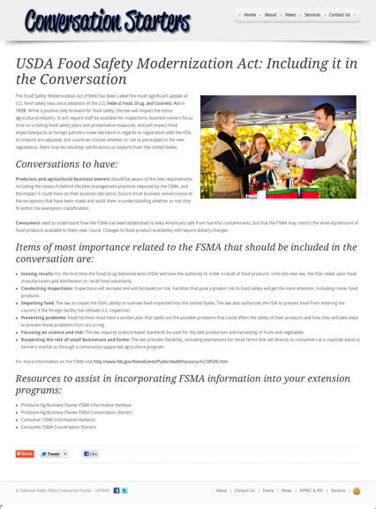
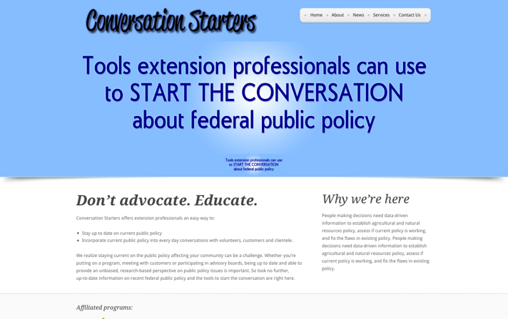




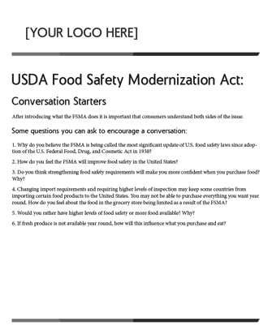

Figure 1: Conversation Starters tools.

Future plans
Conversation Starters will be expanded in an effort to provide a source of federal public policy information for extension professionals nationally. The team has discussed the potential of becoming an eXtension Community of Practice in an attempt to make Conversation Starters an interactive environment, providing a safe place for extension professionals to discuss and obtain federal public policy related information. Lastly, an advisory board to help focus and refine the pilot program, as well as extend its reach to more state Extension services will be created.

Resources needed
To facilitate the Conversation Starters partnerships and expansion, as well as the creation and maintenance of content, a collaborative work environment with the technological infrastructure and assistance associated with web publishing and administration is needed. Team members will require access to training modules for the creation, entry and maintenance of content to improve competencies. Finally, assessment mechanisms to refine the pilot program’s methods and evaluate its effectiveness will be a needed resource.

References

McDowell, G. R. (2001). Land-grant universities and Extension into the 21st century: Renegotiating or abandoning a social contract. Ames, IA: Iowa State University Press.

[Center #1]. (2011). Focus groups & strategic planning with [University]. [City, State]: [Center #1]. Retrieved from
http://www.[center#1].com/research/completed-projects/[university]planning

Rogers, E. M. (2003). Diffusion of innovations, 5th edition. New York, NY: Free Press Inc.

Scheer, S. D., Cochran, G. R., Harder, A., & Place, N. T. (2011). Competency modeling in extension education: Integrating an academic extension education model with an extension human resource management model. Journal of Agricultural Education, 52(3), 64-74. Doi: 10.5032/jae.2011.03064

Spanier, G. B. (1999). Enhancing the quality of life: A model for the 21st century land-grant university. Applied Developmental Science, 3(4), 199-205. Doi: 10.1207/s1532480xads0304_3

