Innovative Idea Poster

Clearer Graphic Representation of the School-Based Agricultural Education Program

Andrew C. Thoron, Assistant Professor
athoron@ufl.edu
Eric D. Rubenstein, Graduate Assistant
erubenstein@ufl.edu
R. Kirby Barrick, Professor
kbarrick@ufl.edu

University of Florida
PO Box 110540
Gainesville, FL 32611-0540
Telephone: (352) 392-0502
Clearer Graphic Representation of the School-Based Agricultural Education Program

Introduction
Historically, agricultural education identified the three-circle model as a conceptual frame to illustrate the main components of the school-based agricultural education (SBAE) program. Classroom/laboratory instruction, Supervised Agricultural Experiences (SAE), and the National FFA Organization (Phipps, Osborne, Dyer, & Ball, 2008) are presented as equal components of the SBAE program. In a report on the state of SAE, Barrick et. al (1992) presented an updated SBAE model that emphasized the need for classroom and laboratory instruction to serve as the initial component of the SBAE program, where the application components (FFA and SAE) of the model are directly influenced by classroom instruction. The model incorporated a student’s employment and career choice which is influenced by student learning (application and classroom instruction). However, the Barrick et. al (1992) model gained little traction within SBAE. Currently, agricultural preservice teachers, instructed on the three circle model, struggle with determining the amount of time that should be dedicated to each component of the SBAE program. A clearer representation of the components that make up the SBAE program has merit for the profession. The proposed model presents the importance of each component and the overall structure of the SBAE program.
How it works
The authors developed a SBAE program model comprised of four main components: classroom and laboratory instruction, SAE, FFA, and agricultural career orientation. The model was developed to more accurately depict the function of the SBAE program. The components serve a distinct purpose in the SBAE program.
The keystone of the SBAE model is classroom and laboratory instruction. Classroom and laboratory instruction provides the fundamental environment where skills and knowledge are developed or enhanced through formal instruction. Formal instruction encourages students to be active participants within the learning environment through various teaching methods. Further, SBAE programs would not exist without the classroom and laboratory instruction being the pinnacle of the program.
SAE programs are one form of real-world application in the total SBAE program. When SAE programs are developed, three essential features must be included: an agriculturally-based experience, individual projects and enterprises, and financial management skills. First, agricultural experiences provide students an avenue for the application for knowledge developed through classroom and laboratory instruction. In addition, community support should be garnered through the inclusion of the community-based agricultural industry. Secondly, a project or enterprise should be constructed for each student experience. Formulated projects should be grounded in one of the following categories: entrepreneurship, research, exploratory, or placement. Individual projects or enterprises should be framed to grow in scope and sequence each year of the overall program. Finally, SAE programs should emphasize financial management skill development during each project or enterprise. The practice of keeping records (financial and labor) assists students in making wise financial decisions regarding their SAE program.
The National FFA Organization is the second real-world application of the SBAE program. Three fundamental outcomes support the use of FFA chapters within SBAE: premier leadership, personal growth, and career success. Initially, as FFA members participate in different aspects of the organization, vital leadership skills are learned and enhanced. These leadership skills allow members to be active citizens in society. Further, personal growth is achieved as students determine their niche within the FFA organization. Personal growth is promoted by recognizing student achievement through the National FFA degree and award system. Finally, career success is developed through student participation in Career Development Events (CDE). CDEs increase a student’s awareness and aspiration within the agricultural industry through hands-on authentic application.
Agricultural career orientation is integral to the previous components of the SBAE program. Career preparation should be interwoven into classroom and laboratory instruction, SAE programs, and FFA participation. SBAE should prepare some students to enter the workforce, while preparing others to continue their education at post-secondary institutions.
Results to Date/Implications
The proposed model graphically displays each SBAE program component. Further, the model enhances preservice and inservice teachers’ conceptualization of the importance and role of each SBAE program component.

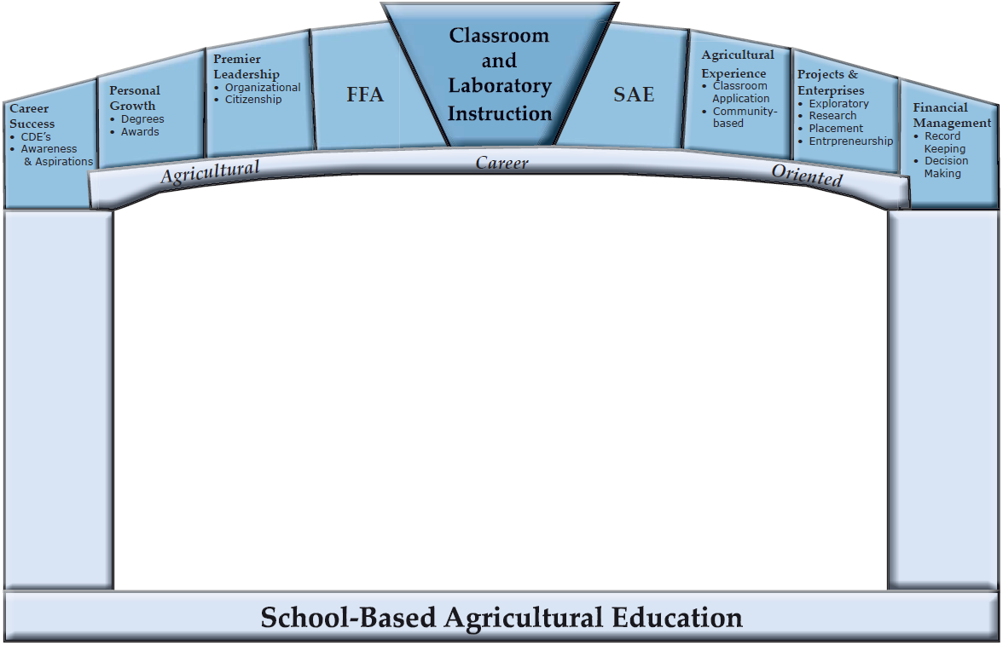
Figure 1: Proposed Agricultural Education Model

Future Plans/Advice to Others
When the proposed model is utilized in preservice teacher education, teacher educators should emphasize that without classroom and laboratory instruction SBAE programs would not function. Likewise, SAE and FFA should be used as application tools for student knowledge gained during classroom instruction. This model will alleviate preservice teacher’s confusion to the attention each component requires; without all three components present, the program is not complete. Balance is achieved through including all of the requisite parts of each component rather than the relevant size of three circles.
Cost/Resources Needed
There were no monetary costs with the development of this model. However, acceptance among the profession on inclusion in promotional and development materials would be needed.
References

Barrick, R.K., Arrington, L.R., Heffernan, T., Hughes, M., Moody, L., Ogline, P., & Whaley, D. (1992). Experiencing agriculture: a handbook on supervised agricultural experience. Alexandria, VA: The National Council for Agricultural Education.

Phipps, L. J, Osborne, E. W., Dyer, J. E., & Ball, A. (2008). Handbook on agricultural education in public schools (6th ed.). Clift Park, NY: Thomson Delmar.

