Strengthening the connection between leadership development programs and research using the Collegiate Leadership Development Model

Elizabeth Foreman
Student Service Specialist
Iowa State University
20 Curtiss Hall
Iowa State University
Ames, IA 50011
(515) 294-4548
bforeman@iastate.edu

Michael S. Retallick
Associate Professor
Iowa State University
206 Curtiss Hall
Iowa State University
Ames, IA 50011
(515) 294-4810
msr@iastate.edu

Strengthening the connection between leadership development programs and research using the Collegiate Leadership Development Model

Introduction

Research has examined the need for leadership education (Astin & Astin, 2000; Boatman, 1999; Dugan & Komives, 2007) and the role of precollegiate (Dugan & Komives, 2007; Kimbrough, 1998; Phinney, 1990; Schumacher & Swan, 1993) and collegiate experiences (Birkenholtz & Schumacher, 1994; Cooper, Healy, & Simpson, 1994; Dugan & Komives, 2007; Layfield, Radhikrisha, & Andresen, 2000) in reaching leadership outcomes. However, a review of the literature revealed that a comprehensive model for program development and research related to collegiate leadership was missing. The primary purpose of this study was to analyze the collegiate leadership development literature and develop a comprehensive framework that could be used for program development and research.

Methods

A six-step integrative inquiry process identified by Roberts (1983) was used to synthesize and interpret the findings. First, the lack of a comprehensive framework was identified as the need for the study. Second, one hundred and seventeen books and scholarly articles from a variety of sources, including the Journal of Agricultural Education, Journal of Leadership Education, Journal of College Student Development, and NASPA Journal were retrieved. Third, studies were screened and organized. Fourth, an existing model (Terenzini and Reason, 2005) was modified to match the emerging themes. Fifth, the model was developed with supporting literature. And finally, the dissemination of the model is planned.

Results

The Collegiate leadership development model was adapted from Terenzini and Reason’s (2005) Comprehensive model of influences on student learning and persistence model, which expanded the inputs (I), environment (E), and outcomes (O) concepts found in the College impact model (Astin & Astin, 2000), incorporated the organizational context (i.e., structure, policies and procedures and faculty culture) and has three components (Figure 1). The first two components are precollegiate (I) and college experiences (E), which previous literature suggested contribute to leadership development in undergraduate college students. The third component, leadership development, is the outcome of the model (O) and was conceptualized using the social change model (SCM; Higher Education Research Institute, 1996).

The pre-collegiate construct includes socio-demographics (Phinney, 1990; Kezar & Moriarty, 2000) and pre-collegiate experiences (Astin & Astin, 2000; 1977; Park & Dyer, 2005) that have been linked to leadership development. The college experiences construct includes classroom experiences, curricular experiences, and extracurricular experiences all of which contribute to leadership outcomes based on previous literature (Birkenholz & Schumacher, 1994; Ewing, Bruce, & Ricketts, 2009; Layfield, Radhakrishna, & Andresen, 2000; Dugan & Komives, 2007). Finally, leadership was used as the outcome construct of the model. While many different theoretical frameworks have been used to study leadership, the Social Change Model (SCM) (HERI, 1996) was chosen as the leadership outcome because it is a widely cited model of student leadership development in higher education (Haber & Komives, 2009) and has a reliable instrument (i.e., SRLS-R2) to measure the core values.

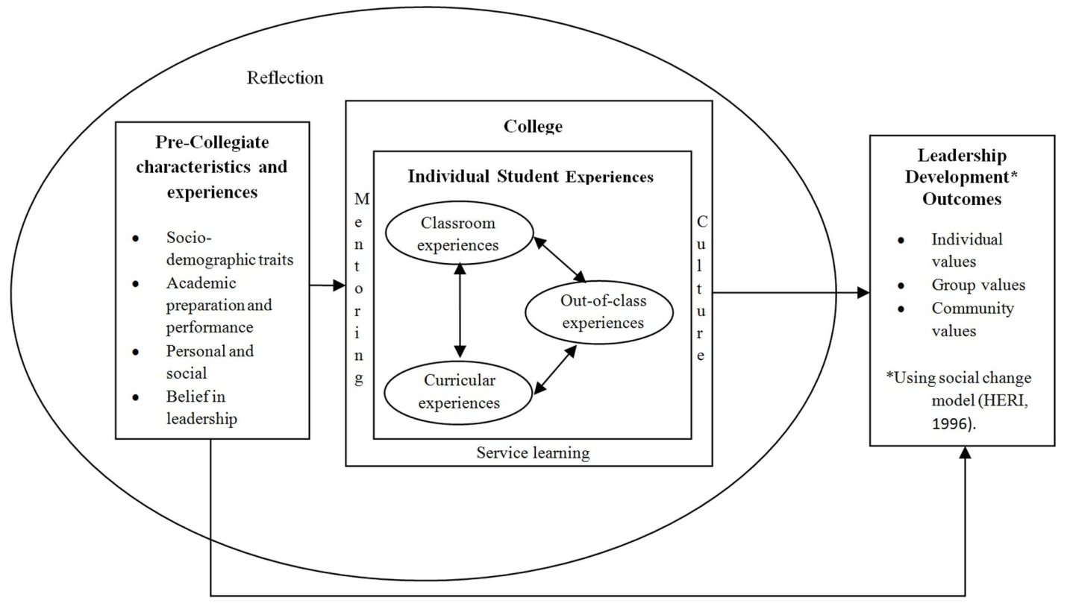

Figure 1. Collegiate leadership development model. Adapted from “First Things First: Developing Academic Competence in the First Year of College”, Research in Higher Education Volume 47 (2), Copyright [2005] by P.T. Terenzini and R.D. Reason.

Conclusions/recommendations

The Collegiate Leadership Development Model that evolved from this study reflects the interrelationship between precollegiate characteristics and experiences and collegiate experiences, including classroom, out-of-classroom, and curricular experiences, and their influence on leadership development outcomes as measured by the Social Change Model. This model provides a conceptual framework for developing and assessing leadership outcomes across college campuses and serves as a model for conducting research related to collegiate leadership development.

The College Leadership Development Model addresses a significant gap that exists between leadership theory and practice (Dugan & Komives, 2007). To reduce this gap, institutions of higher education and perhaps the individual colleges within those institutions should adopt a conceptual framework for developing and assessing leadership outcomes that includes curricular, classroom, and extracurricular components. This model may also serve as a framework for conducting research related to collegiate leadership development.
References
Astin, A. W., & Astin, H. S. (2000). Leadership reconsidered. Engaging higher education in social change. Battle Creek, MI: W. K. Kellog Foundation.

Birkenholz, R. J., & Schumacher, L. G. (1994). Leadership skills of college of agriculture graduates. Journal of AgriculturalEducation, 35(4), 1–8.

Boatman, S. A. (1999). The leadership audit: A process to enhance the development of student leadership. NASPA Journal, 37, 325-336.

Cooper, D. L., Healy, M. A., & Simpson, J. (1994). Student development through involvement: Specific changes over time. Journal of College Student Development, 35, 98–102.

Dugan, J. P., & Komives, S.R. (2007). Developing leadership capacity in college students: Findings from a national study. A Report from the Multi-Institutional Study of Leadership. College Park, MD: National Clearinghouse for Leadership Programs.

Ewing, J. C., Bruce, J. A., & Ricketts, K. G. (2009). Effective leadership development for undergraduates: How important is active participation in collegiate organizations? Journal of Leadership Education, 7, 118–131.

Higher Education Research Institute (1996). A social change model of leadership development (3rd ed. Los Angelos: Higher Education Research Institute.

Kezar, A. & Moriaty, D. (2000). Expanding our understanding of student leadership development: A study exploring gender and ethnic identity. Journal of College Student Development, 41, 55-69.

Kimbrough, W. M. (1998). The impact of membership in black greek-letter organizations on black students’ involvement in collegiate activities and their development of leadership skills. Journal of Negro Education, 67(2), 96–105.

Layfield, K. D., Radhakrishna, R. B., & Andreasen, R. J. (2000). Self-perceived leadership skills of students in leadership programs in agriculture courses. Journal of Southern Agriculture Research, 50 (1), 62–68.

Park, T. D., & Dyer, J. E. (2005). Contributions of agricultural education, FFA, and 4-H to student leadership in agriculture colleges. Journal of Agricultural Education, 46(2), 83 – 95. Doi: 10.5032/jae.2005.02083

Phinney, J. S. (1990). Ethnic identity in adolescents and adults: Review of research. Psychological Bulletin, 108, 499-514.

Roberts, J. M. (1983). Quick turnaround synthesis/interpretation for practitioners. In S.A. Ward and L. J. Reed (Eds.). Knowledge structure and use: Implications for synthesis and interpretation (pp. 425 – 485). Philadelphia: Temple University Press.

Schumacher, L. & Swan, M. K. (1993). Need for formal leadership training for students in a land-grant college of agriculture. Journal of Agricultural Education, 34(3), 1-9.

Terenzini, P. T. & Reason, R. D. (2005, November). Parsing the first year of college: A conceptual framework for studying college impacts. Paper presented at the meeting of the Association for the Study of Higher Education, Philadelphia, PA.

