Identifying the Information Exchange Patterns that Exist Within an Agriculture Production Demonstration Project through the Use of Social Network Analysis (SNA)

Nellie Hill, Graduate Assistant
nellie.hill@ttu.edu

David L. Doerfert, Associate Chair and Professor
david.doerfert@ttu.edu

Department of Agricultural Education and Communications
Texas Tech University
MS 42131
Lubbock, TX 79409
Phone: 806-742-2816
Fax: 806-742-2880

Identifying the Information Exchange Patterns that Exist Within an Agriculture Production Demonstration Project through the Use of Social Network Analysis (SNA)

Introduction

Social networks are the core of human society (Kadushin, 2012). Social network analysis has emerged as a research methodology and data analysis technique that increases understanding of the vast and complex relationships among people (Scott, 2013). Groups of individuals and the relations between them compose a social network. Social network analysis examines these groups, or systems, of social relationships. These systems are represented by networks of points, individuals, groups, or organizations, and lines, the connections (Kadushin, 2012).
A challenge for all researchers is the sharing and application/adoption of knowledge and best practices gained through study. For the [project name] (a farm-based demonstration project focused on conserving agriculture water), concerns remain as to a potential knowledge gap between producers within the project who have gained new water management knowledge and other producers across [state].
The National Research Agenda: American Association for Agricultural Education’s Research Priority Areas 2011-2015 (Doerfert, 2011) places an emphasis on understanding adoption decision processes regarding new technologies, practices, and products. The purpose of this study was to understand how information flows through interpersonal networks among [project] producers by analyzing the connections among them towards the goal of improving information dissemination and related adoption.

Conceptual Framework

The Diffusion of Innovation framework conceptualizes the structures by which an innovation spread throughout a community (Rogers, 2003). Relatedly, social network analysis (SNA) is concerned with the relationships among people and has emerged as a key technique in modern sociology. It has also gained a significant following in anthropology, biology, communication studies, economics, geography, information science, organizational studies, social psychology, and sociolinguistics, and has become a popular topic of speculation and study (Scott, 2013). The resulting data analysis creates a map illustrating the nodes (individuals, groups, communities or organizations) and the connections (shown as lines that represent the relationships ranging from casual acquaintances to close bonds).

Methodology

The researcher-developed questionnaire was based on the sociometric test developed by Moreno (1953) as cited by Peter V. Marsden (2011) to gather relational data. Face-to-face interviews were conducted over a three-month period to collect the data for network analysis. Participants consisted of 16 producers who are a part of the [project]. Each producer was asked to name at least three people whom they go to for information or advice and at least three people who come to them for information or advice. Producers were informed that their names would be changed to report the results.
The data analysis process consisted of creating a one-mode network, producer-to-producer data matrix, also known as an edge list, using Microsoft Excel. An abbreviated version of the edge list is seen in Figure 1. Microsoft Node XL was used to map the relationships to further analyze network properties.

Vertex 1 | Vertex 2
Lee | John
Lee | Joseph
Lee | David
Sheldon | Lee
Donald | Lee
Jeff | George
Jeff | Robert
Figure 1. Abbreviated edge list of [project] producers
Findings
NodeXL created a Harel-Koren Fast Multiscale sociogram (Figure 2). The sociogram shows 52 people with 105 connections amongst them. Measures of betweenness centrality and closeness centrality were analyzed to gain insight into the greatest bridges of producers. Andrew has the highest betweenness centrality score, 1971. Stefan’s betweenness centrality score of 744, the second highest of those interviewed. As the closeness centrality approaches one, the stronger the connections. Andrew has the strongest connection, 0.013, followed by Stefan, 0.009.

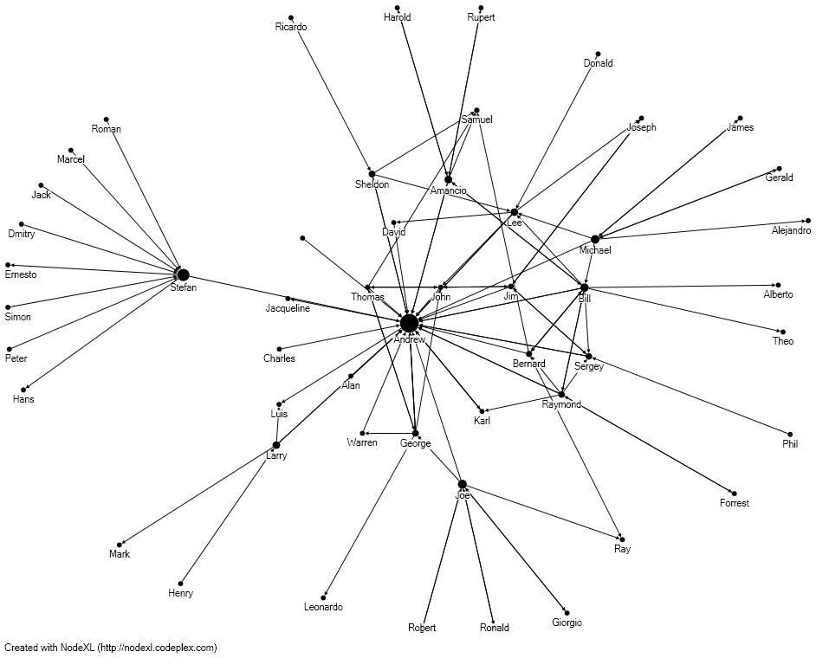
Conclusions

Andrew is an important gatekeeper within the [project], considering his high betweenness centrality, closeness centrality, and in-degree measures. He bridges many connections and is looked to often for information and advice. Bill has the most connections with other producers within the project. Stefan’s subgroup tells us there is a strong possibility for reaching out to producers outside of the project through his influence.

Recommendations

The results of the SNA reviewed that there are smaller communities that exist within the [project]. Based on the results, the [project] should utilize these communities and the identified individuals as opinion leaders within the project.
Figure 2: Harel-Koren Fast Multiscale Sociogram of relationships within the [project].

As the SNA illustrated that the project has reach outside of the 16 involved producers, the [project] should utilize producers connected to individuals outside of the project to share best practices, encourage the use of irrigation monitoring and decision tools, and expand the project beyond its current boundaries.

References

Doerfert, D. L. (Ed.) (2011). National research agenda: American Association for Agricultural Education’s research priority areas for 2011-2015. Lubbock, TX: Texas Tech University, Department of Agricultural Education and Communications.

Kadushin, C. (2012). Understanding social networks: theories, concepts, and findings. New York, NY: Oxford University Press, Inc.

Marsden, P.V. (2011). ‘Survey Methods for Network Data’, in J. Scott and P. Carrington (eds) The Sage Handbook of Social Network Analysis. London: Sage.

Moreo, J.L. (1953). Who Shall Survive? Foundations of Sociometry, Group Psychotherapy, and Sociodrama. Beacon, NY: Beacon House.

Rogers, E.M. (2003). Diffusion of Innovations. (5th ed.). New York: Free Press.

Scott, J. (2013). Social network analysis. (3rd ed.). London, England: SAGE Publications, Ltd.

