Using NodeXL for Social Network Analysis and Adoption-related Research

Nellie Hill, Graduate Assistant
nellie.hill@ttu.edu

David L. Doerfert, Associate Chair and Professor
david.doerfert@ttu.edu

Department of Agricultural Education and Communications
Texas Tech University
MS 42131
Lubbock, TX 79409
Phone: 806-742-2816
Fax: 806-742-2880

Using NodeXL for Social Network Analysis and Adoption-related Research
Introduction
Social change is one of the most fundamental of human processes (Rogers, 2003) and social networks foundational to that process. Groups of individuals and the relations between them compose a social network. The National Research Agenda: American Association for Agricultural Education’s Research Priority Areas 2011-2015 (Doerfert, 2011) places an emphasis on understanding adoption decision processes regarding new technologies, practices, and products. For education/communications professionals involved in outreach efforts designed to influence the adoption process, understanding and subsequently utilizing established networks and potential opinion leaders can increase the effectiveness and efficiency of those efforts.
Social network analysis (SNA) examines these groups, or systems, of social relationships. These systems are represented by networks of points, individuals, groups, or organizations, and lines, the connections (Kadushin, 2012). Social network analysis has emerged as a research methodology and key data analysis technique in sociology that increases understanding of the vast and complex relationships among people (Scott, 2013). It has also gained a significant following in anthropology, biology, communication studies, economics, geography, information science, organizational studies, social psychology, and sociolinguistics, and has become a popular topic of speculation and study (Scott, 2013). Subsequently, social network analysis affords researchers a new perspective on relationships among a group to better understand how information is shared. The purpose of this innovative idea poster is to describe the use of NodeXL to conduct social network analyses.
How it Works
Vertex 1 | Vertex 2
Lee | John
Lee | Joseph
Lee | David
Sheldon | Lee
Donald | Lee
Jeff | George
Jeff | Robert
Figure 1. Abbreviated edge list
There are many different software packages that can be used for social network analysis with varying levels of complexity and capabilities. NodeXL is designed to aid new learners of SNA thus encouraging the exploration of interpersonal relationships and their level of activity. NodeXL (Network Overview, Discovery and Exploration add-in for Excel 2007) is an open source software tool designed to conduct social network analysis with an emphasis on visualization (Hansen, Shneiderman, & Smith, 2011). It supports filtering, calculates network metrics and supports a variety of visual layouts. The tool is free and can be downloaded from http://nodexl.codeplex.com/. As a structured Excel workbook template, NodeXL stores all of the information necessary for analysis. To illustrate the outputs, data from an SNA conducted with 16 farmers in [state] that were involved in a research/demonstration project was used. During analysis, network relationships are entered into an “edge list” (Figure 1). The resulting data analysis then creates a map (Figure 2) illustrating the nodes (individuals, groups, communities or organizations) and the connections (shown as lines that represent the relationships ranging from casual acquaintances to close bonds). Visual properties of the map can be adjusted for review, including the shape, color, size, transparency, and location of nodes and connections.
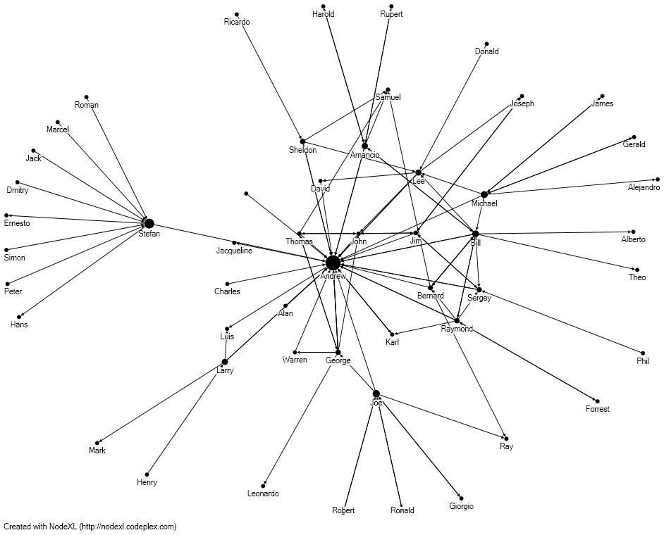
Implications
As Figure 2 illustrates, outputs from NodeXL has the potential to illustrate existing communications networks and any opinion leadership that may exist within the network. Further, NodeXL can illustrate any unanticipated reach beyond a project’s scope that can serve as evidence of a project’s effectiveness to create change or increase the extent and potentially the rate of adoption.
The results can allow educators and communicators to more effectively plan information dissemination and education/ training efforts towards a goal of maximizing effectiveness while reducing the use of valuable resources (including time).
Figure 2: Harel-Koren Fast Multiscale Sociogram of network relationships
Future Plans/ Advice to Others
The authors will be expanding the previously mentioned SNA analysis with 16 farmers to begin creating “maps’ of farmer networks within selected counties in [region] to determine if different network patterns exist based on the agriculture topic/issue being discussed. Further analysis will seek to determine if network variations are present based on individual and county-level factors. Once complete, the researchers will have a greater understanding how information flows through interpersonal networks among farmers. This understanding will then facilitate further research on message development and channel mix as they relate to information assimilation and adoption of practices/technologies disseminated.
The authors recommend learning NodeXL through application. If possible, gather relational data from a local, easily-accessed group to create the edge list and the map to begin an analysis and more deeply learned the process and tool.
Costs/ Resources Needed
Microsoft Excel 2007, or later, is required. The NodeXL add-in is free. Hansen, Shneiderman, and Smith’s book Analyzing Social Media Networks with NodeXL: Insights from a Connected World was the primary guide. The authors (part of the team that developed NodeXL) introduce the basic functions of the tool through a hands-on, step-by-step approach. Social media network analysis case studies are also provided, though the tool can be used for both virtual and real-world networks.

References
Doerfert, D. L. (Ed.) (2011). National research agenda: American Association for Agricultural Education’s research priority areas for 2011-2015. Lubbock, TX: Texas Tech University, Department of Agricultural Education and Communications.
Hansen, D. L., Schneiderman, B., & Smith, M. A. (2011).Analyzing social media networks with NodeXL: Insights from a connected world. Burlington, MA: Elsevier, Inc.
Kadushin, C. (2012). Understanding social networks: theories, concepts, and findings. New York, NY: Oxford University Press, Inc.
Scott, J. (2013). Social network analysis. (3rd ed.). London, England: SAGE Publications, Ltd.

