Innovative Idea

Unclouding Student Learning: Using Word Clouds for Student Reflection

Courtney Gibson
Graduate Research and Teaching Assistant
courtney.d.gibson@ttu.edu

Chelsey Ann Ahrens
Graduate Research and Teaching Assistant
chelsey.ahrens@ttu.edu

Texas Tech University
Box 42131
Lubbock, TX 79409
Phone: 806-742-2816
Fax: 806-742-2880

Unclouding Student Learning: Using Word Clouds for Student Reflection

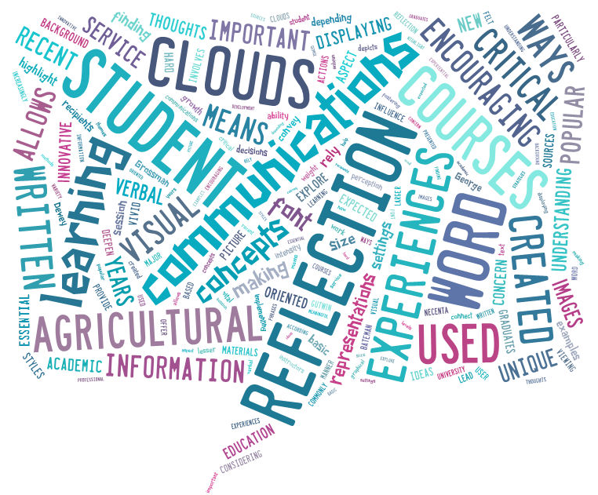

Introduction

Many agricultural communications courses can or have benefited from the use of student reflections, particularly service and experiential learning courses. Reflecting upon their learning and experiences allows students to deepen their understanding of concepts and materials presented to them (Grossman, 2009). According to Dewey (1933), reflection involves critically considering an experience so that new meanings can be created which lead to growth and the ability to make informed decisions and actions. However, reflections are often difficult for students to complete or understand, because students differ in how easily they engage in reflection and in their ability to learn from their reflections (Bringle & Hatcher, 1999).

As students at all levels of education are increasingly encouraged to reflect upon their learning experiences, it has become important for instructors to find unique and innovative ways to foster critical reflection in meaningful ways. Agricultural communications graduates are expected to be both verbal and written communicators; however, it can sometimes be difficult to convey concepts and ideas, especially those associated with reflection, through verbal or written communications. Visual representations of information help to create a more vivid picture of written communications and can help in the understanding of information (George, 2002).

Word clouds have become increasingly popular in a variety of academic settings in recent years and have been found to be seen as a valuable learning enhancement by students (Frances & Read, 2011). Students have noted that word clouds provide increased motivation and allow them to enhance their sense of self (Frances & Read, 2011), which are important aspects of reflection. Word clouds offer a unique way to display students’ thoughts and reflections on courses and experiences in a manner that allows them to visualize and connect with the themes and concepts most important to them.

How it Works
Word clouds create a visual image based on a set of text by analyzing word usage and displaying the most commonly used words in a larger font size than lesser used words. Based on the text from a student’s written reflection, the visual word cloud allows students to see the themes or concepts they believed were most vital to them by displaying their most prominent thoughts and feelings in the larger font sizes. According to Bateman, Gutwin, and Necenta (2008), font size, font weight, and intensity influence a user’s perception of importance when viewing word clouds. Instructors at [University] have implemented the use of word clouds in a variety of agricultural communications courses as a means of encouraging meaningful student reflection.

At the end of each course, instructors assigned students to write a reflection paper about their experiences in the course. Once students had written their reflection paper, they were required to upload the text of their paper to an online word cloud generator such as Wordle or Tagxedo, among others. Some word cloud generators provide users with the ability to choose between different word cloud shapes and many color and font customization options. Others have only a few layout and color customization options. After the students had generated a word cloud, they printed and attached it to their original reflection paper. Students were then asked to evaluate and reflect upon the visual representation of their reflection shown in their word cloud.

Results to Date/Implications
Students have responded very positively to the word cloud reflections in the courses thus far. Students especially liked going back and reflecting upon the word clouds once they were created and felt this brought a new understanding to their original reflections. Some students commented that seeing the words and themes that were most prominent in their written reflection depicted in this visual manner allowed them to connect with their experiences differently. Other students commented that the word clouds made the reflection assignment more fun and provided a unique way to look back at their learning experience. Additionally, students stated they enjoyed implementing the word cloud component to their reflections as this was a new and different way of critically thinking about what they had written. Instructors who have utilized word clouds also responded positively and stated they really enjoyed reading the reflections of their students and seeing the visual representation of them through the word clouds.

Future Plans/Advice to Others
The instructors have plans to continue utilizing word clouds as part of reflection papers in their courses and encourage others who require reflection papers to consider adding a word cloud component to enrich student reflections. The positive feedback from students suggests word clouds are a worthwhile and enriching assignment. It is recommended that instructors require students to complete some sort of reflection of the actual word clouds once they are created as this was a vital part of students’ reflection growth and understanding seen by the instructors in these courses.

Costs/Resources Needed
A variety of word cloud generators are available online and free of charge, including Wordle, Tagxedo, Tagul, and ABC Ya, making them an easy to use and affordable tool for all courses. The only resources necessary to create a word cloud is a computer with Internet capabilities and Java or Flash software to access the online word cloud generator.
References

Bateman, S., Gutwin, C., & Nacenta, M. (2008). Seeing things in the clouds: The effects of
visual features on tag cloud selection. Proceedings of the 19th ACM Conference on Hypertext and Hypermedia. New York, NY.

Bringle, R. G. & Hatcher, J. A. (1999). Reflection in service learning: Making meaning of
experience. Educational Horizons, 77(4), 179-185.

Dewey, J. (1933). How we think: A restatement of the relation of reflective thinking to the
educative process. Boston, MA: D.C. Heath and Company.

Frances, M. & Read, A. (2011). Using word clouds to develop proactive learners. Journal of the
Scholarship of Teaching and Learning, 11(2), 91-110.

George, D. (2002). From analysis to design: visual communication in the teaching of writing.
College Composition and Communication, 54(1), 11-39.

Grossman, R. (2009). Structures for facilitating student reflection. College Teaching, 57(1), 15-
22.

