INNOVATIVE

PUMP IN A BUCKET: A PHOTOVOLTAIC TEACHING TOOL FOR INSTRUCTION OF DIRECT CURRENT ELECTRICITY TO AGRICULTURE STUDENTS

EDWARD A. FRANKLIN
1110 E. SOUTH CAMPUS DRIVE
#205 SAGUARO HALL
TUCSON, AZ 85723
(520) 621-1523
eafrank@ag.arizona.edu

PUMP IN A BUCKET: A PHOTOVOLTAIC TEACHING TOOL FOR INSTRUCTION OF DIRECT CURRENT ELECTRICITY TO AGRICULTURE STUDENTS

INTRODUCTION/NEED FOR IDEA
Concerns about the future and safety of the world’s energy supply have resulted in more attention focused on renewable energy sources such as solar power. Electricity supplied by a photovoltaic (PV) system can replace electricity from other power-generating technology (Dunlop, 2010). According to the Solar Energy Industries Association (SEIA) (February, 2014) the state of [STATE] ranks second (to California) in total number of operating major solar projects in the United States with 1,098 and ranks third nationally in total major PV project capacity and completion status (SEIA, 2014).

The purpose of the activity was to adopt and implement a hands-on activity to engage students in the principles of how electrical power is produced from a photovoltaic (PV) module. The “Pump in a Bucket” (SEI, 2012, p. 26) activity was “borrowed” from our friends at Solar Energy International (SEI).
HOW IT WORKS
A 20-watt photovoltaic module is fitted with MC3 female and male connectors. To connect the module leads to the direct current 12 volt bilge pump, a set of 10 gauge PV “home run leads” are made. The purpose of the “home run lead” is to enable a connection to the PV module and to the bare ends of the bilge pump and fuse using wire nut connectors. This prevents a possible “arc” occurring between the male and female electrodes when the MC3 connectors are disconnected under a load. The bilge pump is placed in the bucket and the outlet is connected to ¾” discharge tubing. The tubing is attached to a plastic or brass barb fitting which threads into a female PVC adapter. Three PVC 90 slip elbows are connected with PVC pipe to move the water from the bottom of the bucket to the top, and redirect it back into the bucket. The PVC pieces are slip-fit so students may assemble and disassemble the unit. The pump requires a 2-amp inline fuse connected to the positive conductor from the pump. The positive and negative conductors of the pump are extended up and out of the bucket. Enough water is placed in the bottom of the bucket to submerge the pump. The “home run leads” are connected to the PV module. Make sure the module is placed face-down to prevent the flow of electrons from the module into the conductors. Connect the bare ends of the conductor with wire nuts. To operate the pump, place the PV module at a direct angle to the sun. Experiment with the flow-rate of the pump by re-positioning the tilt and orientation of the PV module to the sun.

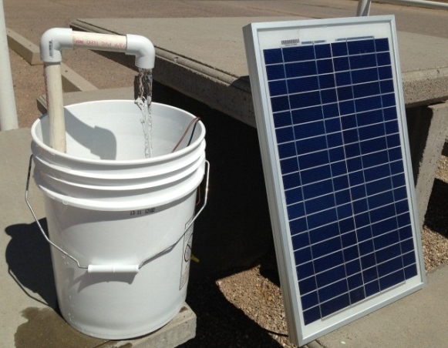
Figure 1. Pump in a bucket with connected PV module under load.
RESULTS TO DATE
Four sets of pump in a bucket were constructed and used with the AGTM 350 class during the PV instructional unit in the fall 2013 class. Students were divided into small groups and were able to perform the following tasks:
- Assemble an operating 12-volt direct current bilge pump to recirculate water powered by a PV module.
- Measure power output (DC voltage) of the module using a digital multimeter.
- Measure the cell temperature of the PV module.
- Determine most appropriate tilt angle of the PV module toward the sun for maximum power output based on observed rate of flow of water.
- Determine the effect of shading of the module on power output of the pump.
- Measure observed open-circuit voltage (Voc) of the PV module and compare to expected open-circuit (Voc) of the PV module.
- Measure observed short-circuit current (Isc) of PV module with a clamp-on meter and compare to the expected short-circuit current (Isc).
- Compare observed PV module maximum power output (Wmp) to expected maximum power output (Wmp) of the PV module.

FUTURE PLANS/ADVICE FOR OTHERS
A future plan is to secure funding from a renewable energy grant to obtain materials to construct four additional “Pump in a Bucket” teaching units. The goal is to (1) reduce the ratio of AGTM students to teaching units from 6:1 to 3:1; (2) to acquire additional pyranometer measuring units to provide student groups with the ability to take multiple irradiance level readings without having to wait for other student groups; and (3) acquire additional pitch & angle finders for measuring tilt and orientation. Additional activities to include in future labs include measuring the flow-rate by pumping a known quantity of water into another bucket at various PV module tilt and orientation. Using the pyranometer, students can measure solar irradiance and chart the effect on power output of the PV module on flow-rate.

COSTS/RESOURCES NEEDED
See Table 1 for approximate cost and sources for materials. Actual costs will vary depend on amount and size or capacity of tools and materials.

Table 1. List, Cost, and Sources of Materials for Pump in a Bucket Activity
Item | Unit Cost | Vendor
20-volt PV module | $ 63.00 | Solarland®
12-volt DC bilge pump | $ 25.00 | Amazon.com
Inline 3-amp fuse | $ 5.00 | Local auto part store
PVC pipe, elbows, fittings, ¾” tubing | $ 10.00 | Local DIY center
PV wire, 10 gauge, w/ connectors, 24” each | $ 2.00 | Solar supplier
Wire nut connectors (3) | $ 1.00 | Local DIY center
5-gallon bucket | $ 4.00 | Local DIY center
Optional Items
Pyranometer | $165.00 | Alt E Store
Pitch & angle finder | $ 6.00 | McFeeley’s
Digital Multimeter (AC-DC, Clamp-on) | $ 53.00 | Sears

REFERENCES
Dunlop, J. P. (2010). Photovoltaic Systems (2nd Ed.) American Technical Publishers, Inc., Orland Park, IL.

Solar Energy Industries Association. (February, 2014). Major Solar Projects in the United States
Operating, Under Construction, or Under Development. Solar Energy Industries Association (SEIA) website. Available: http://www.seia.org/sites/default/files/resources/SEIA%20Major%20Solar%20Projects%20List%202.3.14.pdf

Solar Energy International (2012). Lab: PV Module worksheet part III (of III): Pump in a bucket. PV101: Solar Electric Design and Installation (Grid-Direct) Workshop Notebook, Version 8.1. Solar Energy International, Paonia, CO.

