Science of Agriculture Response (SOAR): Integrating Science Content Standards into 4-H Youth Development Curriculum and 4-H Projects

Joshua E. Rice, Ph.D.
Assistant Professor and Extension Specialist
University of Minnesota

Suite 475 Coffee Hall
1420 Eckles Avenue
St. Paul, MN 55108
612-624-8426
JoshuaRice85@gmail.com

Science of Agriculture Response (SOAR): Integrating Science Content Standards

into 4-H Youth Development Curriculum and 4-H Projects

Need for Idea

Science achievement in the United States among K-12 youth has lagged behind many of their grade level peers from other countries for many years, prompting much concern from researchers (e.g., Miller, 2006; Murcia, 2007; Scearce, 2007) as well as from federal agencies such as the National Academy of Sciences (2007). 4-H encourages members to acquire project and life skills through project-based experiential learning (Boleman, 2003).

Non-formal educational experiences, such as those found in 4-H, can play an important role in increasing children's exposure to, and interest in, science. Science-related projects are the most common among the myriad of projects available to youth through their 4-H programs and account for nearly one-half of all 4-H projects administered nationally (USDA, 2002). Exposure to 4-H science-related programming in particular appears to be significantly associated with higher-level science coursework taken in high school (Heck, Carlos, Barnett & Smith, 2012).

Despite some promising evaluation research on nonformal science education, such as the impacts of educational delivery in an experiential-learning, inquiry format, less attention has been paid to the impact that out-of-school programs may have on science interest in youth. Research on science programs in nonformal settings has suggested that nonformal science programs have the potential to increase science interest among young people and that these programs can have long-lasting impacts. (Heck, Carlos, Barnett & Smith, 2012) The Science of Agriculture Response Program (SOAR) was designed to integrate and make the cognitive connection that exists between science content standards and 4-H member projects.

How it Works

The Extension Center for Youth Development, volunteers, community leaders, and advisory board members collaborated to create the Science of Agriculture Response program. The goal of SOAR is to encourage 4-H members to develop a deeper understanding of science content standards associated with 4-H projects and activities.

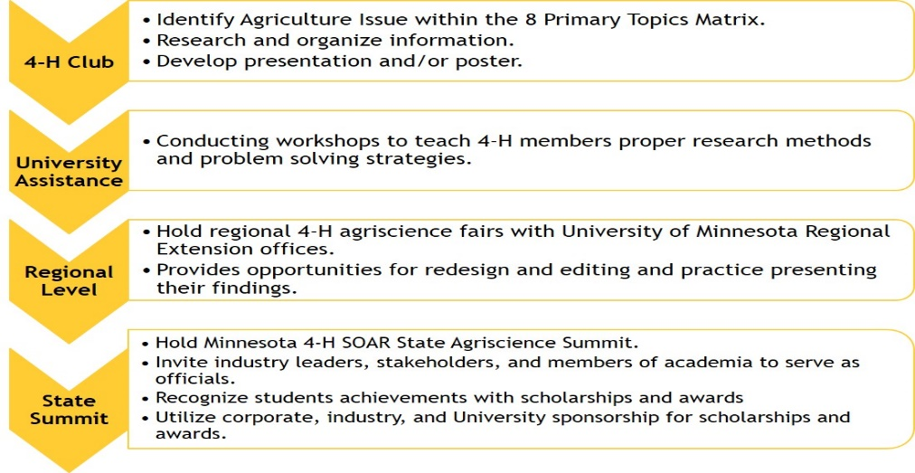
SOAR will utilize an experiential learning approach that employs the skills gained from a 4-H project and require students to demonstrate the acquisition of those concepts via a visual presentation. The 4-H members will participate in the SOAR program on 3 levels; the local club level, regionally, and at the State 4-H Agriscience Summit. The matrix above illustrates the sequence of events for the SOAR program.

Results to Date

During the phase one development of the SOAR program, 8 primary topic areas were identified: animal science, agriculture mechanics, plant sciences, STEM, healthy lifestyles, wildlife and natural resources, biotechnology, and leadership development. Currently, agriculture curricula, resources, and state science content standards that exist are being evaluated by a panel of experts to identify the key components that should be included within the SOAR curriculum. The identified components will be used to develop the SOAR curriculum and the required 4-H volunteer training programs specific to SOAR.

Future Plans

During the spring of 2015, 4-H members will participate in a pilot test for the first annual State 4-H Agriscience Summit. During the Summit, 4-H members will display posters that they developed and/or deliver oral presentations regarding an issue within the topic matrix that relates to their 4-H project. There will be a poster division and presentation division for each of the 8 topic areas identified. The posters and presentations will be evaluated by industry leaders, stakeholders, and members of academia. Scholarships and awards will be presented to the top 5 individuals in each topic area division. Surveys will be provided to the participants and volunteers. The survey data will be analyzed and modifications and improvement will be made to the SOAR program based on data collected. The SOAR program will be used to facilitate the annual State 4-H Agriscience Summit.

Resources Needed

Currently, a faculty member at the [UNIVERSITY] serves as the SOAR program coordinator. The coordinator and panel of experts working on the SOAR program require access to current agriculture curricula and state science content standards. The coordinator is reimbursed for their travel expenses to visit agribusiness/industry locations in order to make connections, deliver workshops, and evaluate program progress. The reimbursement is sourced funding from grants, foundations, and sponsors.

4-H volunteers are needed to deliver the curriculum to 4-H members and locations for volunteer training will be required. Regional 4-H Extension offices will be utilized for Regional 4-H Agriscience Summits. When implementing the State 4-H Agriscience Summit, sponsors will need to be obtained for scholarships and awards. Industry leaders, stakeholders, and members of academia will need to be obtained to evaluate the 4-H posters and presentations. Statistical Package for the Social Sciences (SPSS) data analysis software will be required to evaluate data collected from the surveys collected.

References

Boleman, C. T. (2003). A study to determine the additional income generated to the Texas agricultural sector by four Texas 4-H livestock projects and an assessment of life skills gained from youth exhibiting these projects (Doctoral dissertation): College Station, TX: Texas A&M University.

Heck, K. E., Carlos, R. M., Barnett, C., & Smith, M. H. (2012). 4-H participation and science interests in youth. Journal of Extension, 50(2), 1-14.

Miller, J. (2006, May). Civic scientific literacy in Europe and the United States. Paper presented at the annual conference of the World Association for Public Opinion Research, Montreal, Canada.

Murcia, K. (2007). Science for the 21st century: Teaching for scientific literacy in the primary classroom. Teaching Science, 53(2), 16-19.

National Academy of Sciences. (2007). Rising above the gathering storm: Energizing and employing America for a brighter economic future. Washington, D.C.: The National Academies Press.

Scearce, C. (2007). Scientific Literacy. ProQuest Discovery Guides. Retrieved from:
http://www.csa.com/discoveryguides/scilit/review.pdf

United States Department of Agriculture (USDA). (2002). Annual 4-H youth development enrollment report. Retrieved from http://www.national4hheadquarters.gov/library/4h_stats.htm

