Poster Type: Innovative

Nonlinguistic Representation of the Ag Ed Philosophy

Gaea Hock

Mississippi State University

Box 9745

Mississippi State, MS 39762

662.325.7834

gaea.hock@msstate.edu

T.J. Bradford

Mississippi State University

Box 9745

Mississippi State, MS 39762

662.325.1175

tb306@.msstate.edu

Nonlinguistic Representation of the Ag Ed Philosophy

Introduction/Need for Innovation
Too often students are asked to read and reflect on a text passage without having to take it to the next level. In an effort to engage higher order thinking (Bloom et al., 1956), students need to do more than simply read text. They must be asked to think about the text to create a deeper meaning. The use of creative thinking should be encouraged and fostered. Creative thinking involves “putting together information to come up with a whole new understanding, concept, or idea” (Morre, 2015, p. 380).

No two students are the same in any classroom. The use of differentiated instruction is a practice which is encouraged by all teachers to help meet the needs of all students (Tomlinson, 1999). Differentiated instruction can take place by modifying the instructional delivery or the assignments (Moore, 2015). While this type of instruction has typically been used when teaching students with special needs, all students can benefit from differentiating instruction (including gifted and talented).

One way to accomplish differentiation is through the use of creative assignments. Nonlinguistic representations are helpful in the college classroom because most of the content is delivered orally or in text form (Marzano, Norford, Paynter, Pickering, Gaddy, 2001). Students’ use of such representations help stimulate and increase brain activity (Gerlic & Jausovec, 1999). The use of pictures or pictographs for students to convey comprehension is a practice which should be encouraged and supported (Marzano et al., 2001).

Efforts must be made to meet the diverse learning needs of students, while at the same time asking them to think at a higher level. These items can be accomplished through the purposeful design of course assignments. One such assignment is the nonlinguistic representation of a philosophy.

How it Works/Methods/Steps
Students were taught about the history, development, and philosophy of agricultural education. Students were asked to read and critically think about the nine components of the philosophy of agricultural education (Phipps, Osborne, Dyer, & Ball, 2008). They were then asked to create a visual representation of their interpretation of the philosophy.

A brief description of the nine components of the philosophy of agricultural education (Phipps et al., 2008) include: 1.) Places emphasis on the individual learner, 2). Instructional programs and student learning activities must reflect the dynamic and ever-changing industry of agriculture, 3.) Important responsibility in career guidance and counseling, 4.) Believe in the importance of citizenship and leadership development, 5.) Agricultural education should be accessible to students having a wide range of academic and social skills, 6.) Benefits students in a variety of ways, 7.) Community oriented, 8.) Progressive learning experiences, 9.) Believe in the essential components.

Students were instructed to use minimal text when creating their graphic. They could hand-draw or use computer software to create their nonlinguistic representation. In addition to the visual, they were also asked to write a short explanation to more clearly communicate their graphic to the viewer. Students were assessed on how well the illustration conveyed the philosophy, level of originality, creativity, as well as the clarity statement.

Results to Date/Implications
Students in [class] completed this assignment as a follow-up to a poorly answered test question regarding the philosophy of agricultural education. The goal was to encourage them to think more in-depth about the philosophy. Students created several unique and inventive visualizations of the agricultural education philosophy (Figure 1). Several students drew their interpretation of the philosophy while others used a computer program to assist in the creation of their nonlinguistic representation.

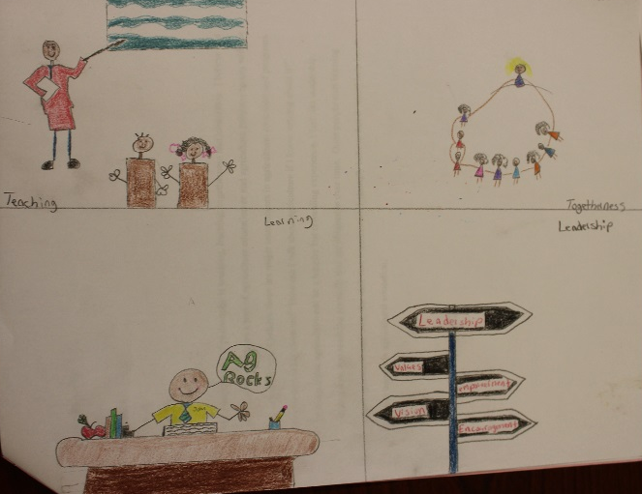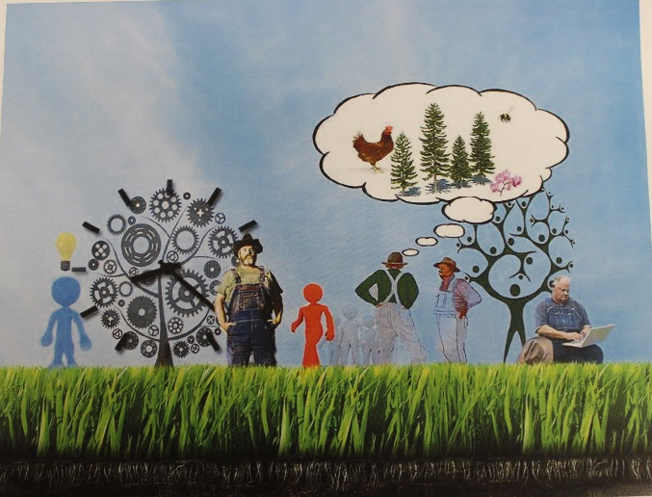

Figure 1. Student examples of their interpretation of the agricultural education philosophy.

Students appeared eager to finish this assignment and their level of artistry was impressive. Some students wanted more direction and an example to look at, but we felt it was important that they only use their own imagination to create their final product.

Future Plans/Advice to Others
This assignment has been added as a regular assignment in the course. Students will be encouraged to create the assignment using as much creativity as possible. They are able to describe their picture/pictograph in the supplemental paragraph. Students may struggle with this assignment because there isn’t a correct answer. The process of asking them to critically think about the philosophy is very important to developing higher order thinking skills. Additional text excerpts could be used to create other nonlinguistic representations of their interpretation and application of material.

Costs/Resources Needed
There are no costs associated for this innovative idea, but the students may incur costs depending on the type of product they create. A copy of the philosophy is required. This course requires the purchase of the textbook so they already have incurred that cost.
References

Bloom, B.S., Engelhart, M.D., Furst, E.J., Hill, W.H., & Krathwohl, D.R. (Eds.). (1956). Taxonomy of educational objectives: Handbook I. Cognitive domain. New York: David McKay.

Gerlic, I., & Jausovec, N. (1999). Multimedia: Differences in cognitive processes observed with EEG. Educational Technology Research and Development, 47(3), 5-14.
Marzano, R.J. (2010). The art and science of teaching/representing knowledge nonlinguistically. The Key to Changing the Teaching Profession, 67(8), 84-86.
Marzano, R.J., Norford, J.S., Paynter, D.E., Pickering, D.J., & Gaddy, B. B. (2001). A handbook for classroom instruction that works. Upper Saddle River, NJ: Pearson Education.

Moore, K.D. (2015). Effective instructional strategies: From theory to practice. Thousand Oaks, CA: SAGE Publications, Inc.

Phipps, L.J., Osborne, E.W., Dyer, J.E. & Ball, A. (2008). Handbook on Agricultural Education in Public Schools. Clifton Park, NY: Delmar, Cengage Learning.

Tomlinson, C.A. (1999). The differentiated classroom: Responding to the needs of all learners. Upper Saddle River, NJ: Pearson Education.

