Innovative Idea Poster

#FarmBill:
Using a Hashtag to Extend the Reach of a
Student-Planned Forum
Elissa McLerran
Graduate Assistant
elissa.mclerran@ttu.edu

Keely Hamman
Graduate Assistant
keely.hamman@ttu.edu

Erica Irlbeck
Assistant Professor
erica.irlbeck@ttu.edu

Trent Seltzer
Department Chairperson, Public Relations
Trent.seltzer@ttu.edu

Kristin Wyllys
Social Media Lab Manager
Kristin.wyllys@ttu.edu

Department of Agricultural Education and Communications
Texas Tech University
Box 42131, Lubbock TX 79404-2131
806-742-2880
Introduction
The evolution of interactive, social, and self-publishing media on the Web has irrevocably changed the way we communicate (Allen, Abrams, Meyers & Shultz, 2010). Social media sites are impacting communication and the way that organizations and publics operate and connect with audiences. These platforms allow for a two-way conversation to be facilitated through direct channels of communication between businesses, organizations and their publics. Social media tools can be beneficial because “they provide a cost-free forum for the expression of ideas, information and opinion” (Wright & Hinson, 2009). Furthermore, “they [social media outlets] increase the immediacy of communication and offer platforms for public opinion on various issues” (Wright & Hinson, 2009).
Beyond the social media outlets, a component that is also beneficial is a “hashtag” (#). A hashtag is a keyword, and when people search for a keyword, all tweets or posts with the “#” ahead of it will pop up (Paulson, 2009). The use of hashtags on [social media] allows for information organization and makes topics more searchable (Cameron, 2009). Many event organizers are utilizing hashtags; without many attendees knowing each other at an event, it is simple to aggregate their tweets. In order to join a community’s discussion about a topic or to participate within [an event] it is sufficient to tag one’s messages with the official hashtag of an event. It becomes easier to share ideas, impressions, comments and additional materials (Ebner, Mühlburger, Schaffert, Schiefner, Reinhardt & Wheeler, 2010). Event attendees and participants can search for tweets within the event hashtag and are able to follow the ongoing microblogging stream from the event.

How It Works
Agricultural communications students at [University] are required to take Professional Development in Agricultural Communications. The course focuses on career and internship preparation as well as event planning and execution. In the event planning portion of the course, students plan and execute an event within one semester for an organization with a need for a professionally planned event. For one of the events, students planned a Farm Bill forum for local agriculture producers and businesses. The forum featured four experts guest speakers that had extensive knowledge about the farm bill, and was a way to bring multiple agricultural and business interest groups together to learn more about a complex issue. Local agricultural producers and businesses, students in the course, university employees, local media, and others with an interest in the farm bill attended. Attendees and participants were encouraged to interact during the forum by posting on Twitter, Facebook or Instagram with the forum-specific hashtag. The students and instructor in the course that organized the forum were sharing the information from the speakers to the event’s Twitter and Facebook accounts. Audience members also participated.
One of the goals of the National Research Agenda (Priority Area 2) is to increase the use of new technologies and social networking for communication to target audiences (Doerfert, 2011, p.17). The event organizers’ goal was to increase the visibility of the university, the outreach of the College of Agriculture and Natural Resources, and to increase audience reach by encouraging and reminding attendees to use the designated hashtag. [University] Department of Agricultural Communications partnered with the College of Media and Communications, which has a social media analysis lab to analyze the posts during the event. The social media monitoring system, Hoot Suite Enterprise, ran analytic reports one week after the event. The analytics provided Twitter retweets, mentions, sentiment, and keywords for the event hashtag, as well as the Facebook daily likes, page activity, post feedback and reach by region.

Results to Date
The hashtag was used 269 times, the organization’s handle, or “@” followed by the organization’s name, was mentioned 14 times, and the Facebook posts had a total of 11 shares throughout the day. The sentiment for the event was positive (see Figure 1).
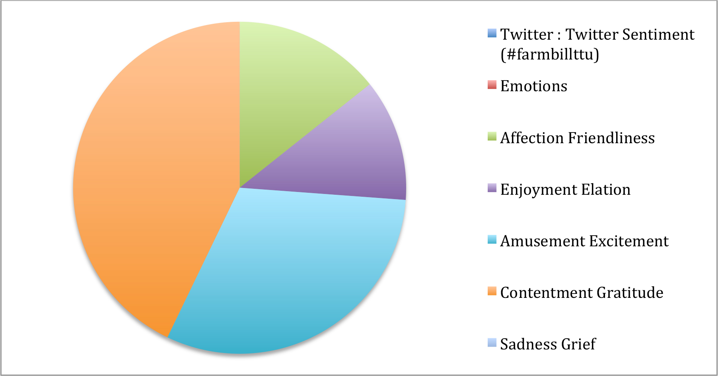
Future Plans
Students enrolled in the class have planned one other issue forum, but it did not have the audience size nor the social media following as the farm bill forum. Plans for the Spring 2016 course include another forum for students to organize, and use of an event hashtag and an active social media presence from all students involved will be required. The event hashtag extended the reach of the forum to those who could not attend. Future event hashtags will be promoted well in advance, and students will be required submit a social media plan with posts beginning several weeks before the event to increase attendance and posts during the event to reach audiences not in attendance.
Costs/Resources
The costs incurred for this event were very minimal. Forum presenters, venue rental, and refreshments cost less than $500. This event was funded through a USDA Non Land Grant Colleges of Agriculture Capacity Building grant. Social media planning and posting did not cost money; however, time was invested by students and the instructor to ensure proper execution.

References
Allen, K., Abrams, K., Meyers, C., & Shultz, A. (2010). A little birdie told me about agriculture: Best practices and future uses of Twitter in agricultural communications. Journal of Applied Communications, 94(2010), 3-4.

Cameron, C. (2009). Is Twitter the start of web 3.0? [Web log message]. Retrieved from http://www.workingthree.com/internet/twitter-is-the-start-of-web-30.

Doerfert, D. e. (2011). National Research Agenda: American Association for Agricultural Education's Research Priority Areas for 2011--2015. Lubbock, TX: Texas Tech University, Department of Agricultural Education and Communications.

Ebner, M., Mühlburger, H., Schaffert, S., Schiefner, M., Reinhardt, W., & Wheeler, S. (2010). Getting Granular on Twitter: Tweets from a Conference and Their Limited Usefulness for Non-participants. Key Competencies in the Knowledge Society IFIP Advances in Information and Communication Technology, 102-113. Retrieved June 12, 2015, from http://download.springer.com/static/pdf/861/chp%3A10.1007%2F978-3-642-15378-5_10.pdf?originUrl=http://link.springer.com/chapter/10.1007/978-3-642-15378-5_10&token2=exp=1440099112~acl=/static/pdf/861/chp%253A10.1007%252F978-3-64

Paulson, H. (2009, August 25). What the heck is Twitter, and what do I do with it? Daily Camera. Retrieved June 12, 2015. http://www.dailycamera.com/ci_13169356?source=most_emailed

Wright, D. K., & Hinson, M. D. (2009). An analysis of the increasing impact of social and other new media on public relations. 12th Annual International Public Relations Research Conference, Miami, FL.

