RESEARCH

Faculty perceptions of discipline specific pedagogies in post-secondary agriculture education

Laura L. Rice, PhD
The Pennsylvania State University
204A Ferguson Building
University Park, PA 16802
814.865.6987
laurarice@psu.edu

Daniel D. Foster, PhD
The Pennsylvania State University
211 Ferguson Building
University Park, PA 16802
814.863.0192
foster@psu.edu
Faculty perceptions of discipline specific pedagogies in post-secondary agriculture education
Introduction
Colleges of Agricultural Sciences are charged with the task of addressing our nation’s societal and industry challenges by preparing “a diverse workforce that includes scientists and professionals with knowledge and skills beyond today’s standards” (Doerfert, 2011, p. 19). By 2018, 44 percent of jobs in agriculture, food and natural resources will require some postsecondary education (U.S. Department of Agriculture Economic Research Service, 2014). University instructors must focus on the continuing need for “quality teaching and learning outcomes and life-long human capital development of our workforce” (Doerfert, 2011, p. 20). Current research must pay more attention to the complexity of teaching when attempting to further understanding of university-level teaching. Researching discipline specific pedagogies holds exciting potential for developing more complex understandings of university academics as teachers, which in turn has implications for the improvement of university-level teaching. The purpose of this research study was to describe faculty members’ perceptions of discipline specific pedagogy at a leading agricultural university.
Conceptual Framework
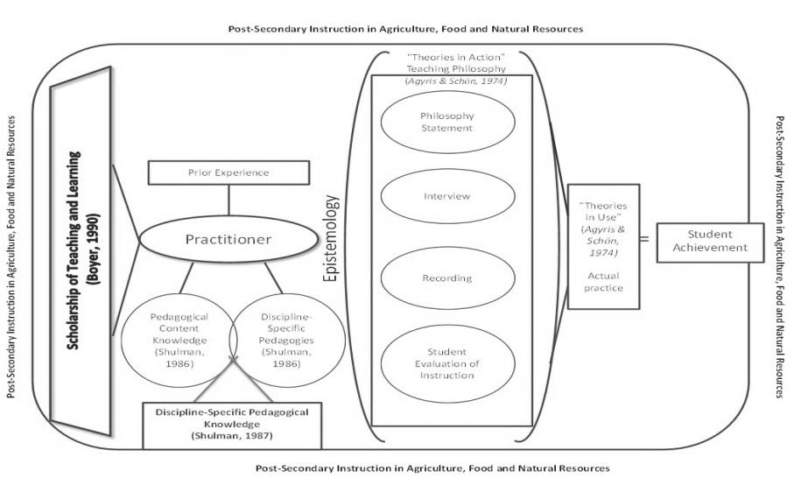
The conceptual framework for this study was guided by relevant theoretical and empirical research. The researcher‘s conceptual model examines practitioners of post-secondary Agriculture Education on the role pedagogical content knowledge and discipline specific pedagogies play in forming a practitioner’s discipline specific content knowledge. Figure 1 provides a visual model of the conceptual framework for this study.

Figure 1. Conceptual Framework examines practitioners of post-secondary Agriculture Education on the role pedagogical content knowledge and discipline specific pedagogies play in forming a practitioner’s discipline specific content knowledge.

Methodology
This study employed a case–study approach (Gall, Gall, & Borg, 2003). The nine faculty selected to participate were deemed to be excellent teachers according to their receipt of an award honoring their teaching. Data was collected using in-depth, structured interviews. A structured standardized open-ended interview method was utilized. Each interview was recorded using a digital recording device. The recordings were then transcribed verbatim by a reputable transcription service. A short faculty questionnaire was developed at the conclusion of the interview process. The questionnaire was utilized to provide clarity and deeper understanding of the findings in the interviews. The main form of data analysis was content analysis. With the amount of text generated by in-depth interviews and the questionnaire, constant comparative data analysis was used. In this method, each occurrence in the data was compared with other incidents for similarities and differences, thus generating as many themes of analysis as possible (Corbin & Strauss, 2008).
Results/Findings
Table 1 provides the perceived discipline specific pedagogy as presented by the respective faculty member for their respective discipline.
Table 1. Perceived Discipline Specific Pedagogies by Award-winning Faculty
Discipline | Discipline Specific Pedagogy
Agricultural and Extension Education | Problem-based Learning
Agroecology | Hands-on/Active Learning
Agronomy | Experiential
Equine Science | None
Landscape Architecture | Project-based; problem-based; Experiential
Rural Sociology | Promote critical thinking
Small Animal Science | Active Learning; Lecture; Laboratory/Hands-on experiences
Soil Biogeochemistry/Environmental Science | Field methods, case studies, virtual field experience
Conclusions/Implications/Recommendations
The faculty’s perceptions of their discipline specific pedagogy included both subject-specific strategies and topic-specific strategies. The participants were able to articulate clearly the instructional practices they use within their classrooms; however, there is insufficient description from the faculty to label the strategies a discipline-specific pedagogy. Shulman (2005) discusses the three dimensions of signature pedagogy, which include a surface structure, a deep structure, and an implicit structure. Although this study has definitely identified the three structures used to formulate a signature pedagogy, it was the opinion of one individual within each respective field. A recommendation for further research would be to measure the discipline specific pedagogies against industry demands and if students are graduating with the knowledge, skills, and dispositions required for careers in their respective discipline.
References
Corbin, J., & Strauss, A. (2008). Basics of qualitative research. Thousand Oaks: Sage Publications Inc.

Doerfert, D. L. (2011). National research agenda: American Association for Agricultural Education’s research priority areas for 2011-2015. In T. T. University (Ed.). Lubbock, TX: Department of Agricultural Education and Communications.

Gall, M. D., Gall, J. P., & Borg, W. R. (2003). Educational research: An introduction (7th ed.). Boston, MA: A & B Publications.

Shulman, L. S., (1986). Those who understand: Knowledge growth in teaching.. Educational Researcher, 15(2), 4-14.

Shulman, L. S. (1987). Knowledge and teaching: Foundations of the new reform. Harvard Educational Review, 57(1), 1-21.

Shulman, L. (2005). Signature pedagogies in the professions, Daedalus, 134, 52-59.
United States Department of Agriculture Economic Research Service. (2014). Ag and Food Statistics: Charting the Essentials. Retrieved from http://www.ers.usda.gov/dataproducts/ag-and-food-statistics-charting-the-essentials.aspx.

