Fake It Till You Make It? College Students’ Perceived Ability Versus Actual Ability to Identify Fake News on Agricultural Topics

Mary Katelynn Horton
Assistant Director
806-834-5013
mary.k.butler@ttu.edu

Texas Tech University
Office of Communications & Marketing
2625 Memorial Circle
Administration 212
Lubbock, TX 79409

Dr. Courtney Gibson
Associate Professor
806-834-8766
courtney.d.gibson@ttu.edu

Dr. Laura Fischer
Assistant Professor
806-834-0630
laura.fischer@ttu.edu

Department of Agricultural Education and Communications
Texas Tech University
Box 42131
Lubbock, TX 79409

Dr. Todd Chambers
Associate Professor & Associate Dean for Undergraduate Affairs
806-834-5712
todd.chambers@ttu.edu

College of Media & Communication
Texas Tech University
Box 43082
Lubbock, TX 79409

Fake It Till You Make It? College Students’ Perceived Ability Versus Actual Ability to Identify Fake News on Agricultural Topics

Introduction/Theoretical Framework

For years, misinformation about agriculture, agricultural practices, and agricultural products has plagued the industry and has contributed to the spread of inaccurate beliefs about agriculture (Baerg, 2018; Robinson & Ruth, 2020; Speer, 2017; Terry & Lawver, 1995). In the last two decades, there has been an onslaught of false information spread about agricultural and food systems in both mainstream and online media (Speer, 2017). Consumer beliefs in this misinformation can be difficult to correct and could lead to political, societal, and personal decisions that have the potential to have serious and lasting consequences (Baerg, 2018; Ecker et al., 2014; Lewandowsky et al., 2012).

Agriculture determines the standard of living and the overall welfare of the nation. Thus, it is critically important for the public to have an accurate understanding of the industry (Colbath & Morrish, 2010); however, the average American is at least three generations removed from a direct connection to agriculture (Brain & Anderson, 2020). This lack of agricultural involvement coupled with the prevalence of misinformation and misperceptions of the industry has given rise to an even more concerning issue for agriculture: fake news. The internet and social media have created an environment where fake news can be created and shared quickly and easily leaving the public to decide for themselves what is real and what is fake with almost no filtering, fact-checking, or verification (Allcott & Gentzkow, 2017; Kumar & Shah, 2018). Prior research on the phenomenon of fake news also shows that it spreads both faster and farther than the truth on social media (Pierri & Ceri, 2019; Vosoughi et al., 2018).

Little to no research exists on how fake news plays a role in the agricultural industry making it difficult for agricultural educators, communicators, and their organizations to understand how fake news may impact their operations. Scholars have called for further investigations of fake news and its impact on people, society, and the economy (Lazer et al., 2018; Lyons et al., 2021; Pierri & Ceri, 2019) and particularly on “college students and their ability to accurately identify and evaluate fake news stories, taking into consideration the predominance of social media as a primary news source” (Leeder, 2019, p. 9). This knowledge may lay a foundation for better understanding fake news and its impact so agricultural educators and communicators can better tailor their messages to seem more trustworthy to consumers in the future.

Our investigation was guided by three conceptual frameworks: the third-person effect, social desirability bias, and the Dunning-Kruger effect. The third-person effect posits that people will overestimate the influence media, including social media, has on others while underestimating the effect of the media on themselves (Davison, 1983). Social media users, in particular, believe the messages they encounter online affect others more than themselves (Zhang & Daugherty, 2009). Similarly, social desirability bias explains that individuals will purposefully paint themselves in a more positive light than others, particularly through “self-report measures resulting from the desire of respondents to avoid embarrassment and project a favorable image to others” (Fisher, 1993, p. 303). While it is possible that participants would be unwilling to admit their level of susceptibility to fake news in order to look more socially desirable, what if they are simply unaware of how vulnerable they truly are? The Dunning-Kruger effect explains that people tend to overestimate their ability to perform tasks they are incompetent at simply because they do not know they are incompetent (Kruger & Dunning, 1999). Figure 1 (below) shows the interplay of the three conceptual frameworks guiding this study. The effects of social desirability bias and the Dunning-Kruger effect may both have an impact on the third person effect, or an individual’s belief that they are not as affected by fake news as others. According to Lyons et al. (2021), “understanding overconfidence may be an important step toward better understanding the public’s vulnerability to false news and the steps we should take to address it” (p.7).

Figure 1

Relationship of the three conceptual frameworks.
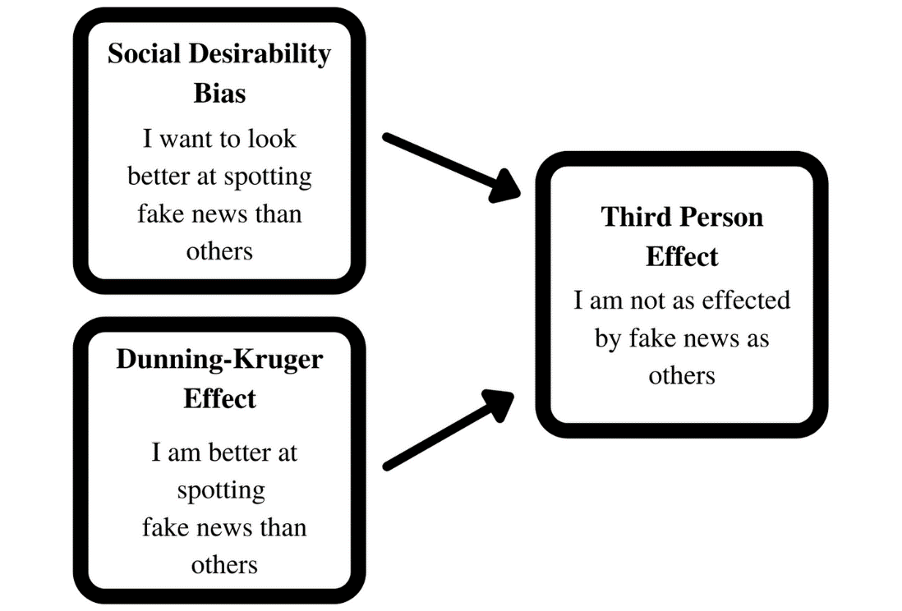

Purpose and Objectives

The purpose of this study was to determine and compare how adept college students think they are at identifying fake news, how adept they think their peers are at identifying fake news, and how well they actually perform at identifying fake news. Additionally, we investigated how college student’s actual performance related to their level of agricultural involvement. The following research objectives guided this study:

RO1: Examine how well college students think they can identify fake news on
agricultural topics vs. how well they think the average college student can

RO2: Explore college students’ ability to identify fake vs. real news on agricultural
topics

RO3: Determine the relationship between college students’ perceived ability to identify
fake news about agricultural topics on their actual performance at this task

RO4: Determine the relationship between college students’ involvement with agriculture
on their ability to identify fake news about agricultural topics

Methods/Procedures

An online survey questionnaire using an embedded within-subjects experimental design was conducted to explore participants’ aptitude at distinguishing between real and fake news on agricultural topics.

Using a Qualtrics questionnaire, participants first answered four direct and four indirect questions related to their own perceived ability to identify fake news versus their perceived ability of other college students to do the same (Lusk & Norwood, 2010). These questions had post hoc reliabilities of Cronbach’s α = .73 and α = .84 respectively.

Participants were then shown the experimental stimuli: 10 mock social media posts (see examples below in Figure 2) that included a picture, a short sample of body text, and a headline. Likes, comments, and shares were consistent across all posts, and the researchers removed the information’s source to minimize bias. The stimuli included five fake and five real new articles covering a variety of agricultural and natural resource topics that were randomized to protect from any possible order effects (Thorson et al., 2012). Participants were shown the 10 mock social media posts one at a time. After each stimulus, the participants were asked to identify if they believed the post contained fake or real news (1 = Fake, 2 = Real) and the level to which they believed the posts were fake (1 = completely fake to 5 = completely real).

Figure 2

Examples of mock social media posts provided to participants (left: fake news; right: real news).
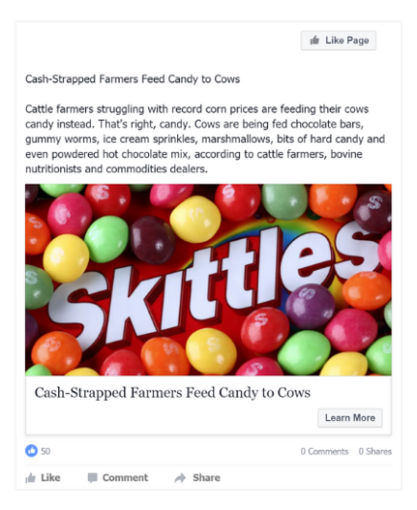
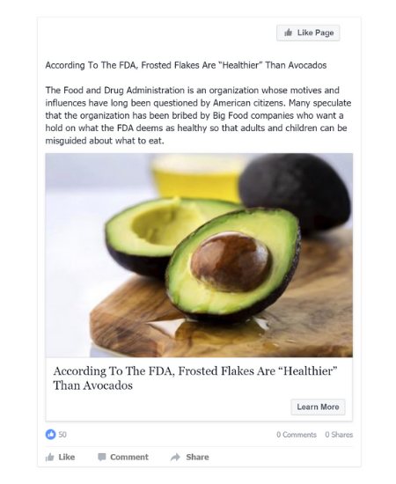

Participants were then presented with an 11-questions scale to measure their level of agricultural involvement based on previous research (Tarpley et al., 2017) which had a post hoc reliability of Cronbach’s α = .86. Finally, participants were asked to respond to a set of demographic questions.

Participants were purposively sampled from the population of undergraduate students at Texas Tech University due to their demographics’ statistically high use of social media and the university’s close proximity to and influence from agriculture in the surrounding community. Participants were recruited through an online research participant pool within Texas Tech University and were awarded course credit or extra credit for their participation. A total of 377 complete and usable responses were collected and analyzed.
Data were analyzed using IBM’s SPSS 26. Descriptive statistics and frequencies were calculated for all data. A paired samples t-test was run to determine if significant differences existed between direct and indirect question responses of the participants. Correlational tests were used to explore possible relationships between participants’ direct scores and their performance on correctly identifying the stimuli as well as participants’ responses to the agricultural involvement scale and their performance on stimuli identification.

Results/Findings

RO1: Examine how well college students think they can identify fake news on agricultural topics vs. how well they think the average college student can. Overall, most participants felt confident in their own perceived ability to identify fake news (M = 3.92, SD = .74). Their responses indicated they mostly agreed or strongly agreed with each of the four direct statements. However, they were not as confident in the ability of their peers (M = 2.63, SD = .81). A significant difference (p < .01) was found between participants’ beliefs about their own ability to identify fake news and their beliefs of others’ ability to do the same, t(376) = 24.82, p < .01, Cohen’s d = 1.65. The Cohen’s d indicated a large effect (Cohen, 1988) between participants’ perceived ability to identify fake news versus their views about the abilities of other students.

RO2: Explore college students’ ability to identify fake vs. real news on agricultural topics. Overall, participants correctly identified real news posts less frequently (50.66%) than the fake news posts (65.42%). Of the 10 mock posts, they were able to correctly identify an average of 58.43% (M = .58, SD = .157) of the posts, or almost six out of 10 posts. Scores ranged from as few as two out of 10 posts correctly identified to as high as all 10 posts correctly identified.

RO3: Determine the relationship between college students’ perceived ability to identify fake news about agricultural topics on their actual performance at this task. Using a Pearson Product-Moment correlation with an a priori alpha level of .05, a correlation of .12 was found between participants’ perceived ability to identify fake news themselves and their actual performance at this task. According to Davis (1971), this exhibited a low association between these variables (r = .12, p = .02), indicating that as participants’ scores on the direct questions increased, their scores on the post identification only increased slightly.

RO4: Determine the relationship between college students’ involvement with agriculture on their ability to identify fake news about agricultural topics. Using a Pearson Product-Moment correlation with an a priori alpha level of .05, a correlation of .12 was found between participants’ involvement with agriculture and their ability to identify fake news about agriculture. Again, this showed a low association (r = .12, p = .02) as described by Davis (1971), indicating that higher levels of agricultural involvement only slightly increased participants’ post identification ability.

Conclusions/ Implications/Recommendations

Findings from this study show that participants consistently believed they would perform well at identifying fake news while their peers would not, which is in line with previous research (Lyons et al.,2021; Wang 2007) and our conceptual frameworks (Davison, 1983; Fisher, 1993; Kruger & Dunning, 1999). If college students believe they are already good at identifying fake news, they may not be putting much effort into verifying information because they already believe they know what is real. If this is the case, fake news has the potential to be a much larger problem than expected. Without diligent fact-checking and verification, consumers could be believing false information about agriculture that changes their purchasing habits and voting behavior (Terry & Lawver, 1995). Once exposed to fake news, it becomes almost impossible to correct (Del Vicario et al., 2016), making our job as agricultural educators and communicators much harder.

Participants in this study were not well adept at identifying fake news, particularly compared to their belief in their ability to do so. In fact, if this assessment were categorized with a letter grade, almost half of the participants would have received an F. While our results were in line with findings from previous research (El Rayess et al., 2018; Leeder, 2019; McGrew et al., 2018), it is still concerning. Given the rise of erroneous self-confidence and a lack of agricultural involvement, coupled with growing separation from agriculture (Brain & Anderson, 2020), increased skepticism from consumers (Colbath & Morrish, 2010; Nordstrom et al., 2000), and the apparent believability of fake news on agricultural topics, the industry is facing an almost overwhelming challenge. How do we begin to combat false information that has so quickly taken hold of the online world? This task rests in the hands of agricultural educators and communicators who are responsible for educating the public about agriculture and dispelling false information.

The low-strength correlations found between participants’ scores on the direct questions and agricultural involvement scale and their actual ability to identify fake news posts also pose some areas of concern. If fake news can mislead even those with a stronger connection to agriculture, how can we expect individuals without experience or connection to know what is fake and what is real? These results illustrate the risks that fake news about agriculture poses to the general population. These results imply that college students, even those more connected to agriculture, are not adequately equipped to judge the agricultural information they see online. Additionally, because they are not currently proficient at identifying fake news, proper techniques for evaluating news and fact-checking could be beneficial to include in curriculum, as it is evident that college students are lacking in this area from our results, as well as the results of Leeder (2019) and El Rayess et al. (2018).

Many recommendations can be made based on this research. Practitioners and educators should take care to create content that aligns with what consumers and students deem credible and trustworthy. Attention should also be given to not just agricultural literacy for students, but also critical skill development to help students better evaluate the information they consume. Further research on this topic is also essential for a better understanding and grasp of the work we must do to combat fake news. Expanding the scope of this work, replicating it with larger and more diverse audiences, exploring the agricultural topics commonly seen in fake news posts, and investigating in-depth the elements that cause students to judge a post as real versus fake are just a few first steps in the right direction. Additionally, research on an individual’s self-confidence to perform a task versus their actual ability could shed light on important factors that may further unlock our potential to combat fake news and protect our industry.
References

Allcott, H., & Gentzkow, M. (2017). Social media and fake news in the 2016 election. Journal of Economic Perspectives, 31(2), 211-236. https://doi.org/10.1257/jep.31.2.211

Baerg, M. (2018, March 20). ‘Fake news’ and the farm. Country Guide. https://www.country-guide.ca/guide-business/fake-news-and-the-farm/

Brain, R. A., & Anderson, J. C. (2020). Anthropogenic factors affecting wildlife species status outcomes: Why the fixation on pesticides? Environmental Science and Pollution Research,24(1), 1-24. https://doi.org/10.1007/s11356-020-08980-1

Cohen. J. (1988). Statistical power analysis for the behavioral sciences (2nd ed.). Lawrence Erlbaum Associates.

Colbath, S. A., &. Morrish. D. G. (2010). What do college freshmen know about agriculture? An evaluation of agricultural literacy. NACTA Journal, 54(3), 14-17. https://www.jstor.org/stable/nactajournal.54.3.14

Davis, J. A. (1971). Elementary survey analysis. Prentice–Hall.

Davison, W. P. (1983). The third-person effect in communication. The Public Opinion Quarterly, 47(1), 1-15. https://doi.org/10.1086/268763

Del Vicario, M., Bessi, A., Zollo, F., Petroni, F., Scala, A., Caldarelli, G., Stanley, H. E., & Quattrociocchi, W. (2016). The spreading of misinformation online. Proceedings of the National Academy of Sciences, 113(3), 554-559. https://doi.org/10.1073/pnas.1517441113

Ecker, U. K. H., Lewandowsky, S., Chang, E. P., & Pillai, R. (2014). The effects of subtle misinformation in news headlines. Journal of Experimental Psychology: Applied, 20(4), 323–335. https://doi.org/10.1037/xap0000028

El Rayess, M., Chebl, C., Mhanna, J., & Hage, R. (2018). Fake news judgement: The case of undergraduate students at Notre Dame University-Louaize, Lebanon. Reference Services Review, 46(1), 146-149. https://doi.org/10.1108/RSR-07-2017-0027

Fisher, R. J. (1993). Social desirability bias and the validity of indirect questioning. The Journal of Consumer Research, 20(2), 303-315. https://doi.org/10.1086/209351

Kruger, J., & Dunning, D. (1999). Unskilled and unaware of it: How difficulties in recognizing one’s own incompetence lead to inflated self-assessments. Journal of Personality and Social Psychology, 77(6), 1121-1134. https://doi.org/10.1037/0022-3514.77.6.1121

Kumar, S., & Shah, N. (2018). False information on web and social media: A survey. ArXiv, 1(1), 1-35. https://arxiv.org/abs/1804.08559v1

Lazer, D. M. J., Baum, M. A., Benkler, Y., Berinsky, A. J., Greenhill, K. M., Menczer, F., Metzger, M. J., Nyhan, B., Pennycook, G., Rothschild, D., Schudson, M., Sloman, S. A., Sunstein, C. R., Thorson, E. A., Watts, D. J., & Zittrain, J. L. (2018). The science of fake news: Addressing fake news requires a multidisciplinary effort. Science (American Association for the Advancement of Science), 359(6380), 1094-1096. https://doi.org/10.1126/science.aao2998

Leeder, C. (2019). How college students evaluate and share “fake news” stories. Library & Information Science Research, 41(3). https://doi.org/10.1016/j.lisr.2019.100967

Lewandowsky, S., Ecker, U. K. H., Seifert, C. M., Schwarz, N., & Cook, J. (2012). Misinformation and its correction: Continued influence and successful debiasing. Psychological Science in the Public Interest, 13(3), 106-131. https://doi.org/10.1177/1529100612451018

Lusk, J. L., & Norwood, F. B. (2010). Direct versus indirect questioning: An application to the well-being of farm animals. Social Indicators Research, 96(3), 551-565. https://doi.org/10.1007/s11205-009-9492-z

Lyons, B. A., Montgomery, J. M., Guess, A. M., Nyhan, B., & Reifler, J. (2021). Overconfidence in news judgments is associated with false news susceptibility. Proceedings of the National Academy of Sciences. 118 (23). https://doi.org/10.1073/pnas.2019527118

McGrew, S., Breakstone, J., Ortega, T., Smith, M., & Wineburg, S., (2018) Can students evaluate online sources? Learning from assessments of civic online reasoning, Theory & Research in Social Education, 46(2), 165-193. https://doi.org/10.1080/00933104.2017.1416320

Nordstrom, P. A., Wilson, L. L., Kelsey, T. W., Maretzki, A. N., & Pitts. C. W. (2000). The use of focus group interviews to evaluate agriculture educational materials for students, teachers, and consumers. Journal of Extension, 38(5). https://archives.joe.org/joe/2000october/rb2.php

Pierri, F., & Ceri, S. (2019). False news on social media: A data-driven survey. SIGMOD Record, 48(2), 18-27. https://doi.org/10.1145/3377330.3377334

Robinson, C. R. H., & Ruth, T. K. (2020). Examining consumers' trust in the food supply chain. Journal of Applied Communications, 104(2). http://dx.doi.org/10.4148/1051-0834.2298

Speer, N. (2017, July 21). Fake news not new for agriculture. Feedstuffs. https://www.feedstuffs.com/commentary/fake-news-not-new-agriculture

Tarpley, T. G., Bigham, A. L., Steede, G. M., & Akers, C. L. (2017, June). Who even cares about agriculture? An instrument for measuring agricultural involvement [Research poster]. Association for Communication Excellence Conference, New Orleans, LA.

Terry, R., & Lawver, D. E. (1995). University students' perceptions of issues related to agriculture. Journal of Agricultural Education, 36(4), 64-71. https://doi.org/10.5032/jae.1995.04064

Thorson, E., Wicks, R., & Leshner, G. (2012). Experimental methodology in journalism and mass communication research. Journalism and Mass Communication Quarterly, 89(1), 112-124. https://doi.org/10.1177/1077699011430066

Vosoughi, S., Roy, D., & Aral, S. (2018). The spread of true and false news online. Science (American Association for the Advancement of Science), 359(6380), 1146-1151. https://doi.org/10.1126/science.aap9559

Wang, Y. (2007), Riding to the future - an investigation of information literacy skills of students at an urban university as applied to the web environment. International Journal on E-Learning, 6(4), 593-603. https://www.learntechlib.org/primary/p/21802/

Zhang, J., & Daugherty, T. (2009). Third-person effect and social networking: Implications for
online marketing and word-of-mouth communication. American Journal of Business, 24(2), 53-63. https://doi.org/10.1108/19355181200900011

