Developing a Leadership Assessment Instrument for Cooperating Teachers
Gaea Wimmer, Todd Brashears, & Scott Burris
Texas Tech University
Box 42131
Lubbock, TX 79409-2131
806-742-2816
gaea.wimmer@ttu.edu
todd.brashears@ttu.edu
scott.burris@ttu.edu

Developing a Leadership Assessment Instrument for Cooperating Teachers

Introduction
For years the profession of Agricultural Education has been battling with a shortage of qualified teachers, Camp, Broyles & Skelton (2002). Researchers in the profession of Agricultural Education have often noted the impact of the cooperating teacher on the student teachers decision to enter the teaching profession (Kitchel & Torres, 2007a). In recent years, studies have been conducted in an effort to determine the leadership preference of the cooperating teacher and its impact when working with student teachers (Kitchel & Torres, 2007a; Kitchel & Torres, 2007b). There have also been studies to evaluate the effectiveness of the relationship of the cooperating and student teacher (Roberts, 2006; Young & Edwards, 2006).
In order to fill the many open positions each year, university teacher education programs need to effectively train student teachers and place them in cooperating teacher sites where they will build their confidence and hopefully make the decision to enter the teaching field. One way to facilitate this process is to ensure that cooperating teachers and student teachers are compatible in leader and follower style and preference.

Methodology
This descriptive study serves as step one in testing the reliability of a tool used to match student teachers and cooperating teachers. The population sample consisted of 20 purposively selected cooperating teachers who have hosted a student teacher within the past two years. The instrument used to assess the leadership preference of the cooperating teacher was the ELSI-AG (Educational Leadership Style Indicator – Agricultural Science Teacher Version). The ELSI-AG was developed by the research team and is based on Blanchard’s Situational Leadership Theory (see Figure 1.).
The ELSI-AG was developed to determine the preferred leadership style of the cooperating teacher. It consists of 20 scenarios that may be encountered while working with a student teacher. Responses to each question are scored in one of four categories and respondents are labeled as a Director, Coach, Supporter or Delegator.
The instrument was reviewed by agricultural education professionals for face and content validity. Reliability was to be determined during the course of the study.
The instrument was delivered and returned online using Zoomerang. Data were analyzed using appropriate statistics within SPSS version 16.

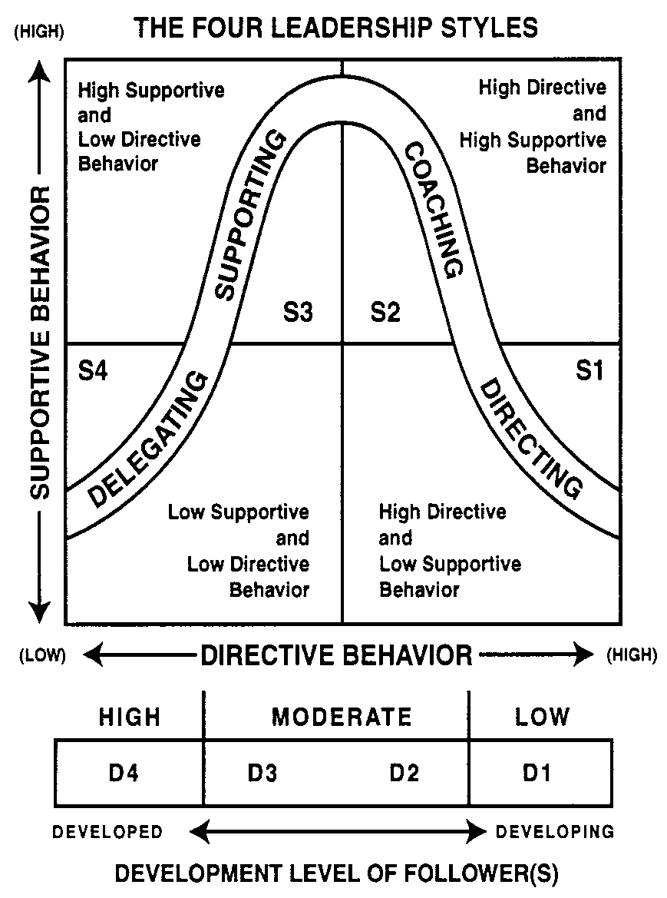

Figure 1. Blanchard’s Leadership Styles and Follower Development.

Results to Date
All 20 participants responded by completing the ELSI-AG. It was determined that 5% preferred Directive leadership, 5% preferred the Coaching style, 90% preferred Supporting and none were primarily Delegators. Comments about the instrument itself included issues with question length, clarity and grammar. These have been corrected for the next round of testing.

Implications
Most cooperating teachers naturally fall into the Supporting category while we consider entry-level teachers to be in the D1 (low) category of follower development. Teachers want to support student teachers but results indicate they need direction to begin their experience. Teaching cooperating teachers to use correct situational leadership styles may lead to an an increase in agricultural education students who decide to enter the teaching profession.

Future Plans/Advice to Others
The researchers intend to continue testing and validating the instrument. A workshop is planned for the Fall 2010 semester to help cooperating teachers learn how to use their leadership styles to most effectively work with student teachers. An instrument is being designed to measure the follower development level of the student teacher.

Costs/Resources Needed
The instrument was developed and administered online. Costs were limited to labor and were minimal.
References
Kitchel, T. & Torres, R. M. (2007a.). The influence of personality type on the extent cooperating teachers provide psychosocial assistance to student teachers. Journal of Agricultural Education, 47(4), 134-44.
Kitchel, T., & Torres, R.M. (2007b.). Possible factors in matching student teachers with cooperating teachers. Journal of Agricultural Education, 48(3), 13-24.
Northouse, P.G. (2004). Leadership: Theory and practice. Thousand Oaks, CA: Sage Publications, Inc.
Roberts, T.G. (2006). Developing a model of cooperating teacher effectiveness. Journal of Agricultural Education, 45(3), 1-13.
Young, R.B., & Edwards, M.C. (2006). A comparison of student teacher’s perceptions of important elements of the student teaching experience before and after a 12-week Field experience. Journal of Agricultural Education, 47(3), 45-57.

