Research Poster

THE EDUCATIONAL PROCESSES: RELATIVE IMPORTANCE TO EXTENSION EDUCATORS
Nav R. Ghimire
Graduate Assistant
Department of Agricultural Education and Studies
Iowa State University, 223 Curtiss Hall, Ames, IA 50011
Phone: 515-708-1373
Email: nghimire@iastate.edu

Robert A. Martin, PhD
Professor
Department of Agricultural Education and Studies
Iowa State University, 201 Curtiss Hall, Ames, IA 50011
Email: drmartin@iastate.edu

The Educational Processes: Relative importance to Extension Educators
Introduction
The Cooperative Extension Service (CES) uses various educational processes to meet the needs of people and improve lives (Seevers et al., 2007). Morse et al. (2006) stated that the needs of people have changed over the years with changing socio-economic and environmental conditions. In today’s changing environment, it has become a challenge for the CES to succeed and communicate those successes to the public (Stone & Bieber, 1997). According to Cooper and Graham (2001), success of the CES largely depends on the professional skills and competencies of extension educators. Therefore, extension educators must develop educational process professional competencies to meet the changing needs of the clientele (Seevers et al., 2007). This study included four educational process professional competency areas identified as most important for the extension educators in the North Central Region of the United States by the NCR-158 Committee on Adult Education in Agriculture (Martin, 1991). These competency areas are: needs assessment and program development, learning systems, delivery systems and evaluation systems. According to the literature, there is lack of a comprehensive assessment of these four competency areas in the North Central Region. The purpose of this study was to determine the relative importance of 42 selected professional competencies as perceived by extension educators in the North Central Region and to identify when these competencies should be learned. These 42 professional competencies were grouped under the four educational processes professional competency areas mentioned above.
Theoretical Framework
The theoretical framework for this study is based on the theory of perception coming from research by Ferguson and Bargh (2004). They stated that social knowledge that is automatically activated in memory during the natural course of perception shapes and guides people’s impressions, judgments, feelings, intentions, and behaviors.
Methods
The population for this study consisted of all extension educators working in the 12 states of the North Central Region from which 811 samples were selected randomly. The questionnaire was emailed to all participants using Survey-Monkey®. The response rate was 55%. A panel of experts reviewed the instrument for face, content, and construct validity and a pilot-study was conducted to establish the reliability of the instrument. The Cronbach’s coefficient (α) of the instruments was .90. Respondent’s perceptions were measured on a five point Likert- type scale ranging from 1- very low importance to 5- very high importance. The best time to learn the competencies was indicated by three different categories: graduate program, on-the-job and in-service program. Descriptive and inferential statics were used to compute the data using SPSS (17.0).
Findings
This study revealed that the extension educators perceived 81% of the professional competencies as highly important and the remaining competencies as moderately important. Respondents preferred to learn 41% of these competencies on-the-job, 33% in a graduate program and 26% of the competencies in an in-service program. Beyond the educational process professional competencies included in this study, some extension educators suggested their need to learn additional competencies such as people skills and organizational management. The findings from the study provided the basis to design a professional development model (Figure 1).
Conclusions, Recommendations, and Implications,
The findings of this study indicate a need for a professional development program based on the four educational process areas: needs assessment and program development, learning systems, delivery systems and evaluation systems. It is recommended that the professional development programs should be offered at one of the three levels of delivery – graduate programs, on-the-job and in-service workshops. The findings of this study have global implications for developing policies and guidelines for designing effective professional development programs related to the educational processes in extension. The best time to learn various competencies indicated by the extension educators in this study has important educational significance for designing professional development courses (1) in graduate programs at universities and colleges, (2) in in-service training programs of the extension service, as well as (3) for designing experiential learning techniques to assist extension educators to acquire these competencies while on-the-job. The findings also have implications for developing the educational process competencies of agriculture educators working both in K-12 and land-grant colleges mainly for: (1) identifying the learning needs of students in rapidly changing agricultural market situations, (2) planning learning programs and developing curricula that fit the changing needs of the marketplace , (3) delivering agricultural knowledge and information to meet the learning needs of students that can prepare them for the world of work, and (4) evaluating the impact of the teaching learning processes to determine whether the learning objectives were met as planned.

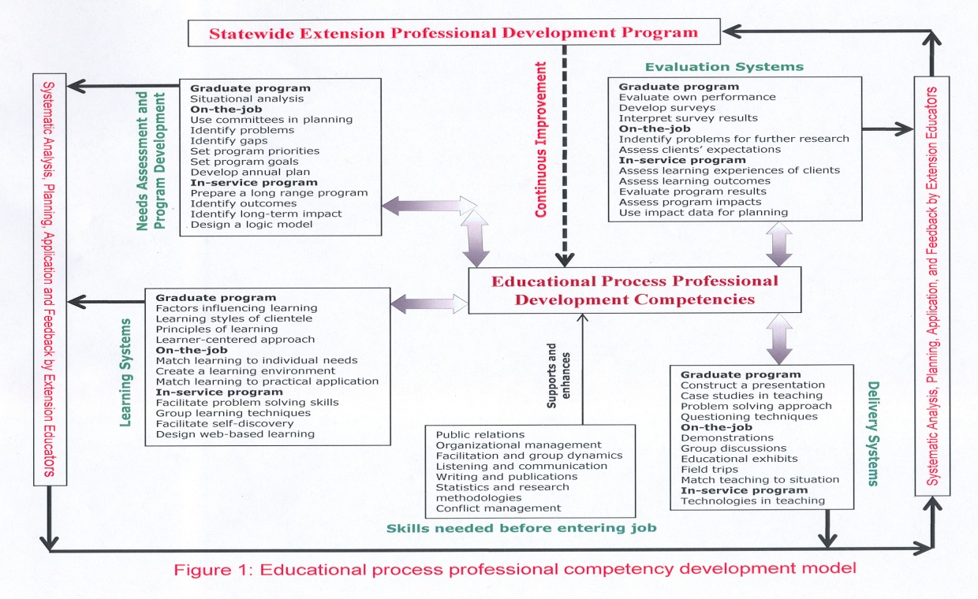

References

Cooper, A. W., & Graham, D. L. (2001). Competencies needed to be successful county agents and county supervisors. Extension, 39(1). Available on line at: http://www.joe.org/joe/2001february/rb3.html.

Ferguson, M. J., & Bargh, J. A. (2004). How social perception can automatically influence behavior. Trends in Cognitive Sciences, 8(1), 33-39.

Martin, R. A. (Ed.). (1991). Empowering adults: A new agenda for agriculture. A model for research collaboration in the North Central Region. NCR-158 Committee on Adult Education in Agriculture.

Morse, R. S., Brown, P. W., & Warning, J. E. (2006). Catalytic leadership: Reconsidering the nature of extension’s leadership role. Extension, 44(2). Available on line at: http://www.joe.org/joe/2006april/a9.shtml.

Seevers, B., Graham, D., Gamon, J., & Conklin, N. (2007). Education through Cooperative Extension (2nd ed.). Albany, NY: Delmar Publishers.

Stone B. B., & Bieber, S. (1997).Competencies: A new language for our work. Extension, 35(1). Available on-line at: http://www.joe.org/joe/1997february/comm1.html.

