School-Based Agricultural Education Teachers’ Comfort Levels in Students' Identities

Stephen C. Cole, University of California, Davis
Jessica M. Toombs, Michigan State University

Introduction

The current secondary student population is more diverse than at any point in US history (Cottrell, 2021). However, some educators may not be fully equipped to teach and advise students in various circumstances, which can lead to students being overlooked or feeling disconnected from the curriculum (Halpern et al., 2022). Many school-based agricultural education (SBAE) teachers are ill-prepared to instruct and mentor lesbian, gay, bisexual, transgender, and queer (LGBTQ) youth (Price & Edwards, 2024). Not only is this an issue in high school, but also in higher education (Taylor, 2021). The struggles of acceptance of diverse populations in all areas of education has had a negative impact on agricultural education (Taylor, 2021). Establishing a healthy environment where all students are seen and heard has been shown to support overall student success (Cottrell, 2021). Diversity embedded in curriculum can help provide a positive environment and respect to others within SBAE (Taylor, 2021).

Members of the LGBTQ community are often discriminated against in agriculture due to their sexual orientation, resulting in the self-removal from their roles (Taylor, 2021). At the same time, there is an increase in women, Latinos, African Americans, and LGBTQ members in agricultural education (Taylor, 2021). With the lack of research pertaining to this issue in SBAE, we need information and resources to foster conversation and education (Murray et al., 2020). By recognizing and responding to students' intersectionality, educators can create a more inclusive and supportive SBAE environment which caters to success and belonging for all students (Gay, 2018). Social distance theory guided this study. Social distance theory proposes to explain how perceived differences impact our comfort in working with others in increasing proximities (Albrecht et al., 1982). As members of an “out group” work and live in closer proximities, members of the “in group” feel less comfortable and may reach a tipping point that result in discriminatory actions (López, 2021).

Purpose and Objectives

The specific research purpose was to identify any potential differences in California SBAE teachers’ comfort levels and approaches to teaching, advising, and mentoring of students with diverse identities. The research objectives were to:
- Describe California SBAE teachers’ comfort levels in teaching, advising, and mentoring students who identify as low income, Hispanic, and/or gay.
- Describe California SBAE teachers’ approaches in teaching, advising, and mentoring with students who identify as low income, Hispanic, and/or gay.

Methodology

A mixed-mode Bogardus Social Distance Scale instrument was designed to meet the purpose and objectives of this study (Gu & Crawford, 2024; Stemler, 2015). The quantitative approach asked participants to rate their comfortability in working with others in an increasing proximity (Maurer & Keim, 2018). Reflecting Vincent and Austin (2021), eight student profiles were developed with identities chosen to represent the demographics of California’s SBAE student population (M. Patton, personal communication, September 10, 2024). Each profile was assigned a combination of middle class or low income, White or Hispanic, and straight or gay identities. The student profiles are described in Table 1 below. The proximities were designed with increasing closeness between SBAE teacher and student (Burris & Keller, 2008; Vincent & Austin, 2021). Post-hoc reliability returned Cronbach’s alpha values of 0.94 to 0.98 for each student profile. Additional open-ended response items allowed participants to elaborate on how they might teach or advise Hispanic, low income, or gay students. Face and content validity was established by two experts in SBAE and survey research.

Table 1.

Eight Student Profiles

Student Profile | Socioeconomic Status | Racial Identity | Sexual Orientation
1 | Middle Class | White | Straight
2 | Middle Class | White | Gay
3 | Middle Class | Hispanic | Straight
4 | Middle Class | Hispanic | Gay
5 | Low Income | White | Straight
6 | Low Income | White | Gay
7 | Low Income | Hispanic | Straight
8 | Low Income | Hispanic | Gay

Instrument examples are included in Figure 1 below. Participants were recruited through the statewide SBAE teacher email listserv. There were 965 SBAE teachers in California during the 2024-2025 school year (M. Patton, personal communication, September 10, 2024). Following Dillman et al. (2014), two reminder emails spaced one week apart were delivered through the listserv to gather responses. A total of 122 responses were collected; 23 of which were omitted due to either not meeting participation criteria or a large number of unanswered items resulting in 99 usable responses with a 10.26% response rate. No statistically significant differences were found when comparing early and late responses. The data showed that 84% of the agricultural educators who responded to the survey were straight (heterosexual) while the remaining 16% responded as LGBTQ. 87% identified as middle class. 87% identified as White and 12% as Hispanic.

Figure 1.

Instrument Examples

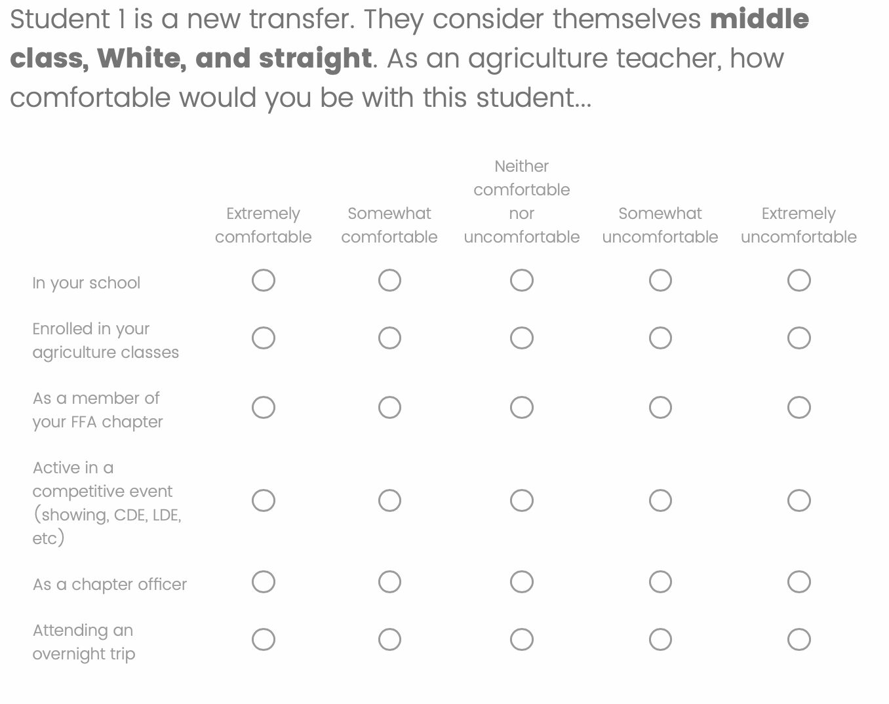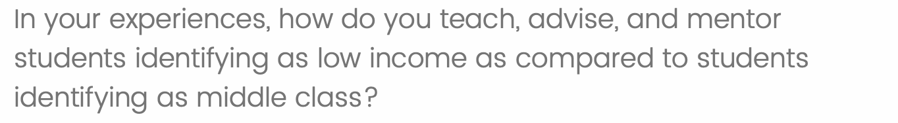

Data was exported from Qualtrics to SPSS version 27. Descriptive statistics in the form of frequencies, means, and standard deviations were analyzed for each student profile across all proximities. A conceptual content analysis was conducted from the qualitative responses (Assarroudi et al., 2018). Codes were derived from participants’ responses and grouped by similarity into themes (Hsieh & Shannon, 2005). Frequency of responses were recorded for each theme (Assarroudi et al., 2018). At the time of this study, Cole was an undergraduate student in agricultural education who identified as middle class and homosexual. Toombs was an assistant professor in SBAE teacher preparation and identified as White, middle class, and heterosexual. Even though participants were advised their responses would remain anonymous, we recognize social desirability bias may impact these self-reported data (van de Mortel, 2008). Additionally, findings and conclusions should not be generalized past the participants in this study.
Findings

Research objective one was to describe California SBAE teachers’ comfort levels in teaching, advising, and mentoring students who identify as low income, Hispanic, and/or gay. The means and standard deviations for each student profile across all proximities is included in Table 2 below. Student profiles identifying as gay (2, 4, 6, and 8) returned the highest level of discomfort and most variability amongst participants.

Table 2.

Means and Standard Deviations for Student Profiles Across Proximities

 | How comfortable would you feel with this student in the following situations?
 | In School |  | In Class |  | FFA Member |  | Competitive Event |  | Chapter Officer |  | Overnight Trip
 | M | SD | M | SD | M | SD | M | SD | M | SD | M | SD
Student 1 | 1.29 | 0.81 | 1.27 | 0.79 | 1.27 | 0.79 | 1.30 | 0.82 | 1.34 | 0.86 | 1.41 | 0.93
Student 2 | 1.31 | 0.75 | 1.29 | 0.75 | 1.27 | 0.71 | 1.35 | 0.80 | 1.40 | 0.91 | 1.79 | 1.17
Student 3 | 1.26 | 0.72 | 1.22 | 0.70 | 1.23 | 0.70 | 1.25 | 0.72 | 1.27 | 0.73 | 1.33 | 0.81
Student 4 | 1.33 | 0.82 | 1.31 | 0.82 | 1.31 | 0.82 | 1.38 | 0.89 | 1.41 | 0.92 | 1.79 | 1.12
Student 5 | 1.24 | 0.72 | 1.21 | 0.69 | 1.21 | 0.69 | 1.26 | 0.72 | 1.26 | 0.72 | 1.33 | 0.80
Student 6 | 1.30 | 0.75 | 1.26 | 0.73 | 1.26 | 0.72 | 1.38 | 0.86 | 1.36 | 0.86 | 1.79 | 1.15
Student 7 | 1.24 | 0.72 | 1.21 | 0.69 | 1.21 | 0.69 | 1.25 | 0.71 | 1.27 | 0.73 | 1.37 | 0.82
Student 8 | 1.34 | 0.87 | 1.30 | 0.82 | 1.30 | 0.82 | 1.42 | 0.93 | 1.40 | 0.92 | 1.79 | 1.15
Note. 1 = Extremely Comfortable, 3 = Neutral, 5 = Extremely Uncomfortable

Research objective two was to describe California SBAE teachers’ approaches in teaching, advising, and mentoring students who identify as low income, Hispanic, and/or gay. The open-ended response related to low-income students received 80 text responses, 36 of which responded they taught, advised, and mentored students similarly across income levels. The most frequently reported (n = 34) support for low-income students were various internal financial supports originating from the school, SBAE program, or teachers’ personal funds. External funding through grants or scholarships were also mentioned by 13 participants. Personal connections with students were described by 12 SBAE teachers in the form of regular check-ins to better understand students’ financial situations. Four participants mentioned efforts to reduce or eliminate costs for student participation. The open-ended response related to Hispanic students received 78 text responses, 42 of which responded they taught, advised, and mentored students similarly across cultures. The most frequent responses (n = 26) describing support for Hispanic students were in relation to cultural awareness and inclusion. Participants (n = 17) also described differentiating instruction, commonly through materials translated into Spanish for students and their families. Seven participants described additional efforts to build relationships with Hispanic families. Four participants mentioned efforts to create relationships with Hispanic students. Spanish Leadership Development Events such as the Spanish Creed and Spanish Opening and Closing Ceremonies were promoted by two of our participants. The open-ended response related to gay students received 78 text responses, 38 of which responded they taught, advised, and mentored students similarly across sexual orientations. The most frequently reported (n = 16) support for gay students focused on hotel room assignments. Participants (n = 14) were also concerned with preventing bullying of gay students in their programs. Creating an inclusive environment and developing personal connections with students were each mentioned by nine participants. Three SBAE teachers described their efforts to dispel gendered and sexual orientation career stereotypes.

Conclusions, Recommendations, and Implications
Overall, SBAE teachers were comfortable in teaching and advising students with all identities in all proximities. However, some differences did emerge. The data indicated teachers had the most apprehensive responses to their roles in relation to the student profiles identifying as gay (2,4,6, and 8). These student profiles returned the highest means and standard deviations when active in a competitive event, serving as a chapter officer, and attending an overnight trip. Social distance theory would describe competing in a competitive event as the tipping point in SBAE teachers’ comfort level in teaching and advising gay students as there is an increase in mean scores in comparison to proximities with a lesser degree of closeness (Wark & Galliher, 2007). These profiles were the only data points with a standard deviation greater than 1.00, indicating the most variability amongst responses on items representing gay students on overnight trips.
This trend was also reflected in the qualitative responses with participants reflecting concern or special efforts in hotel room arrangements for gay students. As one SBAE teacher noted, “Travel becomes a concern with sleeping arrangements and comfort levels of all students involved.” Participants identified the importance of fostering personal relationships with students in their efforts to support low income, Hispanic, and gay students. Additionally, components of Culturally Relevant Teaching (CRT) were represented in participant responses describing the inclusion of representative examples, celebrating cultural holidays, and language translations (Gay, 2018). Though approximately 50% of text responses mentioned no difference in teaching, advising, and mentoring students across income levels, cultures, and sexual orientations, CRT suggests students are best supported when their identities are engaged as learning assets (Ebersole et al., 2016).
In California, 10.3% of the students from public middle and high schools identify as LGBTQ (Choi et al., 2017). Approximately 1,000,000 youth are enrolled in secondary agricultural education programs where 4.5% of the students identify as LGBTQ (Murray et al., 2020). California Agricultural Teachers’ Association, teacher preparation programs, and district personnel should continue their efforts in incorporating multicultural professional development and offer guidance for SBAE teachers in supporting their LGBTQ students on overnight trips. State SBAE staff should be diligent to ensure teachers are aware of and supported in pursuing various grants and scholarships available to their students to bolster local funds supporting low-income students. Additional research should be conducted with student profiles reflecting the demographics of identified populations. Semi-structured interviews would allow future researchers to collect more detailed qualitative data on SBAE teachers’ support of diverse student identities.
References
Albrecht, G. L., Walker, V. G., & Levy, J. A. (1982). Social distance from the stigmatized: A test of two theories. Social Science & Medicine, 16(14), 1319-1327. https://doi.org/10.1016.0277-9536(82)90027-2

Assarroudi, A., Nabavi, F. H., Armat, M. R., Ebadi, A., & Vaismoradi, M. (2018). Directed qualitative content analysis: The description and elaboration of its underpinning methods and data analysis process. Journal of Research in Nursing, 23(1), 42-55. https://doi.org/10.1177/1744987117741667

Burris, S. & Keller, J. (2008). Professional roles and responsibilities: Challenges for induction teachers. Journal of Agricultural Education, 49(2), 118-129. https://doi.org/10.5032/jae.2008.02118

Choi, S. K., Baams, L., & Wilson, B. D. M. (2017). LGBTQ youth in California’s public schools: Differences across the state. The Williams Institute. https://williamsinstitute.law.ucla.edu/wp-content/uploads/LGBTQ-Youth-CA-Public-Schools-Oct-2017.pdf

Cottrell, R. S. (2021). Student performance in online classes at a Hispanic-Serving Institution: A study of the impact of student characteristics in online learning. Online Learning Journal, 25(3), 18-35. https://files.eric.ed.gov/fulltext/EJ1320258.pdf

Dillman, D. A., Smyth, J. D., & Christian, L. M. (2014). Internet, phone, mail, and mixed-mode surveys: The tailored design method (4th ed.). Wiley.

Ebersole, M., Kanahele-Mossman, H., & Kawakami, A. (2016). Culturally responsive teaching: Examining teachers’ understandings and perspectives. Journal of Education and Training Studies, 4(2), 97-104. https://doi.org/10.11114/jets.v4i2.1136

Gay, G. (2018). Culturally Responsive Teaching: Theory, Research, and Practice (3rd ed.). Teachers College Press.

Gu, C. J., & Crawford, C. (2024). Hierarchical social distance: Social attitudes towards ethnic and immigrant groups in a Midwestern city. Sociological Inquiry. https://doi.org/10.1111.soin.12639

Halpern, C., Ozfidan, B., & Rasool, S. (2022). Pre-service teachers’ perceptions of cultural competence to teach culturally and linguistically diverse students. Journal of Multilingual and Multicultural Development, 9(45), 3489-3504. https://doi.org/10.1080/01434632.2022.2102642

Hsieh, H. F., & Shannon, S. E. (2005). Three approaches to qualitative content analysis. Qualitative Health Research, 15(9), 1277-1288. https://doi.org/10.1177/1049732305276687

López, D. G. (2021). A phenomenological approach to the study of social distance. Human Studies, 44, 171-200. https://doi.org/10.1007.s10746-021-09582-7

Maurer, T. W., & Keim, C. (2018). Teaching about prejudice with a Bogardus Social Distance Scale activity: Replication and extension. International Journal Scholarship of Teaching and Learning, 12(1). https://doi.org/10.20429/ijsotl.2018.120107

Murray, K. A., Trexler, C. J., & Cannon, C. E. B. (2020). Queering agricultural education research: Challenges and strategies for advancing inclusion. Journal of Agricultural Education, 61(4), 296–316. https://doi.org/10.5032/jae.2020.04296

Price, T. J., & Edwards, M. C. (2024). Using students’ chosen gender pronouns in school-based agricultural education (SBAE): An exploratory, longitudinal study of preservice teachers’ perceived knowledge and preparedness. Journal of Southern Agricultural Education Research, 74. http://jsaer.org/2024/08/29/using-students-chosen-gender-pronouns-in-school-based-agricultural-education-sbae-an-exploratory-longitudinal-study-of-preservice-teachers-perceived-knowledge-and-preparedness/

Stemler, S. E. (2015). Emerging trends in the social and behavioral sciences. Wiley.

Taylor, G. L. (2021). The Effects of Diversity, Acceptance, and Inclusion of LGBTQ+ Students in Post-Secondary Agricultural Education Setting. [Master’s thesis, Tarleton State University]. ProQuest. http://mantis.csuchico.edu/login?url=https://www.proquest.com/dissertations-theses/effects-diversity-acceptance-inclusion-lgbtq/docview/2539550359/se-2?accountid=10346

van de Mortel, T. F. (2008). Faking it: Social desirability response bias in self-report research. Australian Journal of Advanced Nursing, 25(4), 40-48. https://www.researchgate.net/publication/46574012_Faking_it_Social_desirability_response_bias_in_self-report_research

Vincent, S. K., & Austin, A. L. (2021). Perceived social distances of rural high school seniors toward multicultural student profiles. Journal of Agricultural Education, 62(4), 51-66. https://doi.org/10.5032/jae.2021.04051

Wark, C., & Galliher, J. F. (2007). Emory Bogardus and the origins of the social distance scale. The American Sociologist, 38, 383-395. https://doi.org/10.1007/s12108-007-9023-9

