Delphi Panel Size, Scales, and Consensus Levels in 35 Years of JAE Publications

Dr. Keith J. Frost
University of Idaho - Faculty

Dr. Maggie R.P. Salem
East Texas A&M University - Faculty

Ellie Tesnohlidek
University of Idaho - Graduate Student

University of Idaho
Department of Agricultural Education, Leadership, and Communications
875 Perimeter Drive MS 2040
Moscow, ID 83844-2040

208-885-6358
kfrost@uidaho.edu
Delphi Panel Size, Scales, and Consensus Levels in 35 Years of JAE Publications

Introduction – Framework – Need for Study
Based on the idea that “two heads are better than one” (Dalkey, 1969, p. v) and with origins in complex military projects, the Delphi method of research was developed by the RAND Corporation (Dalkey & Helmer, 1963) as a “method for structuring a group communication process so the process is effective in allowing a group of individuals, as a whole, to deal with a complex problem” (Linstone & Turoff, 2002, p. 3). Since its military-based inception, the method has been described more recently as a series of “techniques” rather than one specific and rigid method (Rowe & Wright, 2011, p. 1487), which has found use in business, nursing, program planning, and the social sciences (Hsu & Sanford, 2007).

Regardless of the subject area, industry, topic, or version of the Delphi techniques used, a Delphi process has, as its foundation, three features: anonymous response, controlled and iterative feedback, and statistical aggregation of group responses (Dalkey, 1969; Geist, 2010; Linstone & Turoff, 2002). Iterative feedback is achieved through a series of data collection events. The first round is often referred to as the generative round and consists of a short questionnaire with open-ended response prompts or questions (Warner, 2017; Geist, 2010; Linstone & Turoff, 2002). Data from this iterative round is analyzed using qualitative techniques with the presenting data used to create a more traditional, quantitative survey (Warner, 2017; Hsu & Sanford, 2007). These surveys seek to determine the level of agreement to the statements typically using a Likert or Likert-type scale.

The aim of a Delphi process is to refine inputs from a group (Dalkey, 1969) and generate consensus among a group of experts (Hsu & Sanford, 2007). Merriam-Webster (2025) defines consensus as a “general agreement.” To achieve this, the quantitative rounds are repeated by keeping statements meeting certain criteria, rejecting those falling well below the defined criteria, and reconsidering those in the middle during subsequent rounds of feedback. Von der Gracht (2012) suggested that a key component of Delphi work is the concept of consensus and further noted that the field of technological forecasting had a lack of consistency in how consensus was defined or determined.

The Journal of Agricultural Education is the primary publication for the American Association for Agricultural Education, a group of social scientists working contextually within the realm of agriculture, food, and natural resources (AAAE, 2023). Given the established application of the Delphi method within social sciences (Hsu & Sanford, 2007), it is unsurprising that this collective of social scientists specializing in agriculture possesses a documented history of employing the Delphi method. A review of articles published in the Journal of Agricultural Education identified numerous studies utilizing the Delphi methodology; however, to date, no comprehensive review has examined the concept of consensus—its nature, significance, or the processes through which it is established—within the context of our field.

The theories conceptually framing this line of inquiry are Ajzen’s Theory of Planned Behavior (TPB) and Kolb’s Experiential Learning Theory (ELT). Ajzen (1991, 2006) suggests that two of the factors impacting an executed behavior are the internal behavioral beliefs and attitudes about the behavior and the influence of referent individuals creating subjective, normative attitudes about the behavior. We couple this knowledge—where beliefs and attitudes shape our intended decisions to act—with Kolb’s ELT, where a key element of the learning process is reflection following an experience (Kolb, 1984).

Purposes – Objectives
Without an analysis on the beliefs shaping the use of Delphi work in our field or investigative work on the methods used and, to stimulate reflection and conversation on the topic, the purpose of this methodological analysis study was to describe the ways consensus was defined inclusive of the scales used in the consensus definitions. The objectives were to:

- Quantify the number of studies published in the Journal of Agricultural Education and
- Describe the size of panels, scales used, and definitions of first round consensus levels over the last 35 years.

Methods
Summative content analysis procedures as outlined by Hsieh and Shannon (2005) were used to address the research objectives. Accessing the online portal for the Journal of Agricultural Education, the search function was used to locate articles using the query “Delphi” as a prompt. Any articles using the Delphi method, within the established timeframe of 1989-2024, were downloaded for analysis. An additional search was performed by accessing the online publications of each edition and scanning the titles for indications of the use of the Delphi method or the inclusion of the term. An initial read of all downloaded files was performed, and one study, identified as an article about the use of Delphi techniques, was excluded. The remaining studies (n = 65) were retained for analysis and evaluation.

With the research questions determined a priori; a table was created to record the following information: journal publication volume number, number and article name (for auditing purposes) along with panels size, scale description, and definition of consensus provided. In the interest of clarity, the researchers decided to only use scales and definitions in the first round following the initial, open-ended reviw of the studies. Articles were read, highlighted, and the data recorded in a Microsoft Excel sheet for organization and sorting purposes. For descriptive analysis, data were copied into SPSS 29.0 for frequency verification and in the case of panel size, mean and standard deviation calculation. Consensus descriptors and definitions were recorded as written in the study. During the analysis and organization stages, a member of the research team with experience in reviewing studies and utilizing Delphi methods, re-read the documents to simplify the recorded scales. For example, if a study indicated a consensus level of 3.5+ and another was worded a priori 3.5+, the two were collapsed into one definition of 3.5+.

Findings
Of the 65 studies identified, 38 different panels sizes were reported ranging from a low of 10 to a high of 1121 (M = 58.57, SD = 142.19) with four panel sizes (13, 17, 30, 31) reported by four studies each. Nine studies (13.8%) reported using a four-point Likert scale where (1 = Disagree, 2 = Slightly Disagree, 3 = Slightly Agree, 4 = Agree), one other (1.5%) used a four-point scale with a range of –2 to 2. Eleven articles (16.9%) reported a six-point Likert-type scale expanding in range from 1 = Strongly Disagree to 6 = Strongly Agree with scale points 2 through 5 identical to the four-point scale. Most studies (n = 33, 50.8%) used a 1-5 Likert type scale with three indicating a neutral response and another five (7.7%) using a similar seven-point scale). One study (1.5%) used a seven-point, reverse-coded scale, two (3.1%) used a 21-point scale, and the remaining three (4.6%) either did not report a scale or did not use one.

Initial coding identified 50 definitions of consensus. Subsequent content analysis re-reads resulting in collapsing 50 definitions to 38; however, the terms used to define consensus are closely related to the scale used. When the terms of consensus are combined with the scale used, 46 unique combinations were identified and shown in Figure 1.

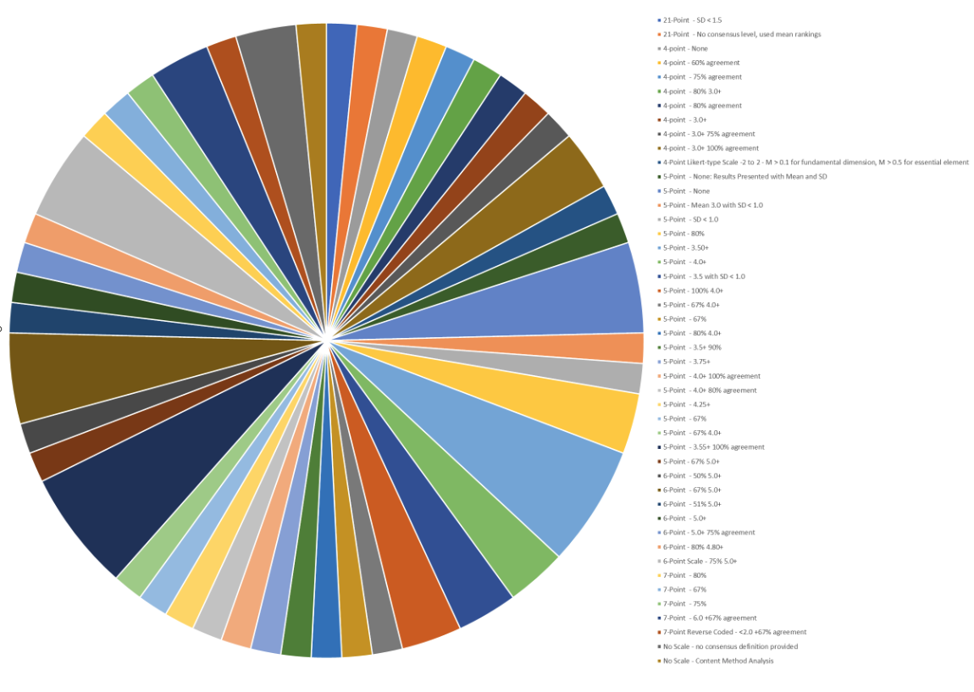

Of those using a four-point scale (n = 9), eight different definitions of consensus were provided. The studies using a five point (n =33) yielded 21 definitions, the six-point studies (n = 11) provided seven, the seven point scales (n = 5) four, and the two 21-point scales had two different definitions. One of the studies with no scale provided indicated the use of content analysis methods and the other did not indicate how consensus was determined. The full table of scales and consensus is provided in Table 1.

Table 1
Definitions of First-Round Consensus of in Studies Using Delphi Methods Published in the Journal of Agricultural Education in the Last 35-Years
Scale and Definition of Consensus | ƒ | % of Whole
4-Point Likert
None Provided | 1 | 2.17
60 % of responses in agreement | 1 | 2.17
75 % of responses in agreement | 1 | 2.17
80% 3.0+ | 1 | 2.17
80 % of responses in agreement | 1 | 2.17
Mean of 3.0+ (or greater) | 1 | 2.17
Mean of 3.0 plus 75% of responses “agree” | 1 | 2.17
Mean of 3.0 plus 100% of responses “agree” | 2 | 2.17
4-Point Likert-type Scale: -2 - 2
M > 0.1 for fundamental dimension, M > 0.5 for essential element | 2 | 2.17
5-Point Likert-type
None: Results Presented with Mean and SD | 1 | 2.17
None | 3 | 6.52
Mean 3.0+ with SD < 1.0 | 1 | 2.17
SD < 1.0 | 1 | 2.17
80% of responses in agreement | 2 | 4.35
Mean of 3.50+ | 4 | 8.70
Mean of 4.0+ | 2 | 4.35
Mean of 3.5 (or greater) with SD < 1.0 | 2 | 4.35
100% of responses 4.0+ | 2 | 4.35
67% of responses 4.0+ | 1 | 2.17
67% of responses in agreement | 1 | 2.17
80% of responses 4.0+ | 1 | 2.17
Mean of 3.5 plus 90% of responses “agree” | 1 | 2.17
Mean of 3.75+ | 1 | 2.17
Mean of 4.0 plus 100% of responses “agree” | 1 | 2.17
Mean of 4.0 plus 80% of responses “agree” | 1 | 2.17
Mean of 4.25+ | 1 | 2.17
67% of responses in agreement | 1 | 2.17
67% 4.0+ | 1 | 2.17
Mean of 3.55 plus 100% of responses “agree” | 4 | 8.70
67% of responses 5.0+ | 1 | 2.17
6-Point Likert-type
50% of responses 5.0+ | 1 | 2.17
67% of responses 5.0+ | 3 | 6.52
51% of responses 5.0+ | 1 | 2.17
Mean of 5.0+ | 1 | 2.17
Mean of 5.0+ 75% of responses “agree” | 1 | 2.17
80% of responses of 4.80+ | 1 | 2.17
75% of responses 5.0+ | 3 | 6.52
7-Point Likert-type
80% of responses in agreement | 1 | 2.17
67% of responses in agreement | 1 | 2.17
75% of responses in agreement | 1 | 2.17
Mean of 6.0+ 67% of responses “agree” | 2 | 4.35
7-Point Likert-type (Reverse Coded)
Mean of less than 2.0 plus 67% of responses “agree” | 1 | 2.17
21-Point Likert-type
No consensus level provided – used mean rankings | 1 | 2.17
Unknown (SD < 1.5) | 1 | 2.17
No Scale Provided or Used
No consensus level provided | 1 | 2.17
Content Method Analysis | 1 | 2.17

Conclusions – Implications – Recommendations
This methodological analysis of 65 Delphi studies published in the Journal of Agricultural Education revealed substantial variation in how consensus is operationalized and reported. Panel sizes varied widely, with no apparent disciplinary standard. The use of Likert-type scales differed across studies, and 46 unique scale-definition combinations were used to describe first-round consensus levels. These findings confirm that, while Delphi methods are consistently used within agricultural education, consensus is inconsistently defined and applied.

The inconsistencies found have potential implications for both the perceived validity and comparability of Delphi studies in agricultural education. This study, theoretically grounded in Ajzen’s Theory of Planned Behavior, suggests that researcher attitudes and perceived norms (or lack thereof) may influence methodological choices, leading to broad variability in practice. The inclusion of Kolb’s Experiential Learning Theory was intended to offer this initial study as a reflective point for the discipline to critically evaluate and improve its research practices. Without clarity or shared expectations on panel size and consensus criteria, readers and reviewers may struggle to assess study rigor or outcomes.

This regional abstract serves as an initial follow-up to a poster submitted and presented by one of the authors (Frost & Rayfield, 2019). With the limited space of this abstract format, the first recommendation is to take the feedback from reviewers or conference participants and expand this into a national presentation and potentially a journal article to foster further reflection and discussion. The hopes for these discussions are three-fold: establish reporting standards, encourage justification of methodological choices, and promote methodological training in the use of Delphi methods.

The agricultural education research community has a strong history of methodological and reporting improvements. It should work toward field-specific Delphi reporting standards—especially around consensus definitions and scale use—to improve clarity, comparability, and methodological rigor. We further recommend that future authors provide theoretical or empirical rationale for panel size, scale design, and consensus thresholds, rather than defaulting to precedent or convenience. A final recommendation is that graduate programs and professional development offerings should include more robust training on Delphi techniques, particularly related to defining and measuring consensus.
References
American Association for Agricultural Education (AAAE). (2023). AAAE Research Values
Ajzen, I. (1991). The theory of planned behavior. Organizational Behavior and Human Decision Processes, 50(2), 179–211. https://doi.org/10.1016/0749-5978(91)90020-T
Ajzen, I. (2006). Behavioral interventions based on the theory of planned behavior. https://people.umass.edu/aizen/pdf/tpb.intervention.pdf
Dalkey, N. C., & Helmer, O. (1963). An experimental application of the Delphi method to the use of experts. Management Science, 9(3), 458–467. https://doi.org/10.1287/mnsc.9.3.458
Dalkey, N. C. (1969). The Delphi method: An experimental study of group opinion. The Rand Corporation.
Frost, K. J., & Rayfield, J. (2019 May 21-24). Delphi Consensus Levels over 30 Years in the Journal of Agricultural Education. Research poster session presention at the National Conference of the American Association for Agricultural Educators. Des Moines, IA.
Geist, M. R. (2010). Using the Delphi method to engage stakeholders: A comparison of two studies. Evaluation and Program Planning, 33(2), 147–154. https://doi.org/10.1016/j.evalprogplan.2009.06.006
Hsu, C. C., & Sanford, B. A. (2007). The Delphi technique: Making sense of consensus. Practical Assessment, Research & Evaluation, 12(10), 1–8. https://doi.org/10.7275/pdz9-th90
Hsieh, H. F., & Shannon, S. E. (2005). Three approaches to qualitative content analysis. Qualitative Health Research, 15(9), 1277–1288. https://doi.org/10.1177/1049732305276687
Kolb, D. A. (1984). Experiential learning: Experience as the source of learning and development. Prentice Hall.
Linstone, H. A., & Turoff, M. (Eds.). (2002). The Delphi method: Techniques and applications. https://web.njit.edu/~turoff/pubs/delphibook/delphibook.pdf
Merriam-Webster. (2025). Consensus. In Merriam-Webster.com dictionary. https://www.merriam-webster.com/dictionary/consensus
Rowe, G., & Wright, G. (2011). The Delphi technique: Past, present, and future prospects – Introduction to the special issue. Technological Forecasting and Social Change, 78(9), 1487–1490. https://doi.org/10.1016/j.techfore.2011.09.002
von der Gracht, H. A. (2012). Consensus measurement in Delphi studies: Review and implications for future quality assurance. Technological Forecasting and Social Change, 79(8), 1525–1536. https://doi.org/10.1016/j.techfore.2012.04.013
Warner, L. A. (2017). Using the Delphi technique to achieve consensus: A tool for guiding Extension programs (AEC521). University of Florida IFAS Extension. https://edis.ifas.ufl.edu/publication/WC183

