The Paths to Developing Teachers: Analyzing the Impacts of Teacher Preparation Program Characteristics on Preservice Teacher Completion Using Path Analysis
Introduction
Teacher quality directly influences student achievement and learning outcomes (OECD, 2005; Rowe, 2002), but what affects teacher quantity? This question has become increasingly difficult to answer as national teacher shortages intensify (Doss et al., 2023; Eck & Edwards, 2019) and certification routes multiply (Feistritzer, 2011). Evidence remains inconclusive across the board, leaving policymakers uncertain where to invest concentrated efforts to alleviate school staffing challenges (Clotfelter et al., 2020; Goldhaber & Brewer, 2000; Witford et al., 2017). While arguments persist about whether the challenge lies with recruitment (Brown & Riden, 2023; Evans et al., 2021), certification routes and scholarship strategies (Bowling & Ball, 2018; Darling-Hammond & Sykes, 2003), or alternative retention efforts (Igo & Perry, 2019), the fact remains: Nearly 40,000 teaching vacancies persisted nationwide in 2024 (Nguyen et al., 2024), compounded by a 336,000-student decrease in teacher preparation program (TPP) enrollment from 2008 to 2016 (Evans et al., 2021).
Arguably, the national teacher shortage is a wicked problem exacerbated by several converging challenges (Boone & Boone, 2009; Boström & Bostedt, 2025; Ingersoll, 2001). One particular challenge lies with matriculation through TPPs. As we consider strengthening the teaching workforce, our primary concern in this study was preparation. With the number of preservice teachers (PST) completing teacher preparation programs declining by 35% since 2012 (AACTE, 2022), a closer look at TPP retention was warranted. Even without a national teacher shortage, this work remains worthwhile. TPPs and their educators are under increasing pressure to demonstrate effectiveness, both in preparing teachers and in graduating enough of them (Hood et al., 2022). The onus is on TPPs to review the program characteristics influencing their enrollments and matriculation. Our study aimed to provide a starting point for TPPs across disciplines to evaluate their efforts to ensure a stable and sufficient workforce for education, as called for in recent school-based agricultural education (SBAE) literature (Haddad et al., 2020; Hur et al., 2023). We employed path analysis to identify and examine the relationships between TPP characteristics and program completion, by posing one research question to guide our study:
RQ: Which TPP characteristics contributed directly and indirectly to predicting program completions?
Literature Review
In undertaking this investigation, we first identified the most influential characteristics shaping PSTs’ experiences and their intentions to remain in or leave their programs. Based on the literature, these characteristics are program coherence and vision, mentorship quality, student teaching experiences, recruitment practices, and coursework design.
Cavanna et al. (2021) defined program coherence as structural and conceptual alignment across curriculum, instruction, and field experiences, which plays a prominent role in the outcomes of TPPs. In fact, when programs clearly articulate their vision and teacher educators consistently achieve it, PSTs are better prepared and more likely to complete their programs. On the other hand, programs lacking unity tend to be disorganized, negatively impacting preservice teacher development (Cavanna et al., 2021). Based on this evidence, we proposed our first hypothesis:
H1: TPPs with clear visions and missions will have higher completion rates.
Although effective mentorship has been defined in multiple ways (Awaya et al., 2003; Clawson, 1996; Kwan & Lopez-Real, 2005; OER, 1993), it significantly influences PSTs’ readiness, retention, and desire to teach (Ambrosetti & Dekkers, 2010; Clarke et al., 2014; Stewart et al., 2017). For example, Greathouse and Dobbins (2023) and Mazzye et al. (2022) illustrated intensive mentorship during the student teaching experience positively affected PSTs. In particular, the selection and training of cooperating teachers (CTs) enhanced PSTs’ preparedness and the likelihood of achieving success early in their careers (Mazzye et al., 2022). Thus, our second hypothesis was:
H2: TPPs utilizing more CTs will have higher completion rates.
Beyond mentoring, the overall student teaching experience is a core characteristic of TPPs (Brown et al., 2015). Notably, the length of these experiences matters. Greathouse and Dobbins (2023) found longer student teaching experiences were positively related to greater feelings of teacher preparedness, early-career effectiveness, and retention than shorter forms (see also Dewey, 1938). Bandura (1986) also emphasized mastery experiences—such as those developed through extended teaching practice—were key to building self-efficacy, which strengthened PSTs’ belief in their ability to succeed and persist in the profession (Knobloch, 2001; McKim & Velez, 2017). Our third hypothesis considered these findings:
H3: TPPs with more hours required in their student teaching experiences and all other field experiences will yield higher completion rates than programs with fewer hours.
How TPPs and their institutions recruit PSTs is critical to understanding how to increase enrollment and completion rates, as these strategies influence who enters the pipeline, thereby affecting program outcomes and overall teacher supply (Baldock et al., 2025; Thieman et al., 2016). Likewise, contact with teacher educators significantly influences PSTs’ enrollment decisions (Love & Love, 2023). Other findings indicated the level of contact between PSTs and faculty during their program made a difference in their success (Jacobs et al., 2017). Therefore, we proposed our fourth hypothesis:
H4: TPPs with a more full-time and adjunct faculty will have higher completion counts.
Educational theory suggests flexible schedules, applied learning, and strong cohort connections help foster professional identity and satisfaction (Anderson & Boutelier, 2021). However, while coursework flexibility supports retention, GPA-based admissions may work against it. Van Overschelde and Lopez (2018) found higher GPA requirements did not improve teacher quality and reduced program diversity and completion. Based on this, we proposed our fifth hypothesis:
H5: Higher GPA admission requirements will negatively impact TPP completion.
Data and Methods
Our literature review identified program coherence, mentorship, residency models, student teaching experiences, targeted recruitment practices, and financial incentives as key characteristics influencing TPP success. Unfortunately, no study or dataset to date had collected data on all these factors from a large sample of PSTs. The most recent available data are in the Title II Report (National Academy of Education, 2024). We analyzed data from the 2023 U.S. Title II Report, which compiled mandatory, state-verified self-reports from 2,217 institutions of higher education on TPP for the 2021-2022 academic year (U.S. Department of Education, 2023). This dataset provided indicators of program structure, enrollment, and completion. Our target population was the accredited TPPs in the United States. Because the Title II report involved only accredited programs, we intentionally excluded non-accredited programs from our inferences. This publicly available dataset enabled us to test H2, H3, H4, and H5 directly, but not H1, because it did not include the variables reported in the literature. Moreover, variables such as GPA requirements and student teaching hours were reported with limited variability or detail, which may have limited our analysis.
Our analysis was restricted to a purposeful sample from the National Education Association (NEA) Zone 3, yielding 509 institutions (National Education Association, 2025). Institutions in this zone share similar student demographics, educational policies, and teacher certification standards, thereby enhancing internal consistency in the analysis (Etikan et al., 2016). To address representativeness, we used unpaired t-tests to compare the Zone 3 sample with the national Title II dataset. Results indicated the sample aligned with the national population in faculty size and gender distribution but differed in the average number of programs per institution and in racial composition (higher White and lower Black, Hispanic, and Asian completers; all p < .05), thereby limiting generalizability beyond Zone 3.
We conducted path analysis in Mplus 8.7 to examine relationships between TPP characteristics and completion (Lleras, 2005). Path analysis allows modeling among observed variables (Raykov & Marcoulides, 2006) and interpretation of direct and indirect effects (Land, 1969). We evaluated model fit with CFI, RMSEA, and SRMR. Our model fit comprised four iterations, guided by Model Fit Indices and fit criteria (Alhija, 2010; Hooper et al., 2008; Hu & Bentler, 1999), as derived from theory. In addition, path analysis can clarify the relationships between observable characteristics and their correlations with program completion (Bollen, 1989). By understanding the joint effects, or the relative contributions, of each observable TPP characteristic, we could arrive at clearer insights into which factors most significantly impacted program completion rates. That said, our study sought to clarify these joint contributions to understand the TPP characteristics that contributed to program completion.
Our hypothesized model included ten variables derived from the 2023 Title II dataset (see Figure 1). We identified theoretical links between these variables and TPP success, operationalized in this study as the number of program completers. Solid arrows indicate hypothesized positive effects, while the lone negative effect is indicated by a dashed arrow. In addition, variables with arrows entering them were considered endogenous, and those with only exiting arrows were exogenous (Kline, 2023).

Figure 1
Hypothesized Path Diagram
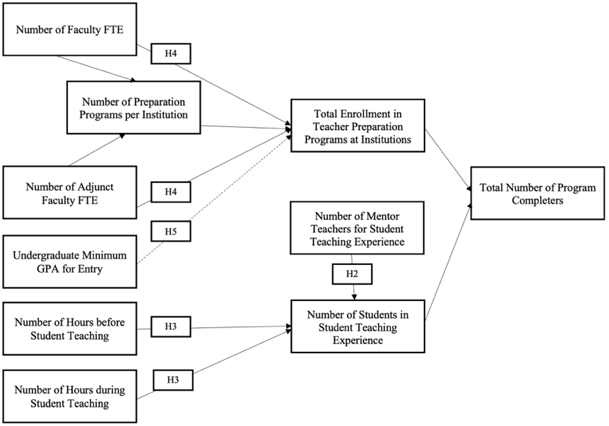

Results
Our path analysis included five iterations to fit the hypothesized path diagram, using both conceptual justification and Model Fit Indices in the Mplus output. The initial model fit the data poorly (χ²(19) = 346.643, p < 0.001), and additional fit indices were consistent with this: CFI = 0.778, RMSEA = 0.215, SRMR = 0.121 (Alhija, 2010). Due to limitations in the dataset and a lack of additional theoretically sound paths, our model yielded an approximate fit (χ2(15) = 56.466, p < 0.001; CFI = 0.972; RMSEA = 0.086; SRMR = 0.035), as reflected in Table 1.
Table 1
Statistically Significant Results of Path Analysis
Paths | Path Coefficients | Standard Error | t
To Total Enrollment in TPPs at Institutions from:
Number of TPPs per Institution | 0.078* | 0.035 | 2.191
Number of Faculty FTE | 0.256* | 0.050 | 5.091
Number of Adjunct Faculty FTE | 0.088* | 0.038 | 2.325
Number of Students in Student Teaching | 0.479* | 0.050 | 9.631
To Number of Students in Student Teaching from:
Number of Faculty FTE | 0.457* | 0.034 | 13.442
Number of Mentor Teachers for Student Teaching | 0.479* | 0.050 | 14.166
To Total Number of TPP Completers from:
Number of Adjunct Faculty FTE | 0.109* | 0.022 | 4.929
Total Enrollment in TPPs at Institutions | 0.633* | 0.028 | 22.411
Number of Mentor Teachers for Student Teaching | 0.224* | 0.031 | 7.135
Number of Students in Student Teaching | 0.126* | 0.033 | 3.811
Note. *p < 0.05
A chi-square difference test revealed χ²(4) = 290.177, p < 0.001, which meant the more constrained model (see Figure 1) fit significantly worse than the retained model (see Figure 2). This validated our modification process (Folk & Savalei, 2024; Savalei & Kolenikov, 2008).
Figure 2
Path Analysis Diagram Results
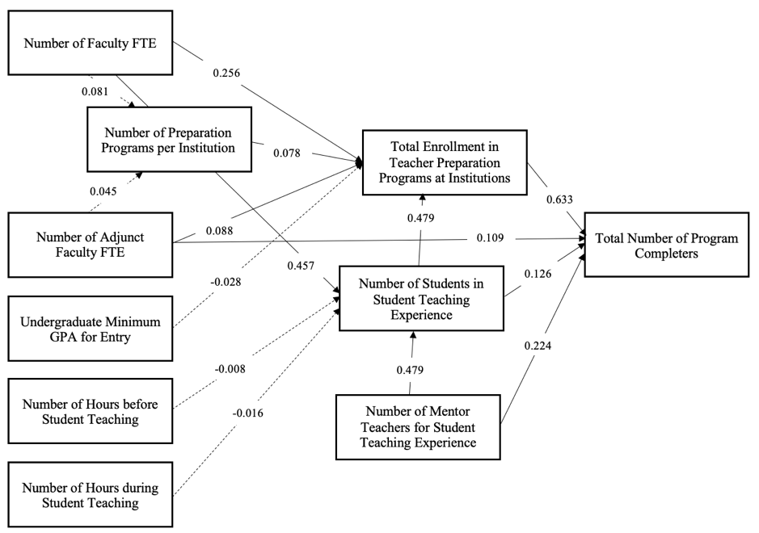

Discussion
We explored how TPPs’ characteristics influenced program success, defined by the number of completers. The findings revealed key insights, answered our research question, and yielded practical implications. Our path analysis confirmed Hypotheses 2 and 4, showing only program size and total enrollment directly predicted program completion. These findings aligned with prior research and theory, emphasizing the necessity of faculty support and involvement (Jacobs et al., 2017) and mentoring structures (Greathouse & Dobbins, 2023; Mazzye et al., 2022). Additionally, the final model addressed our research question as it revealed several pathways through which program characteristics appeared to interact to affect program outcomes. For example, program faculty levels and offerings influenced program completion by shaping total enrollment, suggesting programs with sufficient infrastructure may be better positioned to attract and retain PSTs. Similarly, mentorship structures were significantly associated with the number of student teachers, thereby predicting program completers. These findings contend TPP structures do not function in silos. Rather, they intersect and amplify one another’s effects, shaping whether PSTs complete their respective programs.
The path analysis model’s fit improved across iterations, yet it remained suboptimal, suggesting key TPP characteristics were likely omitted or poorly captured in the Title II Report dataset. Thus, we are left with important questions for future research and policy: What indicators of TPP quality and completion are missing from current national datasets? Does high TPP completion indicate success? And how should TPP balance the natural attrition of PSTs with the need to retain and prepare effective teachers? These questions extend beyond the scope of our study but highlight the need for more nuanced, holistic data in TPP research. Instead of focusing solely on retention, TPPs may benefit from identifying which TPP exits are constructive (e.g., changes in career interests, dispositional challenges) versus problematic (e.g., lack of support). Our field must weigh this as we aim to produce resilient and well-prepared teachers.
Even though prior studies emphasized the importance of engaging PSTs in extensive classroom teaching experiences (Chen, 2013; Greathouse & Dobbins, 2023), we found the number of hours required before and during the student teaching experience did not significantly predict the number of student teachers or program completers. This did not suggest student teaching and other field experiences are unimportant; rather, the amount of time required by programs was insufficient to explain variation in completion outcomes. Likewise, although some researchers found GPA to be a positive predictor of preservice teacher success (Bansiong & Balagtey, 2020), and others have questioned the use of GPA as an admissions screen (Moore, 2019; Van Overschelde & Lopez, 2018), we did not find a significant relationship between GPA requirements and program completers. This may reflect a restricted range issue, as most programs reported similar GPA thresholds (2.0 to 3.0). These discrepancies underscore the limitations of the dataset in capturing the full scope of factors likely influencing TPP success.
Conclusion
We found program capacity and mentoring structures in the United States and its jurisdictions were significantly associated (p < 0.05) with the number of TPP completers through direct and indirect pathways. However, our study was limited: we relied on self-reported data from fewer than 25% of U.S. teacher preparation programs, did not capture key program characteristics such as curriculum and mentorship quality, and aggregated student-level phenomena to the program level, which increased the risk of ecological error (Harron et al., 2017; Robinson, 1950). Moreover, the dataset we analyzed reported raw completion counts rather than completion rates, which inherently made larger programs appear more successful. While program-level patterns are suggested to guide policy (Kline, 2022), future work must be paired with richer, multi-level data and completion rate measures to examine whether these programs also yield higher completion rates. This would allow researchers to more precisely model how individual experiences and characteristics influence and interact with TPP components. Our results suggested teacher education reform must remain at the forefront of the agendas of teacher educators and policymakers. These groups should heed this study’s findings and invest in expanding and bolstering TPP infrastructure and faculty capacity to enhance program effectiveness and address the ongoing teacher shortage crisis.
References
AACRAO. (2025). Higher education act. [American Association of Collegiate Registrars and Admissions Officers]. https://www.aacrao.org/advocacy/issues/higher-education-act
AACTE. (2022). Colleges of education: A national portrait (2nd ed.). American Association of Colleges for Teacher Education.
Alhija, F. A. N. (2010). Factor analysis: An overview and some contemporary advances. In P. Peterson, E. Baker, B. McGaw (Eds.), International encyclopedia of education (3rd ed.) (pp. 162-170). https://doi.org/10.1016/b978-0-08-044894-7.01328-2
Ambrosetti, A., & Dekkers, J. (2010). The interconnectedness of the roles of mentors and mentees in preservice teacher education mentoring relationships. Australian Journal of Teacher Education, 35(6), 42-55. https://doi.org/10.14221/ajte.2010v35n6.3
Anderson, M., & Boutelier, S. (2021). Converging andragogy with working adult professionalism in initial teacher preparation. Journal of Educational Research and Practice, 11(1). https://doi.org/10.5590/JERAP.2021.11.1.14
Awaya, A., McEwan, H., Heyler, D., Linsky, S., Lum, D., & Wakukawa, P. (2003). Mentoring as a journey. Teaching & Teacher Education, 20(1), 45-57. https://doi.org/10.1016/s0742-051x(02)00093-8
Baldock, K. D., Dusenbery, J., Drake, M., & Vetterly, M. (2025). New Mexico school-based agricultural educators’ inspirations to teach. Journal of Agricultural Education, 66(3), Article 13. https://doi.org/10.5032/jae.v66i3.3015
Bandura, A. (1986). Social foundations of thought and action: A social cognitive theory. Prentice-Hall.
Bansiong, A. J., & Balagtey, J. L. M. (2020). Predicting success in teacher education: Revisiting the influence of high school GPA, admission, and standardized test scores on academic and licensure performance. Journal of Research, Policy & Practice of Teachers and Teacher Education, 10(2), 1-17. https://doi.org/10.37134/jrpptte.vol10.2.1.2020
Bollen, K. A. (1989). Structural equations with latent variables. John Wiley & Sons, Inc.
Boone, H. N., & Boone, D. A. (2009). An assessment of problems faced by high school agricultural education teachers. Journal of Agricultural Education, 50(1), 21-32. https://doi.org/10.5032/jae.2009.01021
Boström, L., & Bostedt, G. (2025). The teacher shortage in Sweden: An unexplored area with various views on causes and solutions. Frontiers in Education, 10. https://doi.org/10.3389/feduc.2025.1633409
Bowling, A. M., & Ball, A. L. (2018). Alternative certification: A solution or an alternative problem?. Journal of Agricultural Education, 59(2), 109-122. https://doi.org/10.5032/jae.2018.02109
Brown, A. L., Lee, J., & Collins, D. (2015). Does student teaching matter? Investigating pre-service teachers’ sense of efficacy and preparedness. Teaching Education, 26(1), 77-93. https://doi.org/10.1080/10476210.2014.957666
Brown, T., & Riden, B. (2023). Increasing enrollment and diversity in special education preparation through grow your own programs. Journal of Special Education Preparation, 3(2), 26–36. https://doi.org/10.33043/JOSEP.3.2.26-36
Cavanna, J. M., Molloy Elreda, L., Youngs, P., & Pippin, J. (2021). How methods instructors and program administrators promote teacher education program coherence. Journal of Teacher Education, 72(1), 27-41. https://doi.org/10.1177/0022487119897005
Chen, X. (2013). STEM attrition: College students' paths into and out of STEM fields [NCES 2014-001]. National Center for Education Statistics, Institute of Education Sciences, U.S. Department of Education.
Clarke, A., Triggs, V., & Nielsen, W. (2014). Cooperating teacher participation in teacher education: A review of the literature. Review of Educational Research, 84(2), 163-202. https://doi.org/10.3102/0034654313499618
Clawson, J. G. (1996) Mentoring in the information age. Leadership & Organization Development Journal, 17(3), 6-27. https://doi.org/10.1108/01437739610785414
Clotfelter, C., Ladd, H., & Vigdor, J. (2010). Teacher credentials and student achievement in high school: A cross-subject analysis with student fixed effects. Journal of Human Resources, 45(3), 655–681. https://doi.org/10.1353/jhr.2010.0023
Darling-Hammond, L. (2000). Teacher quality and student achievement: A review of state policy evidence. Education Policy Analysis Archives, 8(1), 1-44. https://doi.org/10.14507/epaa.v8n1.2000
Darling-Hammond, L., & Sykes, G. (2003). Wanted: A national teacher supply policy for education: The right way to meet the “highly qualified teacher” challenge. Education Policy Analysis Archives, 11(33), 1-57. https://doi.org/10.14507/epaa.v11n33.2003
Dewey, J. (1938). Experience and education. Macmillan Company.
Doss, W., Rayfield, J., & Lawver, D. (2023). A national study assessing the influence of perceived challenges faced by school-based agricultural education teachers on their ability to do their job. Journal of Agricultural Education, 64(3), 184-202. https://doi.org/10.5032/jae.v64i3.2476
Eck, C. J., & Edwards, M. C. (2019). Teacher shortage in school-based, agricultural education (SBAE): A historical review. Journal of Agricultural Education, 60(4), 223-239. https://doi.org/10.5032/jae.2019.04223
Etikan, I., Musa, S. A., & Alkassim, R. S. (2016). Comparison of convenience sampling and purposive sampling. American Journal of Theoretical and Applied Statistics, 5(1), 1-4. https://doi.org// 10.11648/j.ajtas.20160501.11
Evans, C., Burrell, T., Chavis, K., Farrow, J., Williams, C., Cooper, L., Langford, J., Williams, D., Pierre, L., & Byrd, R. (2021). Teacher preparation enrollment trends: A review of national and statewide data. Focus on Colleges, Universities, and Schools, 15(1), 1-12.
Feistritzer, E. C. (2011). Profile of teachers in the U.S. 2011. National Center for Education Information.
Folk, D., & Savalei, V. (2024). Examining the performance of the chi-square difference test when the unrestricted model is slightly misspecified. Behavior Research Methods, 56(7), 6687-6706. https://doi.org/10.3758/s13428-024-02384-6
Goldhaber, D., & Brewer, D. J. (2000). Does teacher certification matter? High school teacher certification status and student achievement. Educational Evaluation and Policy Analysis, 22(2), 129-145. https://doi.org/10.2307/1164392
Greathouse, L., & Dobbins, C. N. (2023). Transformative teacher preparation through paid yearlong residencies: Program design to implementation. SRATE Journal, 32(2), 1-7.
Groves, R. M., Fowler, J. F., Couper, M. P., Lepkowski, J.M., Singer, E., & Tourangeau, R. (2009). Survey methodology (2nd ed.). John Wiley and Sons.
Haddad, B., Knight, K. J., Stewart, J., & Velez, J. J. (2020). Will the first through fifth years please stand up? Quantifying national SBAE teacher experience. Journal of Agricultural Education, 61(4), 266-282. https://doi.org/10.5032/jae.2020.04266
Harron, K., Dibben, C., Boyd, J., Hjern, A., Azimaee, M., Barreto, M. L., & Goldstein, H. (2017). Challenges in administrative data linkage for research. Big Data & Society, 1, 1-12. https://doi.org/10.1177/2053951717745678
Henry, G. T., Bastian, K. C., Fortner, C. K., Kershaw, D. C., Purtell, K. M., Thompson, C. L., & Zulli, R. A. (2014). Teacher preparation policies and their effects on student achievement. Education Finance and Policy, 9(3), 264-303. https://doi.org/10.1162/EDFP_a_00134
Hood, S. L., Dilworth, M. E., & Lindsay, C. A. (2022). Landscape of teacher preparation program evaluation policies and progress. National Academy of Education Committee on Evaluating and Improving Teacher Preparation Programs, National Academy of Education.
Hooper, D., Coughlan, J., & Mullen, M. R. (2008). Structural equation modelling: Guidelines for determining model fit. Electronic Journal of Business Research Methods, 6(1), 53-60. https://doi.org/10.21427/D79B73
Hu, L. T., & Bentler, P. M. (1999). Cutoff criteria for fit indexes in covariance structure analysis: Conventional criteria versus new alternatives. Structural Equation Modeling, 6, 1-55. http://dx.doi.org/10.1080/10705519909540118
Hur, G., Barry, D. M., Jagger, C. B., Alford, K., & Roberts, T. G. (2023). Investigating the impacts of a preservice agriculture teacher recruitment program using Kirkpatrick’s program evaluation model. Journal of Agricultural Education, 64(1), 184-200. https://doi.org/10.5032/jae.v64i1.37
Igo, E. A., & Perry, D. K. (2019). Examining the reasons agricultural education teaching graduates choose to enter, leave, or stay in the teaching profession. Journal of Agricultural Education, 60(2), 109-125. https://doi.org/10.5032/jae.2019.02109
Ingersoll, R. M. (2001). Teacher turnover and teacher shortages: An organizational analysis. American Educational Research Journal, 38(3), 499-534. https://doi.org/10.3102/00028312038003499
Jacobs, J., Hogarty, K., & West Burns, R. (2017). Elementary preservice teacher field supervision: A survey of teacher education programs. Action in Teacher Education, 39(2), 172-186. https://doi.org/10.1080/01626620.2016.1248300
Keese, J., Waxman, H., Asadi, L., & Graham, M. (2022). Retention intention: Modeling the relationships between structures of preparation and support and novice teacher decisions to stay. Teaching and Teacher Education, 110, 103594. https://doi.org/10.1016/j.tate.2021.103594
Kline, N. (2022). Using administrative data in social policy research [OPRE Report 2022-163]. Office of Planning, Research, and Evaluation. https://acf.gov/opre
Kline, R. B. (2023). Principles and practice of structural equation modeling (5th ed.). The Guilford Press.
Knobloch, N. A. (2001). The influence of peer teaching and early field experiences on teaching efficacy beliefs of preservice educators in agriculture. Proceedings of the National Agricultural Education Research Conference, New Orleans, LA, 28, 119-131.
Kwan, T., & Lopez-Real, F. (2005). Mentors’ perceptions of their roles in mentoring student teachers. Asia-Pacific Journal of Teacher Education, 33(3), 275-287. https://doi.org/10.1080/13598660500286267
Land, K. C. (1969). Principles of path analysis. Sociological Methodology, 1, 3-37. https://www.jstor.org/stable/270879
Lleras, C. (2005). Path analysis. In K. Kempf-Leonard (Ed.), Encyclopedia of social measurement (Vol. 3, pp. 25-30). Elsevier. https://doi.org/10.1016/B0-12-369398-5/00483-7
Love, T. S., & Love, Z. J. (2023). The teacher recruitment crisis: Examining influential recruitment factors from a United States technology and engineering teacher preparation program. International Journal of Technology and Design Education, 33(1), 105-121. https://doi.org/10.1007/s10798-022-09727-4
Mazzye, D. L., Duffy, M. A., & Etopio, E. (2022). Transformative features of teacher residency programs: A textual narrative synthesis. School-University Partnerships, 15(1), 21-33.
McKim, A. J., & Velez, J. J. (2017). Developing self-efficacy: Exploring preservice coursework, student teaching, and professional development experiences. Journal of Agricultural Education, 58(1), 172-185. https://doi.org/10.5032/jae.2017.01172
Moore, A. (2019). What are the doorways and barriers to enrollment in college preparatory courses for students who are Black, Hispanic, and American Indian? [Doctoral dissertation, Hamline University].
National Academy of Education. (2024). Evaluating and improving teacher preparation programs. K. M. Zeichner, L. Darling-Hammond, A. I. Berman, D. Dong, & G. Sykes (Eds.). National Academy of Education.
National Education Association. (2025). About NEA: Purpose and power in community. https://www.nea.org/about-nea
Nguyen, T. D., Lam, C. B., & Bruno, P. (2024). What do we know about the extent of teacher shortages nationwide? A systematic examination of reports of U.S. teacher shortages. AERA Open, 10(1), 1-18. https://doi.org/10.1177/23328584241276512
Organisation for Economic Co-operation and Development. (2005). Teachers matter: Attracting, developing and retaining effective teachers.
Office of Education Research (OER). (1993) Consumer guide, No.7, October 1993. Available online at: www.ed.gov/pubs/OR/ConsumerGuides/mentor.html
Raykov, T., & Marcoulides, G. A. (2006). A first course in structural equation modeling (2nd ed.). Lawrence Erlbaum Associates, Inc.
Robinson, W. S. (1950). Ecological correlations and the behavior of individuals. American Sociological Review, 15(3), 351-357.
Rowe, K. (2002). The importance of teacher quality. Retrieved March 13, 2025, from http://www.cis.org.au/issue_analysis/IA22/IA22.HTM
Savalei, V., & Kolenikov, S. (2008). Constrained versus unconstrained estimation in structural equation modeling. Psychological Methods, 13(2), 150-170. https://doi.org/10.1037/1082-989x.13.2.150
Shuls, J. V., & Trivitt, J. R. (2015). Teacher effectiveness: An analysis of licensure screens. Educational Policy, 29(4), 645-675. https://doi.org/10.1177/0895904813510777
Stewart, J., Lambert, M. D., Ulmer, J. D., Witt, P. A., & Carraway, C. L. (2017). Discovering quality in teacher education: Perceptions concerning what makes an effective cooperating teacher. Journal of Agricultural Education, 58(1), 280-299. https://doi.org/10.5032/jae.2017.01280
Thieman, E. B., Rosch, D. M., Suarez, C. E. (2016). Consideration of agricultural education as a career: A statewide examination by high school class year of predicting factors. Journal of Agricultural Education, 57(4), 29-43. https://doi.org/10.5032/jae.2016.04029
U.S. Department of Education, Office of Postsecondary Education. (2013). Preparing and credentialing the nation’s teachers: The secretary’s ninth report on teacher quality.
Van Overschelde, J. P., & López, M. M. (2018). Raising the bar or locking the door? The effects of increasing GPA admission requirements on teacher preparation. Equity & Excellence in Education, 51(3-4), 223-241. https://doi.org/10.1080/10665684.2018.1539355
Whitford, D. K., Zhang, D., & Katsiyannis, A. (2018). Traditional vs. alternative teacher preparation programs: A meta-analysis. Journal of Child and Family Studies, 27, 671-685. https://doi.org/10.1007/s10826-017-0932-0

