I Didn’t Say It Would be Easy, I Only Said It Would be Worth It: A Multiple Case Study Examination of Intentional Community Building in a Multi-institutional Global Learning Program

Introduction
Researchers emphasize that people learn more effectively in collaborative settings and that fostering a sense of community enhances learning outcomes, collective action, and deeper understanding (Clark & Paulsen, 2016; Ludvik et al., 2023). Despite its value, building community in educational settings is complex and often challenging (Clark & Paulsen, 2016; Ludvick et al., 2023). Instructors play a crucial role in fostering a sense of belonging, especially when learners encounter complex content or diverse environments (Ambrose et al., 2010; Ladson-Billings, 1995; Strayhorn, 2019). High-impact practices (HIPs), such as study abroad and cohort-based programs, often rely on collaboration and community to support transformative learning (Kuh, 2008).
In agricultural education, community-building aligns naturally with the discipline’s focus on collaboration, mentorship, and experiential learning (Roberts & Ball, 2009). Research has highlighted the importance of preservice teachers learning both how to engage in learning communities and how to create them in their future classrooms (Washburn & Myers, 2008). However, learning communities can involve interpersonal conflict, inconsistent commitment, and the need for ongoing instructor support (Smalley & Retalick, 2012). These challenges may intensify when working across institutional boundaries (Alexander et al., 2017; Doss & Rayfield, 2021; Lawver & Smith, 2014; Smalley & Retalick, 2012; Warner & Washburn, 2008). In study abroad and immersion programs, relational dynamics and intentional pre-departure community-building have a significant influence on group cohesion and intercultural learning (Lave & Wenger, 1991; Mezirow, 2000; Onosu, 2020; Sullivan et al., 2025). Despite these insights, limited research in agricultural education has explored how intentional community-building affects group identity and intercultural development. Most studies focus on individual outcomes rather than collective dynamics (Warner & Washburn, 2008).

Theoretical Framework
This study was grounded in Lave and Wenger’s (1998) Communities of Practice (CoP) theory, which views learning as a socially situated process that unfolds through engagement, context, and shared practice. Learners begin as peripheral participants, observing and engaging in low-risk tasks, and progress toward full participation, marked by mutual engagement and a collective identity. In a fully functioning community of practice, individuals shift from identifying as separate learners to aligning with the group as a cohesive learning unit. CoP theory provided both the design lens and analytical framework for this study. By focusing on the processes of participation, identity formation, and knowledge sharing within a learning community, it allowed for a structured comparison between two cohorts and highlighted how intentional design influenced their progression toward full participation.
Figure 1
The [Program Name] Community of Practice Model (adapted from Heung & Tse, 2022; Wenger, 1998; Wenger-Trayner & Wenger-Trayner, 2015).

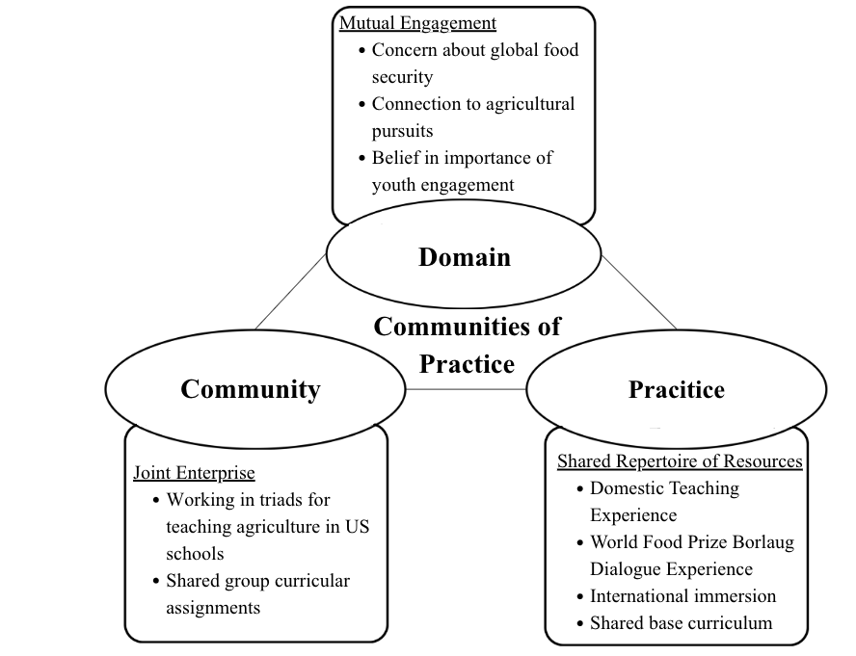

Purpose of Study
The purpose of this study was to examine how intentionally designed community-building strategies shaped the Global Orientation to Agricultural Learning (GOALs) cohort culture, student support, and group dynamics in a multi-institutional program focused on food security and global citizenship. The study addressed one research question: How did the intentional inclusion of community-building activities influence the development of student community in a year-long, multi-institution program?

Methods/Procedures
This study employed a qualitative comparative case study design (Creswell & Creswell, 2018; Yin, 2008) to explore two cohorts (2023–2024 and 2024–2025) participating in the year-long, multi-institutional GOALs program focused on food security and global citizenship through the lens of agricultural education. A theoretical replication approach guided the comparison, using Lave and Wenger’s (1998) Communities of Practice framework to identify cross-case patterns and distinctions.
Each [program] cohort participated in synchronous coursework during a fall and spring semester, a fall domestic immersion during the World Food Prize Borlaug Dialogues in Des Moines, Iowa; a spring domestic school-based agricultural teaching immersion as triad teams with representation from different institutions. An optional summer international immersion in Belize focused on agriculture and conservation education through indigenous knowledge. Participants were selected from 1862 and 1890 land-grant institutions as part of the USDA NIFA funded program call for applicants. Cohort 1 included 14 students from five institutions: Kentucky State University, Penn State University, Tuskegee University, University of Idaho, and University of Maryland Eastern Shore. Cohort 2 included 13 students from five institutions: Alcorn State University, Penn State University, Tuskegee University, University of Idaho, and University of Maryland Eastern Shore. Community-building activities and instructional approaches were revised between cohorts based on formative feedback from the participants and the instructional team. This feedback included discussion and minutes from monthly instructional team meetings, informal discussions between instructional team members and participants, formal program evaluation surveys, and an external evaluator’s findings. All points of feedback from Cohort 1 were evaluated during a mid-project instructional team meeting held in person at the NACTA Conference. Based on the Cohort 1 feedback, instructional design was modified, and intentional elements of community building occurred more frequently to the curriculum and program design for Cohort 2.
To ensure trustworthiness, each member of the research team completed a reflexivity statement related to perspectives on global competency, working with groups of students, study abroad components, and working with multi-institutional and cross-cultural groups. Commonalities in reflexivity statements included a background and strong belief in the value of agricultural education, belief in the value of high-impact experiences to transform student learning, and apprehension surrounding leading multi-institutional teams and cross-cultural groups due to both positive and negative prior experiences. To further address trustworthiness, we kept a detailed audit trail of both primary data sources (student artifacts) and secondary sources (instructor written observations), triangulated data within the team for both individual case analysis and comparative analysis, and conducted member checking with members of each cohort for the individual case analysis following rigorous protocols as defined by Lincoln & Guba (1985).

Description of Instructional Modification from Year 1 to Year 2
Program instructional changes were made following the mid-project meeting of the instructional team. This team consisted of five faculty and one doctoral candidate from two 1862 land-grant institutions, three 1890 land-grant institutions, and one external evaluator, who is also a subject matter expert in intercultural teaching. Based on the collective experiences, faculty reflections, and student feedback from the external evaluator, significant changes were made to the curriculum, refining learning objectives, learning activities, and assessment strategies.
The first cohort's curriculum and pedagogical practices focused heavily on technical content related to global food security, school-based agricultural education, teaching practice, and global citizenship. Perceptions of the student experience during Cohort 1 were captured through external evaluations, which included reflective interviews and focus groups conducted by the external evaluator after each major immersion point in the program and at the program's conclusion. After the completion of Cohort 1, the instructional team relied on feedback from the students' experiences in the external evaluation, as well as their own lived experiences as instructors, to inform curriculum and pedagogical changes for Cohort 2. These modifications were implemented for Cohort 2:
- Include the Intercultural Development Inventory (IDI) as an assessment tool for student growth throughout the GOALs program.
- Incorporate more diverse voices as lead instructors into class sessions to facilitate the learning objectives from different lenses and lived experiences.
- Embed community and culture-building objectives and activities through reflective and identity-building strategies into the curriculum.
Following these reflections, the instructional team acknowledged that even though technical knowledge and pedagogical skill development remained essential, such were not sufficient. It became clear that cultivating students’ capacities for community-building, collaboration, and intercultural understanding needed to be an explicit focus within the curriculum, rather than an incidental outcome.
These changes directly addressed issues identified in Cohort 1. Students in that cohort often self-segregated by institution, and engagement remained superficial during reflective discussions. To address this, instructors embedded structured identity-based activities at the beginning of the program, such as the taking and reflecting on their results of the 16 Personalities Test, as well as introducing SWAPs (small tokens or items that represent themselves to trade with each member of the group) and community norm-setting exercises in Cohort 2. Additionally, guest speakers representing diverse backgrounds and agricultural contexts were invited to broaden perspectives and normalize multiple ways of knowing.
The Intercultural Development Inventory (IDI) was introduced to Cohort 2 not only as an assessment tool but as a developmental guide. Results were used to help students set intercultural goals and reflect on their growth during structured debriefs. These interventions were designed to build trust early, promote vulnerability in cross-institutional partnerships, and support deeper engagement with global issues.

Results
GOALs Cohort 1 exhibited low student cohesion, limited peer engagement, and minimal connection to program goals. Students were frequently self-isolated in their home institutions, and instructional prompts were often met with silence or canned responses of what participants thought the instructional team wanted to hear. One student reflected: “I can’t say what I want because there is no way the group will respect me for who I am.” Observations and reflections revealed ongoing interpersonal tension, with students expressing frustration about group dynamics throughout the year. A student reflected on an incident: “I don’t know how [student] and I can reach a point of respect if [student] can’t respect me. It's a never-ending cycle!” While the program's content emphasized food security and global competency, participants' responses often remained at the awareness level and reflected deficit-oriented perspectives. Statements like, “it’s amazing how other countries don’t have the means to address their food security issue” or “I didn’t know it was that bad in other countries” lacked analysis of global agriculture issues and making connections to their own communities and lives.
GOALs Cohort 2, in contrast, demonstrated higher levels of collaboration, trust, and community. Instructional design changes, such as identity-based sharing activities, partner autonomy, and clearer community expectations, helped foster strong interpersonal connections. Students consistently referred to the group using collective language such as “us”, “we”, and the GOALs name. One participant stated, “It’s just so cool that we get to be here experiencing this with each other.” Reflective data indicated deeper engagement with global issues, stronger cohesion, and evidence of community-of-practice dynamics. “I have learned so much about [state] because of [student]. It’s made me think of how we can share ideas to address the food security issues here in my own town.” Another participant asked the instructional team, “Can we do a GOALs alumni immersion next year? That would be so cool to see everyone again and see what we are doing in our degree program.” This sentiment was repeated by multiple students throughout the Belize immersion experience multiple times. Table 1 summarizes the key differences between the [program] cohorts based on the observations, reflections, and artifacts collected by the instructional team.
Table 1
Summary of Key Differences between GOALs Cohort 1 and Cohort 2
Category | Cohort 1 | Cohort 2
Group Dynamics | Low engagement, isolation by institution | High engagement, strong cross-institutional bonds
Peer Interaction | Frequent conflict, lack of collaborative voice | Mutual support, peer-led collaboration
Connection to Content | Surface-level, deficit framing | Critical, reflective engagement

Conclusions and Recommendations
The intentional redesign of community-building strategies between Cohort 1 and Cohort 2 led to markedly different outcomes in student cohesion, engagement, and learning. This shift demonstrates the value of designing high-impact practices (HIPs) that are grounded in the principles of learning communities and identity development. Kuh’s (2008) HIPs emphasize the power of structured, immersive experiences, and when aligned with Lave and Wenger’s (1991) Communities of Practice framework, such experiences can foster both individual transformation and cohort’s collective growth.
The success of Cohort 2 reinforces the importance of embedding relational scaffolding into program design, particularly in cross-institutional and multicultural settings. Instructional teams must proactively build environments that support trust, shared identity, and sustained collaboration. When programs prioritize not only content delivery but also the cultivation of social learning spaces, they can better facilitate progression from peripheral to full participation within a learning community. Practically, this means intentionally designing early and ongoing community building, integrating reflective activities throughout the program, and avoiding schedules that limit the depth of interaction. Instructors should also receive preparation in facilitating inclusive, emotionally safe learning environments that support vulnerability, especially in culturally diverse groups. Students frequently reflected on and referred back to their IDI reports and recommendations throughout the course, suggesting that an assessment such as the IDI would aid students in developing intercultural and global competency with guidelines provided to them based on their results. By incorporating these strategies at the beginning of programming, the experiences for both student participants and instructional team members were significantly better as the program progressed and came to a close.
Future research should examine how participation in high-impact practices (HIPs) structured as communities of practice influences long-term teacher identity development, retention, and intercultural competence. Additional studies could explore how these design elements could be scaled across disciplines or utilized to support alumni networks and cross-cohort collaborations. A key takeaway from this study that warrants further investigation is the combined use of the Intercultural Development Inventory (IDI) and structured reflective activities, which highlights the importance of integrating both assessment and intentional community-building. Even though inventory-style assessments offer valuable diagnostic insights, it is the pairing with reflective practice and relational scaffolding that appears to deepen learning outcomes in global education programs.

References

Alexander, J. C., Rucker, K. J., Graham, D. L., Miller, J. D., & Apple, J. K. (2017). Perceptions of agricultural leadership academic programs of 1862 Land-Grant Universities. Journal of Agricultural Education, 58(4), 65–82. https://doi.org/10.5032/jae.2017.04065

Ambrose, S. A., Bridges, M. W., DiPietro, M., Lovett, M. C., & Norman, M. K. (2010). How learning works: Seven research-based principles for smart teaching. Jossey-Bass/Wiley.

Clark, T. K., & Paulsen, T. H. (2016). Analyzing student teacher critical thinking through blogs in an electronic community of practice. Journal of Agricultural Education, 57(2), 75–92. https://doi.org/10.5032/jae.2016.02075

Creswell, J. W., & Creswell, J. D. (2018). Research design: Qualitative, quantitative, and mixed methods approaches (5th ed.). SAGE Publications.

Doss, W., Rayfield, J., & Lawver, D. (2023). A national study assessing the influence of perceived challenges faced by school-based agricultural education teachers on their ability to do their job. Journal of Agricultural Education, 64(3), 184–202. https://doi.org/10.5032/jae.v64i3.2476
Heung, Y., & Tse, A. (2022). The influence of an online community of practice on professional development for online teaching: Case study on kindergartens. The 30th International Conference on Computers in Education. https://www.researchgate.net/publication/373192346_The_Influence_of_an_Online_Community_of_Practice_on_Professional_Development_for_Online_Teaching_Case_Study_on_Kindergartens
Kolb, D. (1984). Experiential learning: Experience as the source of learning and development. Prentice-Hall.

Kuh, G. D. (2008). High-impact educational practices: What they are, who has access to them, and why they matter, (pp 34). AAC&U, Washington, DC.

Ladson-Billings, G. (1995). But that’s just good teaching! The case for culturally relevant pedagogy. Theory Into Practice, 34(3), 159–165. http://www.jstor.org/stable/1476635

Lave, J., & Wenger, E. (1998). Communities of practice: Learning, meaning, and identity. Cambridge University Press.

Lawver, R. G., & Smith, K. L. (2014). Coping mechanisms Utah agriculture teachers use to manage teaching-related stress. Journal of Agricultural Education, 55(1), 76–91. https://doi.org/10.5032/jae.2014.0107

Lincoln, Y. S., & Guba, E. G. (1985). Naturalistic inquiry. SAGE Publications. https://doi. org/10.1016/0147-1767(85)90062-8

Ludvik, M. B., Wills-Jackson, C., Eberhart, T. L., Mulholland, S., Bhansali, S., Nolan-Arañez, S., & Henline, J. (2023). Exploring the potential of mindful compassion pedagogies for effective global citizenship education and education for sustainable development. International Review of Education, 69(3), 275-297. https://doi.org/10.1007/s11159-023-10009-x

Mezirow, J. (2000). Learning to think like an adult. Core concepts of transformation theory. In J. Mezirow, & Associates (Eds.), Learning as transformation. Critical perspectives on a theory in progress (pp. 3-33). Jossey-Bass

Onosu, O. G. (2020). Cultural immersion: A trigger for transformative learning. Social Sciences. 9(20). https://doi.org/10.3390/socsci9020020

Roberts, T. G., & Ball, A. L. (2009). Secondary agricultural science as content and context for teaching. Journal of Agricultural Education, 50(1), 81–91. https://doi.org/10.5032/jae.2009.01081

Smalley, S. W., & Retallick, M. S. (2012). Agricultural education early field experience through the lens of the EFE Model. Journal of Agricultural Education, 53(2), 99–109. https://doi.org/10.5032/jae.2012.02099

Strayhorn, T. (2019). College students’ sense of belonging. Routledge. http://doi.org/10.4324/9781315297293.

Sullivan, M., Smith, K., Foster, D. D., Miller Foster, M., Rice, L., & Falk, J. (2025). Global citizenship: Change in agricultural teacher candidates from a high impact experience. Journal of Agricultural Education, 66(1), Article 32. https://doi.org/10.5032/jae.v66i1.2914

Warner, W. J., & Washburn, S. G. (2009). Issues facing urban agriscience teachers: A Delphi study. Journal of Agricultural Education, 50(1), 105–115. https://doi.org/10.5032/jae.2009.01105

Wenger, E. (1998). Communities of practice: Learning, meaning, and identity. Cambridge University Press.

Wenger-Trayner, E., & Wenger-Trayner, B. (2015). Introduction to communities of practice. A brief overview of the concept and its uses. https://www.wenger-trayner.com/introduction-to-communities-of-practice/

Yin, R. K. (2008) Case study research: Design and methods (4th ed.). SAGE Publications.

