Pre-Service Teachers Preparedness to Implement Effective Teaching Behaviors
in School-Based Agricultural Education
Morgan Sweeney, Oklahoma State University
Christopher J. Eck, Oklahoma State University
Abstract
This study sought to assess the self-perceived level of effectiveness of SBAE pre-service teachers during the semester prior to their student teaching experience. Specifically, this study aimed to compare the effectiveness of pre-service SBAE teachers prior to their student teaching experience based on their intention to enter the teaching profession. The objectives for the study were identified as: determine the self-perceived level of teaching effectiveness of SBAE pre-service teachers prior to student teaching and compare the self-perceived level of teaching effectiveness with intent to teach. The population of interest was pre-service school-based agricultural education teachers at Oklahoma State University in an Inquiry-Based Instruction in Agricultural Education course. The instrument used was the Effective Teaching Instrument for School Based Agricultural Education (ETI-SBAE). Pre-service teachers enter student teaching with the inability to maintain work-life balance based on the findings. Furthermore, participants perceived their ability to develop students through FFA and SAE to be higher than that of their preparedness to deliver classroom instruction. Lastly, pre-service teachers perceive themselves as possessing the personal dispositions needed to be a successful teacher helping them be more appreciative and accepting of others. This study highlights the necessity of continually assessing pre-service teacher effectiveness to better prepare preservice teachers for the demands of the classroom.

Author Note: This manuscript is based on data published in the Proceedings of the Southern
Region Conference of the American Association for Agricultural Education, Sweeney & Eck
(2026).

Introduction
Teaching is a rewarding career providing the opportunity for teachers to greatly impact a student's future (Iram, 2022). A school-based agricultural education (SBAE) teacher is a specialized teacher following a three-component model including advising students in FFA, supervising agricultural experiences (SAE) and classroom/laboratory instruction (National FFA Organization, 2015). Classroom and laboratory instruction is where inquiry-based learning begins, with opportunities for further expansion in SAEs and FFA. Classroom and laboratory instruction are imperative to student learning, serving as the initial opportunity to engage students in agriculture (Parr & Edwards, 2004; Phipps et al., 2008; Roberts & Ball, 2009; Talbert et al., 2014). Supervised agricultural experiences serve as a work-based learning approach where students are able to have their own agricultural project to work on outside of the classroom (Rank & Retallick, 2016; Smith & Rayfield, 2016). FFA is a student led organization supporting middle and high school students in areas of agriculture career development and leadership development (National FFA Organization, n.d.).

Figure 1
School-Based Agricultural Education Three-Component Model
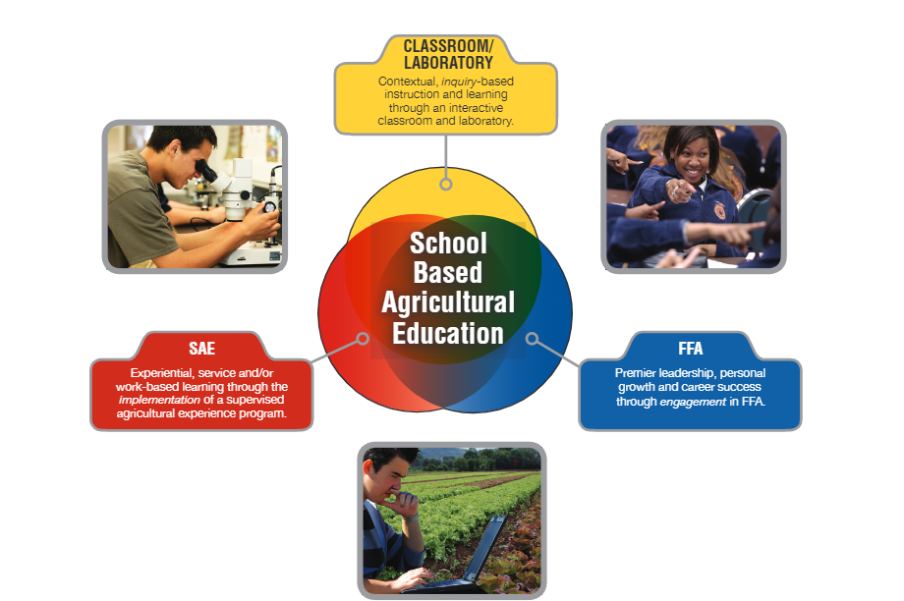
Note. From National FFA Organization. (2015). Agricultural education.
https://www.ffa.org/agricultural-education/

The responsibilities of an SBAE teacher differ from those of other subject teachers and coaches considering they have intracurricular duties as a part of their job description (National FFA Organization, 2015). Best (2023) identified 238 job specific tasks required of SBAE teachers. Such duties included preparing classroom instruction, supervising SAE projects, managing professional relationships, and creating a welcoming learning environment for students (Best, 2023). These demands can put strain on a teachers’ work-life balance due to being daunting and time-consuming (Torres et al., 2008). Due to a lack of standardization within the job duties of an SBAE teacher, many can be discouraged and overwhelmed with the job (Best, 2023). In addition, beginning SBAE teachers often feel self-conscious, unprepared, and struggle with student discipline (Boone & Boone, 2007).
Work-life balance (WLB) is the ability to manage work-related stress, balance priorities, and make time for career and family/personal life (Sorensen et al., 2016). Hours worked, marital status, years of teaching experience, number of students per class, other life roles, and personal children are factors impacting WLB (Sorensen et al., 2016). Establishing WLB can be challenging for an SBAE teacher due to the number of tasks required by them specific to the profession (Best, 2023).
Teachers are working about 50 hours per week in school and complete between 7 and 11 percent of their work on weekends, between 14 to 18 percent before school begins or after 6pm on weekdays (Bubb & Earley, 2004). The excessive workload leaves teachers feeling exhausted, stressed, and with little time for a social and home life (Bubb & Earley, 2004). This heavy load of tasks contributes to the shortage of SBAE teachers seen across the nation (Romero & Romero de la Torre, 2025). Therefore, it is important for educators to prioritize academic and emotional well-being (Ingersoll & Strong, 2011; Sutcher et al., 2016).
Early career teachers feel immense pressure to be successful immediately upon starting their career and often compare themselves to late career teachers who have already established their programs (Traini et al., 2020). Many early career teachers have expressed a desire to set clearer WLB boundaries, but there is a cultural norm against talking about WLB (Traini, et al., 2020). Instead, SBAE teachers are expected to just deal with it, although early career teachers know this is not sustainable (Traini et al., 2020). Without establishing WLB, it is hard to form a thriving foundation as an SBAE teacher (Traini et al., 2020).
Evaluating the success of a SBAE teacher is difficult given the multitude of tasks required by them (Eck et al., 2019; Roberts & Dyer, 2004). An effective teacher can be described as someone who has expertise in their subject matter, holds at least a baccalaureate degree, and has passed the required certification examinations in their respective states (U.S. Department of Education, n.d.). Other characteristics of an effective teacher can include servant leadership, self-efficacy, nonverbal communication, providing variability, clarity, enthusiasm, and opportunities to their students (Rosenshine & Furst, 1971; Steele, 2010).
Personal dispositions are critical to successful teachers, with empathy and consideration being identified by in-service teachers as essential (Eck et al., 2024). Empathy and consideration are described as being concerned for the well-being of others, focusing on the good in people, and respecting all learners’ abilities, backgrounds, and perspectives (Eck et al., 2024). Classrooms are becoming more diverse; therefore, it is important for teachers to be welcoming and accepting of everyone (Eck et al., 2020).
Purpose and Objectives
There are approximately 800 students graduating from agricultural education teacher preparation programs in the United States each year (Smith et al., 2025). Furthermore, in 2024, the National Association for Agriculture Education (NAAE), reported there were more than 9,000 SBAE programs employing more than 15,000 agricultural education teachers (Smith et al., 2025). In 2024, of this number of agriculture teachers, more than 1,900 were new hires and about 500 of them were newly licensed undergraduate students prepared in their respective state (Smith et al., 2025). The number of graduates still leaves empty SBAE teaching positions across the nation with 828 unfilled positions (Smith et al., 2025).
How can we be sure we are preparing our pre-service teachers optimally to fill as many positions as we can with quality teachers? This is important to consider as pre-service teachers move into the student teaching experience which is a crucial piece of a teacher preparation program, providing students with real-world experiences in the classroom working alongside an experienced teacher acting as a mentor (Ronfeldt & Reininger, 2012).
Pre-service teachers enter teacher preparation programs with vastly different backgrounds, not beginning with the same human capital and efficacy needed to be effective (Eck et al., 2019; Eck et al., 2024). Dispositions, such as trustworthiness, respectfulness, and empathy are crucial pieces of being an effective teacher beyond having content knowledge and pedagogical preparedness (Eck et al., 2024). Teacher preparation programs are tasked with helping pre-service teachers develop appropriate dispositions needed for the classroom in addition to content (Eck et al., 2024).
Few studies have been conducted to evaluate the current state of SBAE pre-service teachers’ self-perceived effectiveness prior to their student teaching internship due to the difficulty in evaluating such a measure with the wide array of tasks required by the profession. This study sought to assess the self-perceived level of effectiveness of SBAE pre-service teachers during the semester prior to their student teaching experience. Specifically, this study aimed to compare the effectiveness of pre-service SBAE teachers prior to their student teaching experience based on their intention to enter the teaching profession.
Theoretical and Conceptual Framework
This study was guided by the Human Capital Theory. Human capital refers to value a person gains from their education, skills, and experiences (Becker, 1964; Smylie, 1996), ultimately developing a more sought-after employee (Becker, 1964; Figure 2). Figure 2 illustrates Human Capital described Becker by showcasing the overlap in how investing in being a student, education, and training you increase overall productivity (Pace, 2016). Productivity can be described as an increase in salary, job skills, desirability by employers, and job competitiveness. SBAE teachers often improve human capital through professional development as it relates to their profession (Heckman, 2000). Human capital of teachers is developed more quickly when it is related to past and future tasks and when applied can have a positive impact on student successes (Ost, 2009; Pil & Leana, 2009).
A teacher is motivated to strengthen their human capital in areas such as work-life balance, personal dispositions, professionalism, intracurricular engagement, pedagogical preparedness, and diversity and inclusion because these factors significantly influence classroom outcomes. With 238 job-specific tasks and long work hours, SBAE teachers often struggle to find time for their personal lives (Best, 2021; Bubb & Earley, 2004). Learning strategies to better manage work-life balance can positively impact personal dispositions, leading to improved engagement and instruction in the classroom (Sorensen et al., 2016). Many responsibilities of an SBAE teacher involve intracurricular engagement and pedagogical preparedness. Enhancing human capital in these areas can increase salary potential and make teachers more desirable to school administrators (Becker, 1964). SBAE teachers strive to improve their own human capital while simultaneously encouraging their students to grow alongside them.

Figure 2
Human Capital Model
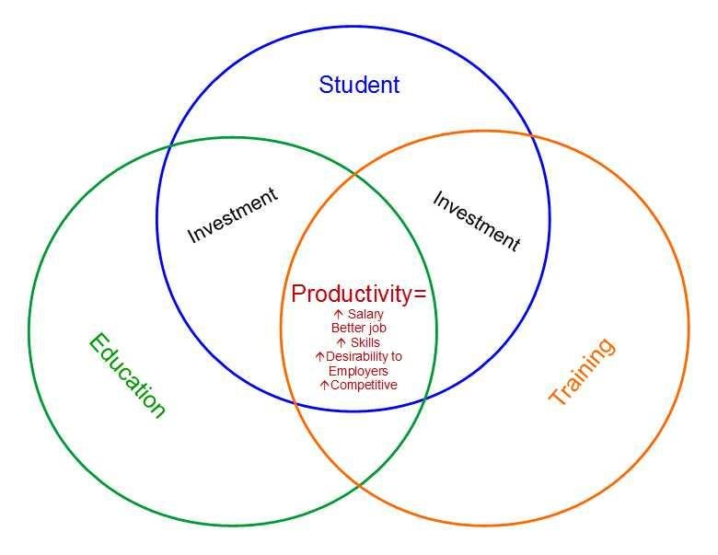
Note. From Pace, R. L., Jr. (2016). Relationship of institutional characteristics to CACREP accreditation of doctoral counselor education programs (Doctoral dissertation, Walden University). ProQuest Dissertations Publishing. https://scholarworks.waldenu.edu/dissertations/2097/

The timing and route SBAE teachers take to gain human capital can look very different depending on the individual (Smith, 2010). Smith (2010) further states individuals begin life with the same natural characteristics, but they can choose the development they receive throughout their life to tailor their training for a specific job or skill. One of the ways human capital is developed is through job training (Schultz, 1961). For traditional SBAE teachers, the student teaching internship is a primary tool used to develop human capital prior to entering the profession. Knowing this, we sought to gauge the self-perceived human capital needs of pre-service teachers just prior to their student teaching internship.
Considering the many factors impacting teaching effectiveness of SBAE teachers, a conceptual framework was developed to better understand the relationship between human capital and effective teaching (figure 3). Figure 3 represents the conceptual factors impacting teaching effectiveness for SBAE teachers and the personal and professional characteristics identified within the study. The development of effective teaching characteristics alongside personal and professional characteristics enhances human capital and both have implications on one another. Improving teachers’ human capital can improve their teaching effectiveness as seen in figure 3. Furthermore, effective teaching plays a role in improving human capital too (figure 3).

Figure 3
Conceptual Model of Effective Teaching for SBAE Teachers
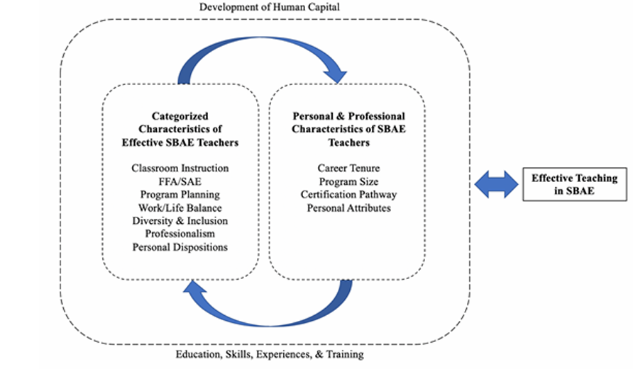
Note. From Eck, C. J., Robinson, J. S., Cole, K. L., Terry Jr., R., & Ramsey, J. W. (2020). Validation of the effective teaching instrument for school-based agricultural education teachers. Journal of Agricultural Education, 61(4), 229–248. http://doi.org/10.5032/jae.2020.04229

Methods
As a required component of the Agricultural Education Teacher Preparation Program at Oklahoma State University, students enroll in an Inquiry-Based Instruction in Agricultural Education course. The course used CASE AFNR curriculum as the foundation to explore curriculum and develop effective teaching principles. Specifically, the course included modeling of the CASE AFNR curriculum, hands-on lab practicums, guided discussions, and early-field teaching experiences using the curriculum. Students enrolled in this course at Oklahoma State University were chosen as the sample for the study due to accessibility and it being a required course just prior to their student teaching experience.
This non-experimental, survey research design (Privitera, 2017) aimed to determine the self-perceived teaching effectiveness after a semester-long undergraduate inquiry-based laboratory teaching methods course using the effective teaching instrument for school-based agricultural education teachers (ETI-SBAE; Eck et al., 2020). Regarding validity and reliability, ETI-SBAE had an overall Cronbach’s alpha value of 0.87 (acceptable) and reliability coefficients greater than 0.70 (acceptable) for five of the constructs and less than 0.70 (unacceptable) for one construct (Eck et al., 2020). The construct with the unacceptable value was retained due to only containing two items and being related to professionalism (Eck et al., 2020). Table 1 includes the six constructs include in the ETI-SBAE instrument with the characteristics they include.

Table 1
ETI-SBAE Constructs and Characteristics
Construct | Characteristic
- Intracurricular Engagement | I instruct students through FFA.
- Intracurricular Engagement | I advise the FFA officers.
- Intracurricular Engagement | I advise the FFA chapter.
- Intracurricular Engagement | I facilitate record keeping for degrees and awards.
- Intracurricular Engagement | I am passionate about FFA.
- Intracurricular Engagement | I instruct students through SAEs.
- Intracurricular Engagement | I use the complete agricultural education 3-component model as a guide to programmatic decisions.
- Personal Dispositions | I am trustworthy.
- Personal Dispositions | I am responsible.
- Personal Dispositions | I am dependable.
- Personal Dispositions | I am honest.
- Personal Dispositions | I show integrity.
- Personal Dispositions | I am a hard worker.
- Appreciation for Diversity and Inclusion | I value students regardless of economic status.
 | I value students of all ethnic/racial groups.
 | I value students regardless of sex.
 | I care about all students.
 | I understand there is not an award for all students, but that does not mean they are not valuable.
- Pedagogical Preparedness | I demonstrate classroom management.
- Pedagogical Preparedness | I demonstrate sound educational practices.
- Pedagogical Preparedness | I am prepared for every class.
- Work-Life Balance | I have the ability to say no.
- Work-Life Balance | I lead a balanced life.
- Work-Life Balance | I am never afraid to ask for help.
- Professionalism | I have patience.
- Professionalism | I show empathy.

Data were collected from preservice SBAE teachers (N = 60) students across three semesters at Oklahoma State University in which the course was offered. Forty-eight pre-service teachers completed the instrument, resulting in a 80.0% response rate. While the majority of population of interest participated in this study, the study was limited to the students enrolled in the Inquiry-Based Instruction in Agricultural Education course at Oklahoma State University across the past four semesters. Findings and conclusions should be considered based on this limiting factor.
The online Qualtrics survey instrument included the 26-items associated with the ETI-SBAE and one question asking participants their intention to enter the SBAE teaching profession post-graduation (i.e., I intend to teach, I do not intend to teach, or I am undecided). The original instrument's validity and reliability were established in previous studies, and no modifications were made to the instrument for this study. Students self-reported their preparedness to teach effectively using a four-point Likert-type scale (i.e., 1 = very weak; 2 = somewhat weak; 3 = somewhat strong; 4 = very strong).
Students enrolled in the course were informed about the study’s purpose during class, but data collection took place on their own time outside of class as an optional reflective practice. and their consent was obtained before participation. Measures were taken to ensure confidentiality, including anonymizing the data and securely storing survey responses. Oklahoma State University Institutional Review Board approved this study prior to data collection, ensuring that all procedures adhered to ethical guidelines for research involving human subjects.
Data were imported to Microsoft Excel to calculate composite effectiveness scores on the ETI-SBAE, then transferred to SPSS Version 29 for data analysis. Descriptive statistics (i.e., mean and standard deviation) were used to summarize the data for each of the six ETI-SBAE constructs, while a non-parametric independent samples Kruskal-Wallis test was employed to determine the impact of participants intent to enter the profession on their composite teaching effectiveness score.
Results/Findings
The responses to the 26 survey questionnaire items were analyzed by determining grand means for each construct within the ETI-SBAE instrument (see Table 2). Participants appreciation for diversity and inclusions was their greatest strength (M = 3.97), followed by their perceived level of personal dispositions (M = 3.95). Work-life balance was the only construct to result in a somewhat weak grand mean (i.e., 2.84 on a 4-point scale). Table 2 outlines the grand mean and standard deviation for each of the six constructs associated with the ETI-SBAE. Figure 4 showcases a visual of the grand means for each construct of the ETI-SBAE instrument.

Table 2
Descriptive Statistics of the ETI-SBAE Constructs for Each Dataset (n = 48)
ETI Construct |  |  | M | SD
Appreciation for Diversity and Inclusion |  |  | 3.97 | 0.19
Personal Dispositions |  |  | 3.95 | 0.23
Professionalism |  |  | 3.51 | 0.66
Intracurricular Engagement |  |  | 3.39 | 0.68
Pedagogical Preparedness |  |  | 3.28 | 0.66
Work-Life Balance |  |  | 2.84 | 0.84
Note. Min = Items were ranked on a four-point scale (1 = very weak; 2 = somewhat weak; 3 = somewhat strong; 4 = very strong).

Figure 4
Graph of the ETI-SBAE Construct Grand Means

To further understand pre-service SBAE teachers self-perceived teaching effectiveness, composite scores were calculated across the six constructs. Given the 26-item instrument and equal weighting across items (McDonald, 1997), composite scores could range from a low of 26 (very weak) to a high of 104 (very strong). Participant scores ranged from 82.00 to 104.00, with a mean score of 92.63 (SD = 6.06).
The final component of the study asked participants to identify their intentions related to teaching SBAE, of which, 85.4% (n = 41) intended to enter the profession, while 4.2% (n = 2) did not intend to enter the profession, and the remaining 10.4% (n = 5) were undecided. To understand the impact of participants intentions to teach on their composite effectiveness scores, a non-parametric independent samples Kruskal-Wallis test was used to determine differences in composite scores based on intent to teach. A non-parametric test was used due to the data violating assumptions (Field, 2022), resulting in a non-statistically significant difference, with a test statistic of 0.47, p = 0.79.
Conclusions, Discussion, Implications, Recommendations
Pre-service teachers enter student teaching with an inability to maintain a work-life balance (WLB) based on the findings of this study. WLB is the ability to manage work-related stress with personal life demands given factors such as hours worked, marital status, and years of teaching experience (Sorensen et al., 2016). The immense pressure placed on early career SBAE teachers to be successful immediately, is being noticed by pre-service teachers (Traini et al., 2020). Many teachers often feel ‘trapped’ into having to maintain and build upon an already successful program instead of making it their own, contributing to difficult WLB (Traini et al., 2020). The inability to manage WLB can hinder the development of human capital, as teachers who are overwhelmed may struggle to fully engage in professional growth opportunities as shown in figure 3.
Many early career teachers have expressed a desire to set clearer WLB boundaries, but there is a cultural norm against talking about WLB. Instead, SBAE teachers are expected to just deal with it, although early career teachers know this is not sustainable (Traini et al., 2020). It is concerning that pre-service teachers are perceiving themselves as ineffective at WLB due to not having a true grasp on what it is like to manage a successful SBAE program. If pre-service teachers lack strategies to manage WLB, their human capital development may be compromised ultimately affecting long-term productivity. Engaging in human capital development related to WLB could enhance a teacher’s job productivity, and commitment leading to better retention (Becker, 1964; Sorensen et al., 2016).
Does work-life balance truly exist? Sorensen et al. (2016) mentions personal factors as affecting WLB. Every person has different personal lives, as no two require the same demands. In a study by Sorensen et al. (2016), it was reported that females had a higher WLB than males, and non-married teachers rated themselves as having higher WLB than married teachers. Non-married teachers do not have the extra stress of worrying about their spouse, only themselves, while married teachers have a spouse to consider, potentially kids to care for, etc. (Sorensen et al., 2016). There is not a one-size-fits-all for WLB, instead the definitions and appearances of WLB looks different depending on who you ask, thus posing a challenge for stakeholders because there does not appear to be a clear solution.
Pre-service teacher educators should continue to have open conversations with their students about WLB. These conversations can provide examples of what WLB may look like and provide suggestions for way to better manage WLB. Implementing curriculum on work-life balance into teacher preparation courses could also be impactful. Redesigning curriculum involving strategies and boundaries to implement in the future can be beneficial for pre-service teachers to learn and help them feel like they are not alone and can talk about WLB (Traini et al., 2020). Such curriculum represents an investment into human capital by equipping teachers with resilience and time-management skills enhancing their overall productivity.
Healthy work-life balance behaviors should be modeled to pre-service teachers. Teacher educators can be a source of support for pre-service and early career teachers providing mentorship and a safe place to talk. Mentorship programs holding regular meetings can be encouraging to early career teachers as it can provide a place to network with others and talk through issues they may be feeling. The support can provide a network to go to for solutions to try to implement.
Administrators and other stakeholders should be cognizant of the external pressure they are placing on SBAE teachers, especially pre-service and early career teachers as they get established into their program. Stakeholders can adopt supportive practices such as creating mentorship programs, easy access to mental health services, and professional development on resilience and self-care.
Lastly, pre-service teachers can continue to be intentional with their time and be confident enough to set boundaries when and where needed. This may need to happen when deciding what contests to do or how many hours to work in a week depending on the factors discussed by Sorensen et al. (2016). Furthermore, it is imperative for pre-service teachers to create a network of peers to navigate the highs and lows of being an SBAE teacher together. Conversations need to continually be had to begin to change the cultural norm of WLB in SBAE.
Participants perceived their ability to develop students through FFA and SAE (i.e., Intracurricular engagement) to be higher than that of their preparedness to deliver classroom instruction (i.e., pedagogical preparedness). It is unsurprising pre-service teachers perceive their ability to develop students through FFA and SAE as higher than their ability to prepare and teach in the classroom or laboratory. FFA and SAE are components of the three-component model depicted by the National FFA Organization (2015). Students grow up in agriculture programs where they see the tasks of a SBAE teacher modeled by their teacher while participating actively in FFA and SAEs. Being familiar with FFA and SAE processes can contribute to a higher perceived effectiveness in these areas, especially when compared to pedagogical preparedness, which preservice teachers are typically not exposed to until they enter a teacher preparation program.
SBAE teachers are advertised and hired as a teacher and not as FFA advisors or SAE supervisors. The components of the three-component model are equal sizes; however, classroom instruction is central to student learning. If teachers feel unprepared in this area, it could lead to lower instructional quality overall. How do we help our pre-service teachers become more efficacious in pedagogical preparedness?
Stakeholders should continue to implement practices to improve self-efficacy of pre-service teachers. Teacher educators should annually review and revise curriculum to make sure students are having many opportunities to learn and practice concepts being taught to increase self-efficacy. Redesigned courses can be specific to providing time for students to practice their teaching skills. Such opportunities may include micro-teaching experiences with gradually increasing rigor, along with constructive feedback, which can be a valuable tool to be utilized by teacher educators and cooperating teachers during student teaching.
SBAE stakeholders should consider creating and implementing professional development opportunities for early-career SBAE teachers to increase their human capital in the areas of pedagogical preparedness. Such professional development may include workshops pertaining best practices in teaching SBAE and providing new ideas and lessons to implement into the classroom. These professional development initiatives directly build human capital by increasing teachers’ pedagogical preparedness and confidence, which are critical for improving overall success (Eck et al., 2020).
It is also important for all stakeholders to consider seeking ways to recognize pre-service and early-career SBAE teachers for their work. This could be in many ways including a yearly state organization awards banquet, county awards, national awards, etc. Recognition could provide these teachers with validation and a boost of confidence they can then grow upon. Lastly, as a pre-service teacher it is important to always set realistic goals and seek feedback from mentors.
Pre-service teachers perceive themselves as possessing the personal dispositions needed to be a successful teacher helping them be more appreciative and accepting of others. In a study conducted by Eck et al. (2024), dispositions are key to the effectiveness of a teacher with empathy and consideration being identified by in-service teachers as being important. Furthermore, descriptions of empathy and consideration may include being concerned for the well-being of others, focusing on the good in people, and respecting all learners’ abilities, backgrounds, and perspectives (Eck et al., 2024). Dispositions are a part of human capital as they contribute to emotional competencies that enhance teacher effectiveness (Eck et al., 2020).
When compared to in-service teachers, pre-service SBAE teachers also value inclusivity. This implies SBAE pre-service teachers enter the profession with key dispositions required to be effective teachers in the profession. The dispositions allowing pre-service teachers to be inclusive and accepting will be beneficial to their future classroom climate. A positive classroom climate improves overall student well-being and behavior issues (Allred, 2014; Skinner & Belmont, 1993). Culturally responsive teachers will incorporate cultural pedagogy making students more engaged, especially for marginalized students (Rahaman, 2024).
The effectiveness of pre-service teachers should be continually researched to help teacher preparation programs be the most effective. Within the area of work-life balance, it is recommended to further research changes in work-life balance as pre-service teachers transition to in-service teachers. This could become a longitudinal study tracking WLB behaviors over time. Also, a comparative study between the work-life balance of SBAE teachers and other disciplines could be explored. Exploring other disciplines may provide SBAE with possible suggestions to implement. In addition, a study could be conducted to explore the experiences that shape high diversity acceptance in SBAE pre-service teachers. It is recommended a study be conducted to assess how SBAE teacher dispositions influence classroom climate and student outcomes. Lastly, an examination of why SBAE pre-service teachers feel more confident in intracurricular activities more than classroom instruction. By continuing to research and better understanding our pre-service teachers, we can impact their effectiveness entering the classroom and retention rates.

References
Allred, A. D. M. (2014). Principal emotional intelligence and teacher perceptions of
school climate in middle schools. https://core.ac.uk/download/pdf/
301299308.pdf

Becker, G. S. (1964). Human capital: A theoretical and empirical analysis with special reference
to education. National Bureau of Economic Research.

Best, R. W. (2023). Tasks associated with teaching school-based agriculture education: A modified Delphi approach [MS Thesis]. Oklahoma State University.

Boone, H. N., & Boone, D. A. (2007). Problems faced by high school agricultural education
teachers. Journal of Agricultural Education, 48(2), 36–45.
https://doi.org/10.5032/jae.2007.02036

Bubb, S., & Earley, P. (2004). Managing Teacher Workload: Work-Life Balance and Wellbeing.
https://doi.org/https://www.sagepub.co.uk

Eck, C. J., Robinson, J. S., Cole, K. L., Terry Jr., R., & Ramsey, J. W. (2020). Validation of the
effective teaching instrument for school-based agricultural education teachers. Journal
of Agricultural Education, 61(4), 229–248. http://doi.org/10.5032/jae.2020.04229

Eck, C. J., Robinson, J. S., Ramsey, J. W., & Cole. K. L. (2019). Identifying the characteristics
of an effective agricultural education teacher: A national study. Journal of Agricultural
Education, 60(4), 1–18. https://doi.org/10.5032/jae.2019.04001

Eck, C., Thiel, B., & Claflin, K. (2024). The validation of preservice school-based
agricultural education teacher dispositions. Journal of Agricultural
Education, 65(2), 256–275. https://doi.org/10.5032/jae.v65i2.2579

Greenberg, J., Pomerance, L., & Walsh, K. (2011). Student teaching in the United States.
National Council of Teacher Quality. Retrieved March 21, 2024, from
https://www.nctq.org/dmsView/Student_Teaching_United_States_NCTQ_Report

Heckman, J. J. (2000). Policies to foster human capital. Research in Economics, 54(1), 3–
56. https://doi.org/10.1006/reec.1999.0225

Ingersoll, R. M., & Strong, M. (2011). The impact of induction and mentoring programs
for beginning teachers: A critical review of the research. Review of Educational
Research, 81(2), 201–233. https://doi.org/10.3102/0034654311403323

Iram, N. (2022). Effect of teachers’ emotional intelligence on school climate at secondary school
level. Bulletin of Education and Research, 44(3), 18–36. https://files.eric.ed.gov/fulltext/EJ1384236.pdf

McDonald, R. P. (1997). Haldane’s lungs: A case study in path analysis. Multivariate Behavioral Research, 32(1), 1–38. https://doi.org/10.1207/s15327906mbr3201_1

National FFA Organization. (n.d.). What is FFA? https://www.ffa.org/about-us/what-is-ffa

National FFA Organization. (2015). Agricultural education.
https://www.ffa.org/agricultural-education/

Ost, B. (2009). How do teachers improve? The relative importance of specific and general capital
[Electronic version]. Cornell University, School of Industrial and Labor Relations site: http://digitalcommons.ilr.cornell.edu/workingpapers/125/

Pace, R. L., Jr. (2016). Relationship of institutional characteristics to CACREP accreditation of doctoral counselor education programs (Doctoral dissertation, Walden University). ProQuest Dissertations Publishing. https://scholarworks.waldenu.edu/dissertations/2097/

Parr, B., & Edwards, M. C. (2004). Inquiry-based instruction in secondary agricultural education: Problem-solving – An old friend revisited. Journal of Agricultural Education, 45(4), 106–117. https://doi.org/10.5032/jae.2004.04106

Phipps, L. J., Osborne, E. W., Dyer, J. E., & Ball, A. (2008). Handbook on agricultural education
in public schools (6th ed.). Thomson Delmar Learning.

Pil, F. K., & Leana, C. (2009). Applying organizational research to public school reform: The
effects of teacher human and social capital on student performance. Academy of Management Journal, 52(6), 1101–1124. https://doi.org/10.5465/amj.2009.47084647

Privitera, G. J. (2017). Research methods for the behavioral sciences (2nd ed.). Sage.

Rahaman, N. (2024). The impact of culturally responsive teaching on student engagement in
Class 12 classrooms. International Journal of Literacy and Education, 4(2), 142–145. https://www.educationjournal.info/article/221/4-2-26-220.pdf

Rank, B. D., & Retallick, M. S. (2016). Synthesis of contemporary SAE research 1994–2014.
Journal of Agricultural Education, 57(4), 131–145. https://doi.org/10.5032/jae.2016.04131

Roberts, T. G., & Ball, A. L. (2009) Secondary agricultural science as content and context for
teaching. Journal of Agricultural Education, 50(1), 81–91. https://doi.org/10.5032/jae.2009.01081

Roberts, T. G., & Dyer, J. E. (2004). Characteristics of effective agriculture teachers. Journal of Agricultural Education, 45(4), 82–95. https://doi.org/10.5032/jae.2004.04082

Romero, D., & Romero de la Torre, A. (2025) Adapting to changing times and new realities: Supporting future teachers amid the ongoing teacher crisis. International Technology, Education, and Development Conference, 396-400. https://doi.org/10.21125/inted.2025.0168

Ronfeldt, M., & Reininger, M. (2012). More or better student teaching? Teaching and
Teacher Education, 28(8), 1091–1106. https://doi.org/10.1016/j.tate.2012.06.003

Rosenshine, B., & Furst, N. (1971). Research on teacher performance criteria. In B. O. Smith
(ed.), Research in Teacher Education – A Symposium (pp. 37–72). Prentice Hall.

Schultz, T. W. (1961). Investment in human capital. The American Economic Review, 51(1), 1-
17. https://www.jstor.org/stable/1818907?seq=3#metadata_info_tab_contents

Skinner, E. A., & Belmont, M. J. (1993). Motivation in the classroom: Reciprocal effects
of teacher behavior and student engagement across the school year. Journal of
Educational Psychology, 85(4), 571–581. https://doi.org/10.1037/0022-
0663.85.4.571

Smith, A. R., Spiess, M., Foster, D. D., & Lawver, R. G. (2025). National Agricultural Education
Supply and Demand Study, 2024 Executive Summary.
https://nsd.aaaeonline.org

Smith, E. (2010). Sector‐specific human capital and the distribution of earnings.
Journal of Human Capital, 4(1), 35–61. https://doi.org/10.1086/655467

Smith, K. L., & Rayfield, J. (2016). An early historical examination of the educational intent of
supervised agricultural experiences (SAEs) and project-based learning in agricultural education. Journal of Agricultural Education, 57(2), 146–160. https://doi.org/10.5032/jae.2016.02146

Smylie, M. A. (1996). From bureaucratic control to building human capital: The importance of
teacher learning in education reform. Educational Researcher, 25(9), 9–11.
https://doi.org/10.3102/0013189X025009009

Sorensen, T. J., McKim, A. J., & Velez, J. J. (2016). A national study of work-family balance and job satisfaction among agriculture teachers. Journal of Agricultural Education, 57(4), 146–159. https://doi.org/10.5032/jae.2016.04146

Steele, N. A. (2010). Three characteristics of effective teachers. MENC: The National
Association for Music Education, 27(2), 71–78. https://doi.org/10.1177/8755123310361769

Sutcher, L., Darling-Hammond, L., & Carver-Thomas, D. (2016). A coming crisis in
teaching? Teacher supply, demand, and shortages in the U.S. Learning Policy Institute.
Sweeney, M., & Eck, C. J. (2026). Pre-service teachers preparedness to implement effective teaching behaviors in school-based agricultural education [Paper presentation]. 2026 Southern Region AAAE Conference, Louisville, KY.

Talbert, B. A., Vaughn, R., Croom, B., & Lee, J. S. (2014). Foundations of agricultural education. Pearson Education, Inc.

Torres, R. M., Ulmer, J. D., & Aschenbrener, M. S. (2008). Workload distribution among
agriculture teachers. Journal of Agricultural Education, 49(2), 75–87.
https://doi.org10.5032/jae.2008.02075

Traini, H. Q., Yopp, A. M., & Roberts, R. (2020). The success trap: A case study of early career agricultural education teachers’ conceptualizations of work-life balance. Journal of Agricultural Education, 61(4), 175–188. https://doi.org/10.5032/jae.2020.04175

U.S. Department of Education (n.d.). No Child Left Behind – Public Law 107–110.
https://www2.ed.gov/policy/elsec/leg/esea02/107–110.pdf

