Synthesizing Teacher-Community Dynamics: An Empirically Informed Theoretical Model
Abstract

Retaining early-career teachers remains a complex and persistent challenge in agricultural education. In response to increasing calls for systems-based approaches, this manuscript presents a system dynamics model - the Teacher-Community Interface - that offers a theoretical framework for examining how communities may influence agriculture teacher workload, power, and margin. Derived from primary and secondary sources, as well as lived experience, the Teacher-Community Interface consists of two sub-models that explore the influence of community supporters on teachers. Feedback mechanisms are examined to inform postulations of system behavior, and the implications are discussed for teacher educators, researchers, early-career teachers, and supporters of agricultural education.

Introduction

In the archives of The Agricultural Education Magazine, there is an editorial by Ed Osborne (1992) titled “A Profession That Eats Its Young.” In this article, Osborne expressed concern for promising early-career teachers, sharing the story of a young teacher who left teaching to enter agribusiness before the end of his third year. He goes on to present personal observations about how teachers leave before their third year for the same reason: “the expectations and demands of the position are overwhelming” (p. 3). He states, “[t]he stress, heavy workload, and constant pressure to be better has resulted in a profession that literally devours its young and forces them to look elsewhere for professional and personal satisfaction” (p. 3), referring to this as “professional cannibalism” (p. 3).

It has been 34 years since Osborne expressed concern about professional cannibalism. In fact, many of the demands listed by Osborne may have intensified over time, as agricultural education continues to strive to improve. The list of tasks presented by Best et al. (2025a, 2025b), both classroom- and FFA-related, is extensive and demonstrates the breadth of tasks teachers may undertake. Compounding this list of potential duties is the expansion of all teachers’ roles within their schools and a decrease in public respect for teachers (Kraft & Lyon, 2024), resulting in doing more with less public support.

Researchers have been working to understand and address this professional cannibalism for years, yet it persists. Persistent problems are often indicators of a systemic issue (Meadows, 2008). There has been a growing clamor in the Journal of Agricultural Education (e.g., Haddad et al., 2023; Marzolino & McKim, 2024; Traini et al., 2021, 2025) suggesting systems thinking is necessary to make progress toward teacher retention. Many published articles examine teacher retention through an individual lens, exploring burnout (e.g., Croom, 2003; Kitchel et al., 2012; Smith & Smalley, 2018), resilience (e.g., Easterly & Myers, 2018; Pauley et al., 2019; Thieman et al., 2014), self-efficacy (e.g., Blackburn et al., 2017; Hasselquist et al., 2017; McKim & Velez, 2015), relationships (e.g., DeLay & Washburn, 2013; Moser & McKim, 2020), work-life balance (e.g., Sorensen & McKim, 2014; Traini et al., 2020), and more. As a discipline, while we have studied various dimensions of these systems, professional cannibalism continues; we need to leverage our understanding of these dimensions of teacher retention and lived agriculture teacher experience to deepen and complicate our approach.

To address the need for more systematic and experience-based frameworks to guide early-career teachers, a theoretical system dynamics model was created. This model, called the Teacher-Community Interface (TCI), was created by synthesizing scientific literature, personal research experiences, and experiential knowing. The TCI captures and builds on prior research to identify innovative (yet deeply traditional) ways to prevent further cannibalization of early-career agriculture teachers. This manuscript has two sub-models which come together to form the TCI; the models are built out in stages, then integrated. The TCI is then used as the foundation for recommendations for future research and teacher preparation.

Theoretical Framework

McClusky’s theory of margin (1963) underpins the TCI. There are three primary components of this theory: Load, power, and margin. Load refers to tasks an individual needs to complete, encompassing the personal and professional domains. Power refers to an individual’s ability to achieve their load, encompassing various types of power, such as social, financial, personal, bodily, spiritual, and more. Margin is the difference between power and load; when someone has more margin in life, they are better able to learn. McClusky likens this to mental hygiene – the more margin in life someone has, the less cluttered their mind. The theory of margin primarily lends vocabulary and concepts to the TCI. The lens of margin in life is useful because it is holistic; when individuals have greater margin, they are less stressed and freer to create and learn. In this way, agriculture teachers with more margin in their lives may feel they have a better work-life balance, leading to greater job satisfaction and career commitment (Sorensen et al., 2016; Sorensen & McKim, 2014).

Methods

Modeling the TCI was an expert-led process employing primary and secondary data (Barbrook-Johnson & Penn, 2022; Baugh Littlejohns et al., 2021). The TCI was developed from years of knowledge accumulation, including reviewing the literature, assimilating it into mental schemas, and teasing apart the causal dynamics identified. As this process was expert-led, it’s important to share more about my positionality; I taught for three years in a rural high school where there was a reputation of success garnered by a long-term teacher who had since retired. I came into this district after several early-career teachers had vacated the position. The school community was close-knit and I had a robust Alumni and Friends Chapter to help me, but leveraging this resource and building community relationships was challenging. In graduate school, I partnered with other teachers to explore their experiences and layered them with my own and with the literature I engaged with. Therefore, the TCI was developed in a highly reflective, metacognitive manner. Prior research conducted demonstrates facets of my thought process and evolution; data presented here is informed by these larger datasets (i.e., Marzolino, 2025), as well as other literature synthesized. Citations are provided when ideas synthesized could be parsed apart.

The TCI is a causal loop diagram (CLD) created with Stella®, a modeling software. CLDs are a method in system dynamics for visualizing systems and creating heuristic models. CLDs are especially useful for examining feedback mechanisms within systems, but they are non-simulated; they cannot predict the strength of those mechanisms or the system's behavior (Richardson, 1997). Hypotheses can be drawn, but the TCI is intended as a heuristic, theoretical tool for exploration. CLDs have been used in various contexts, such as exploring children’s fruit and vegetable intake (Gerritsen et al., 2019) and examining children’s environmental health (Brereton & Jagals, 2021).

As CLDs use a variety of symbols and concepts, it’s important to introduce them. First is a variable, or element, represented by words; these refer to a singular aspect of the system (e.g., teacher power). There are two types of feedback mechanisms presented in the TCI: Reinforcing feedback loops and balancing feedback loops. Reinforcing feedback loops are represented by an R inside a curved arrow. These loops amplify or reinforce system behavior. Balancing feedback loops are represented by a B inside a curved arrow. Balancing feedback loops seek systemic equilibrium through interconnections. Numbers are assigned to these loops for reader clarity. Delays in the system are represented by an equal sign (=) over a connecting arrow; this is used when the variables impact one another, but not immediately (i.e., something occurs over time). Each interconnection is also assigned polarity. An arrow with a plus sign (+) indicates a direct relationship between the variables (i.e., as one increases, so does the other; as one decreases, so does the other). An arrow with a minus sign (-) indicates an indirect relationship between variables (i.e., as one (in/de)creases, the other does the opposite). These definitions are informed by Meadows (2008).

Iterations of the TCI were shared with and member checked by seven faculty, three of whom were teacher educators, four of whom were in disciplines adjacent to agricultural education, and one of whom was a system dynamics modeling expert. The TCI was also shared with a practicing teacher whose community informed much of this work (Curtis, featured in Marzolino, 2025) who confirmed that the TCI felt true to his lived experiences. When missing variables were highlighted, they were added to the TCI.

Findings & Discussion

The TCI is presented as two branches: teacher load and teacher power. Teacher load includes all aspects of load as defined by McClusky (1963); practically, this could include training teams, developing curriculum, instruction itself, managing facilities, managing emotions, planning, and more. Teacher power is also defined holistically; practically, this could include funding to support program activities, strong self-efficacy, access to pre-made curriculum, strong relationships with others, and more. The TCI will be presented and narrated in segments to promote clarity for readers and model accessibility.

Sub-Model 1: Teacher Load

Starting with teacher load, the greater the load, the greater the supporters' desire to help the teacher achieve their load. In many communities, folks seek to support their agriculture teacher and remove things from their plate. The act of assisting teachers with their duties is complicated by the presence of reliant support, defined as support from individuals who may have good intentions but lack the knowledge necessary to act without teacher assistance. Over time, reliant support increases the teacher’s emotional and/or cognitive load, as teachers need to train their reliant supporters. The act of providing training compounds the teacher’s load, expanding beyond the cognitive and emotional aspects. After training, reliant supporters transition to being autonomous supporters. See Figure 1.1; other elements are discussed following the figure.

Figure 1.1

Reliant Support Increasing Teacher Load
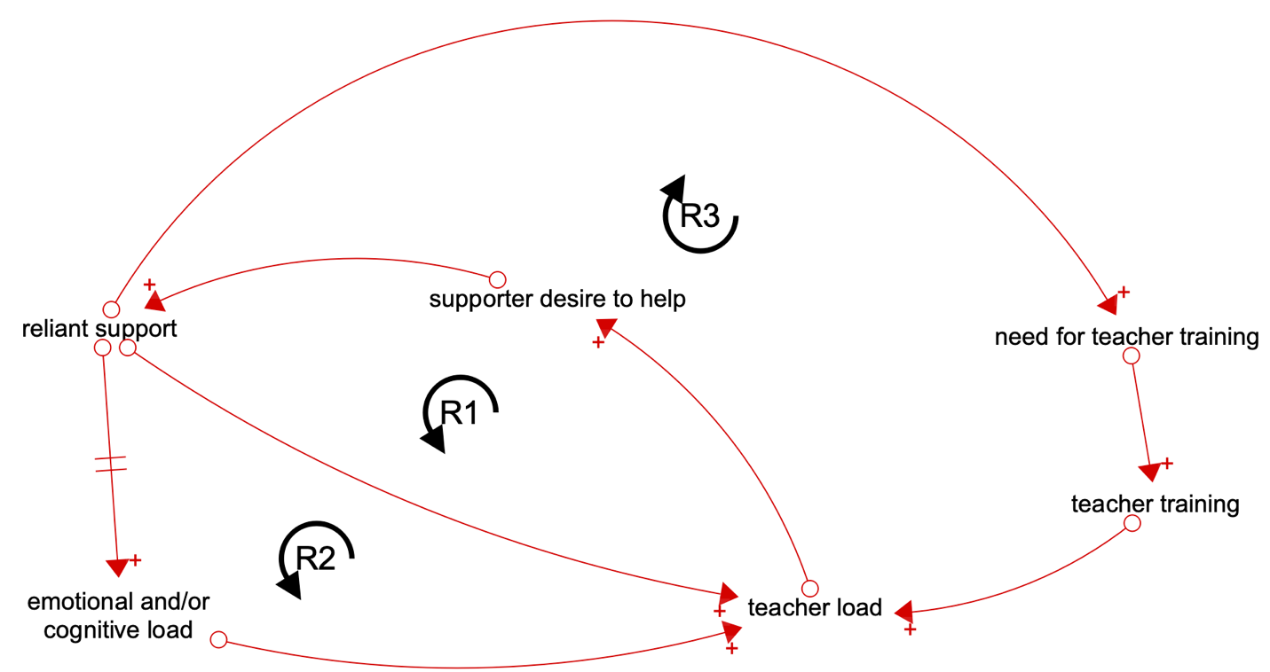

Reinforcing loops R1 and R2 are introduced in Figure 1.1. Loop R1 highlights how supporters’ desire to help responds to teacher workload: as the teacher's workload increases, supporters recognize this and wish to help, leading to more reliant support, which in turn increases the teacher's workload. Loop R2 illustrates how, over time, reliant support can lead to additional emotional and/or cognitive load for the teacher. For example, the more reliant support available, the easier it may be for the teacher to say “I’ll just do it myself!” when explaining what must be done to others brings frustration and additional work. Overall, these loops suggest teacher load is increased by the existence of reliant support.

It is in the teacher’s best interest to cultivate relationships with supporters, even if they are reliant supporters. Greater amounts of reliant support necessitate teachers training their reliant supporters (e.g., providing lists, materials, explanations, phone calls, emails, etc.). Doing this increases the teacher’s workload, which leads to the loop R3. Loop R3 begins as supporters wish to help the teacher with their workload, provide reliant support, need training, receive training, and end up adding to the teacher’s workload before they can affect it.

Once supporters have been trained by teachers and understand what they are doing, they can be more autonomous. Autonomous supporters anticipate teacher needs, understand protocols, know expectations, and perform tasks independently as needed. Teachers with strong relationships with supporters, especially experienced supporters who are familiar with programming and heavily involved, may greatly reduce a teacher’s load. This introduces the idea of autonomous support in the TCI, defined as support from community members, parents, and others who can now anticipate needs, know what they are doing, and know how to do it. Loops B1, B2, and B3 all work to reduce teacher load. See Figure 1.2.

Figure 1.2

Autonomous Support Reducing Teacher Load
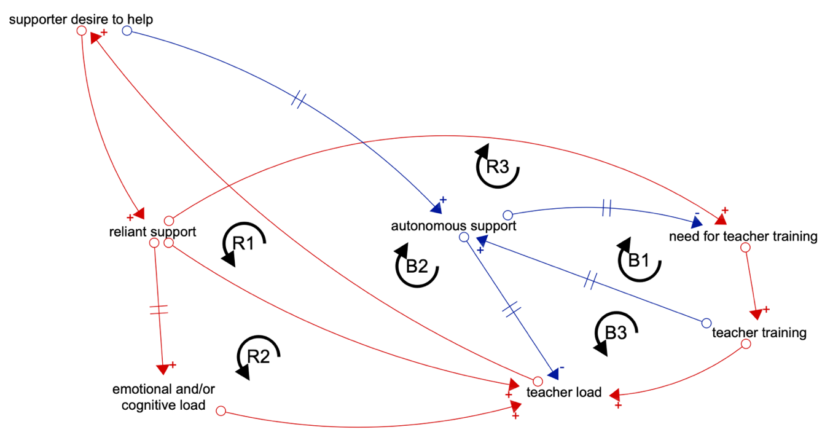
Loop B1 demonstrates how autonomous support decreases the need for teacher training of supporters, which leads to less training being implemented. After being trained, reliant supporters become autonomous supporters. The larger loop, B3, shows that this helps reduce teacher load. Loop B2 shows how, as teacher load increases, supporters wish to help; as autonomous support increases in response, teacher load decreases. The TCI demonstrates that, theoretically, as teachers stay in their communities, train supporters, and move away from reliant support, their workload may be greatly reduced and/or stabilized by their autonomous supporters. Therefore, this necessitates that teachers develop relationships and “take the hit” to their margin in life to achieve an abundance of load-reducing autonomous support. Furthermore, autonomous support networks may be more readily available to teachers in more established programs (e.g., those that have been around for years and have a robust Alumni and Friends Chapter, or those who have been trained by previous teachers) and/or to teachers who are more socially engaged in their communities. This part of the system is socially complex and deeply context-dependent.
The story this section of the TCI tells is: as teachers receive autonomous support, the more supporters who wish to help can act upon and reduce teacher load. If supporters remain in the reliant support category, they are inadvertently burdening their teacher(s). To reduce strain caused by providing reliant support, supporters could avoid asking questions like “What can I do for you?” or “What do you need?” and instead offer to take things from the teacher’s plate without adding to it. Supporters are good-intentioned, and it takes time to become accustomed to a teacher’s needs, so grace may be necessary.

As there are many delays in this portion of the system, it becomes increasingly important to acknowledge relationships leading to autonomous support do not happen overnight and may take years before things begin to fall into place. Due to these systemic delays, teachers may feel strain as they have a greater load, and this greater load reduces margin in life. When people are willing to take direct action without needing instructions, they can avoid increasing load accidentally. However, supporters need to be familiar enough with their teacher(s) to assist in this way, and teachers need to be comfortable ceding control. As a practical example, if a teacher shares that they need help feeding students participating in a contest, an autonomous supporter might volunteer to handle it; they would order enough pizza for students, buy a case of water, and bring the supplies to the contest location, as that is what the teacher has trained them to do.

Sub-Model 2: Teacher Power

We now turn to teacher power. To refresh, teacher power includes physical, mental, spiritual, financial, emotional, and social components. In practice, this could look like funding to support program activities, strong self-efficacy, pre-made curriculum, relationships with others, strong officer teams, and more. Teacher power is influenced in various ways. The first variables introduced are teacher power and student achievement, which form an intuitive reinforcing loop (R4). This loop demonstrates how, as students succeed, teachers have greater power in life. Teacher participants in studies have repeatedly mentioned they love seeing their students succeed (Ismail & Miller, 2021; Solomonson et al., 2021), and many teachers choose to teach because student achievement and program success are their goals (Ismail & Miller, 2021; Traini et al., 2019). Teacher power is also influenced by self-efficacy; teachers who feel more adequately prepared for tasks may feel they have more self-efficacy, thus greater power. See Figure 2.1.

Figure 2.1

Student Achievement Reinforcing Teacher Power
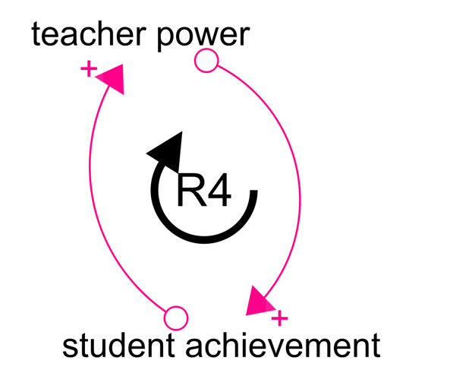
Naturally, teacher power is not solely influenced by student achievement. See Figure 2.2. Community connections, or the practical network of supporters surrounding a teacher, can bolster teacher power. Loop R5 shows how greater teacher power can lead to increased community connections (e.g., a teacher feeling they can get out and interact with their community), which, over time, leads to greater teacher power as relationships are built. Connectivity and collaboration – interpreted as relationships – have been shown to promote teacher retention via increased career commitment (DeLay & Washburn, 2013; Moser & McKim, 2020). Therefore, relationships via community connections may increase the teacher’s feeling of belonging in their community, as they have supporters who care about them and their program. Langley et al. (2014) highlight how differences between past and present community culture may surprise teachers; this may tie into feelings of belonging and comfort with vulnerability. Greater belonging increases teacher power, and results in loop R6. Finally, community connections can also support student achievement, as community members can help teachers train students for contests, make FFA events successful, steward successful SAEs, and more. As community connections increase student achievement, teacher power grows from seeing this success, resulting in loop R7. Teacher belonging may also tie into comfort with vulnerability.

Figure 2.2

Community Connections Reinforcing Teacher Power
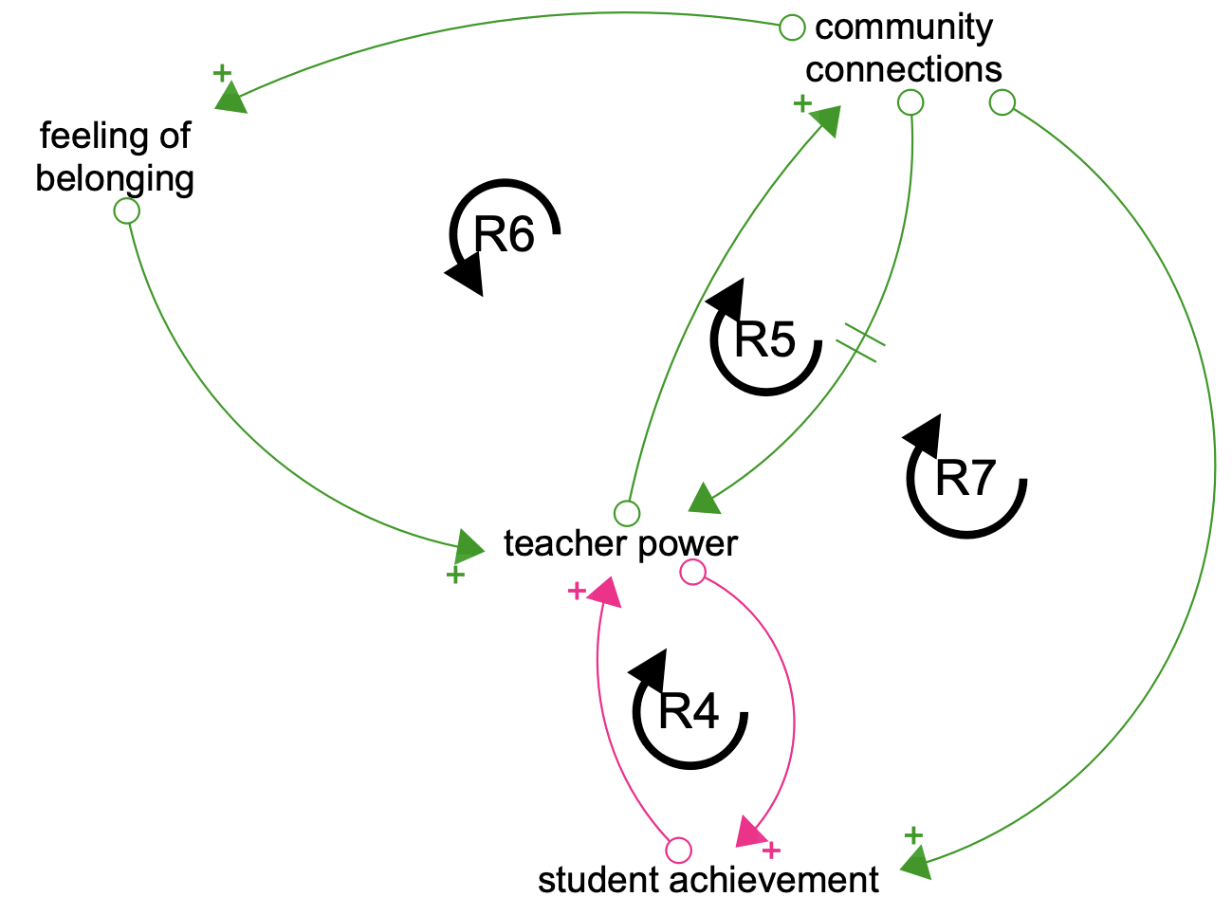
When a teacher feels like they belong in their community, they may have an easier time expressing their needs. See Figure 2.3. As teachers are more comfortable being open about their struggles, they may receive more school-based individual supports. The school-based individual support variable refers to administrators, other teachers, and others within and surrounding the school who can help bolster teacher power (loop R8). For example, if a teacher feels comfortable being vulnerable, they may be more likely to approach their principal to request assistance. Assuming a positive relationship with the principal, there will be action taken to support the teacher. As this action is taken, the teacher’s power increases, as they know they are supported in their community. Unfortunately, this loop may also work in the opposite way; if a teacher is not comfortable being vulnerable or if they have an unsupportive administrator, their lack of power may be reinforced, which negatively impacts their margin in life.

Figure 2.3

Introducing School-Based Individual Support
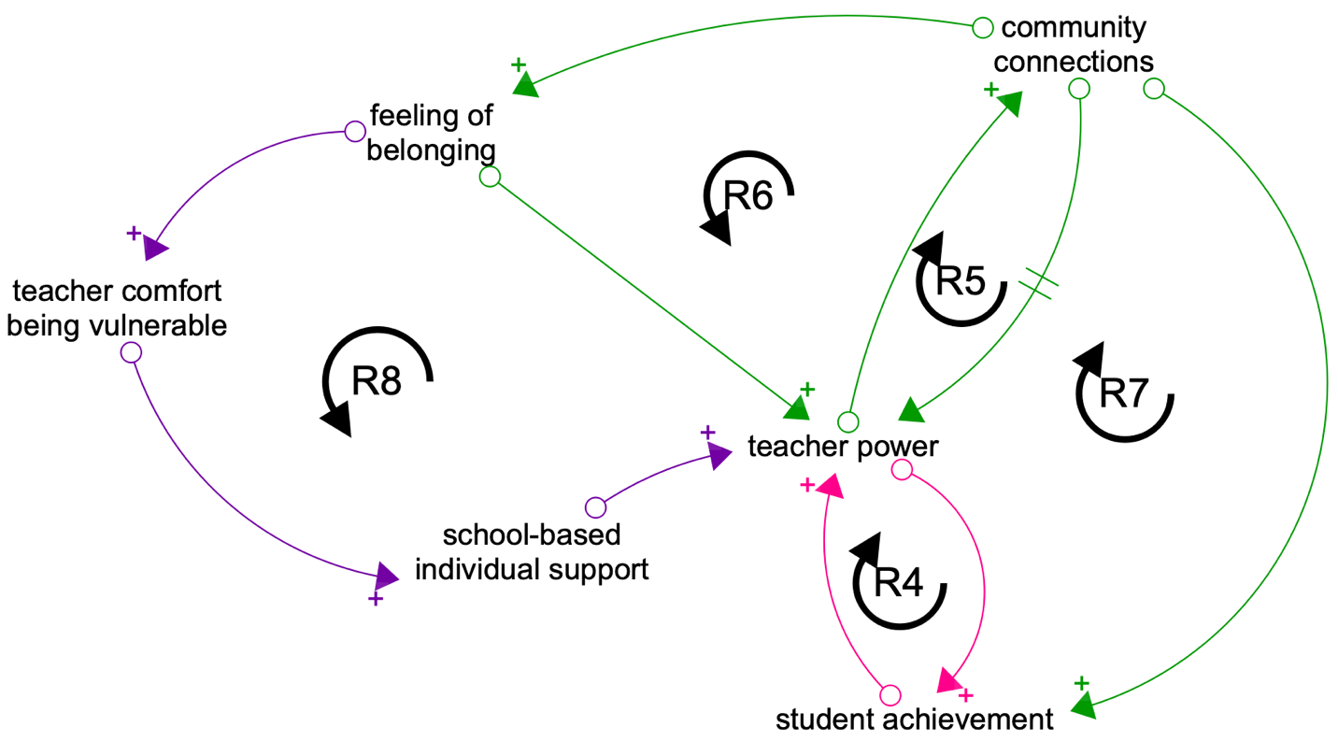

If a teacher is well-networked within their community and has built relationships with community members, those connections may provide a platform and strength-in-numbers to help advocate for teachers to get what they need. This may take time, as there are many people and means of navigating social situations which could present obstacles for this to occur. However, community members – especially those serving on advisory boards – may sway administrators into taking action. As a practical example, supporters could speak to the need to fix the driveway to the barn at an advisory board meeting. This recommendation may be heard by the principal, and the driveway is then fixed. This is another way strong community connections can increase teacher power via increasing school-based support, and is captured by loop R9. See Figure 2.4.

Figure 2.4

Community Connections Increasing Support
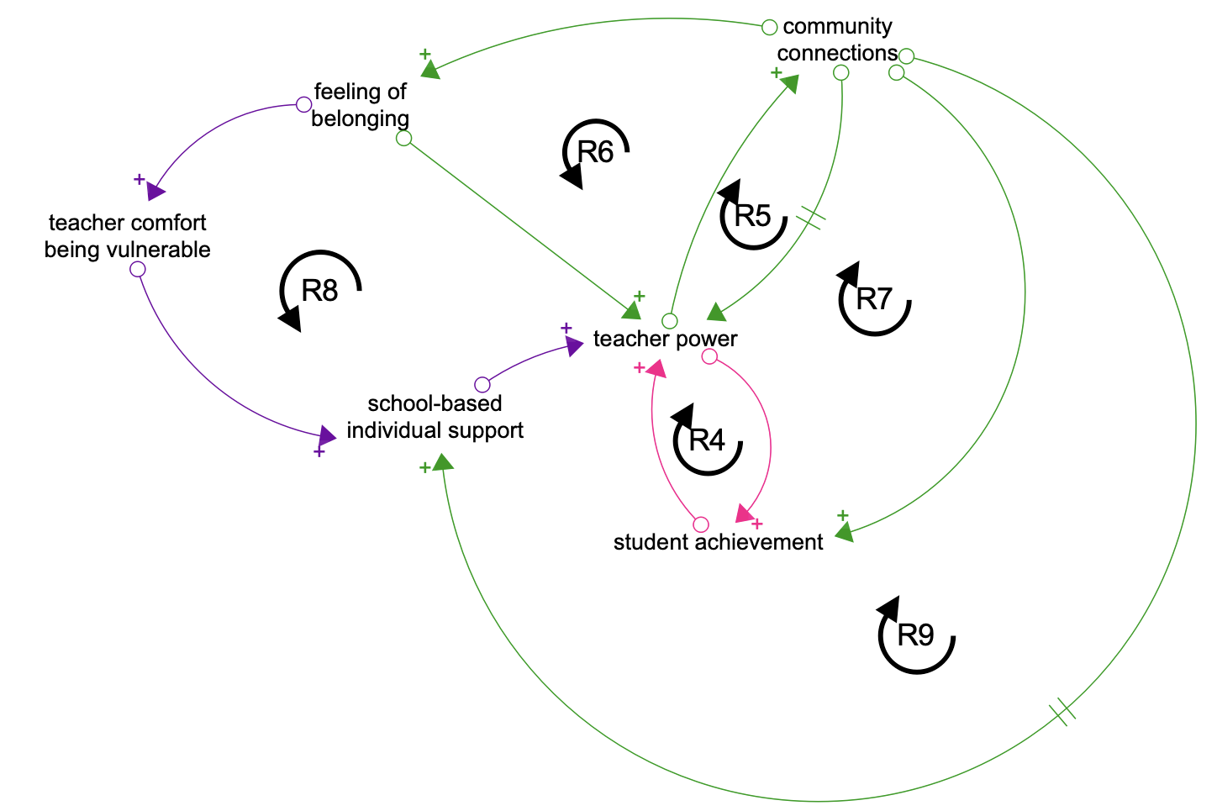
Figure 2.4 represents the conclusion of the teacher power portion of the TCI.

The teacher load and power sub-models are brought together in Figure 3, connected by supporter desire to help. Community connections build teacher-supporter relationships, and these relationships can increase supporter desire to help; this has potential to decrease teacher load and increase teacher power, thus increasing margin in life. Loop R10 demonstrates how, as supporters want to help, the teacher may feel a greater sense of belonging and that will increase their power. Next, loop R11 shows how supporters wanting to help may make the teacher more comfortable with vulnerability due to feeling they belong; this can lead to an increase in asking for school-based individual support and reinforce teacher power. Finally, as community connections are leveraged and community members help with chapter activities, students may achieve more; when students achieve more, assisting the teacher and/or the FFA Chapter may become more appealing. As people witness this momentum, we see loop R12, wherein teacher power ultimately grows via the potential surge in support from others. In part, this may also show the teacher they are running a “successful” program, which can make them feel they belong.
Figure 3

The Full Teacher-Community-Supporter Complex

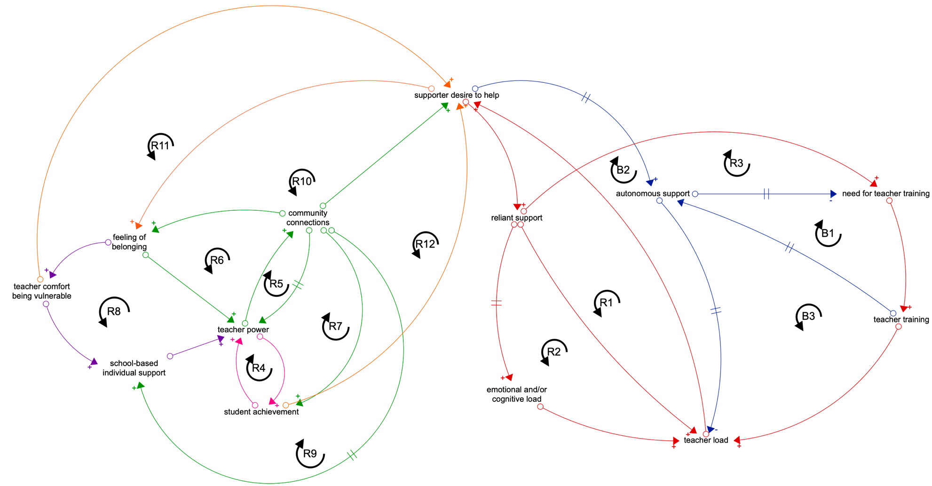

The Teacher-Community Interface

The power portion of the TCI has nine reinforcing feedback loops. Due to the polarity of these loops – variables increasing or decreasing in tandem – it is important to seize opportunities and harness the power of these loops. For example, student achievement is incredibly broad; when it is rigidly defined, it will be less accessible to teachers. Causing one student to smile a day is more readily accessible than having a state-winning career development event team. Student achievement, therefore, can be adjusted to reinforce teacher power positively. Traini et al. (2019, 2020) showcase differences in how teachers and communities define and achieve success. Another example would be harnessing the positive potential of loop R12, wherein community members are seeing student achievement (meaning that achievement is being widely shared and showcased) and wanting to help students succeed more, bolstering teacher power and reducing teacher load (via loop B2). When these loops are not seized, they may work in a negative way, amplifying decreases in teacher power, student achievement, felt-belonging, vulnerability, and other variables within the system. For example, if a teacher is not dedicating time to building community connections while they have greater power, they may have less connections and thus less benefits from those connections in the future. Therefore, the TCI presents a framework for assisting early-career teachers in thinking through their community systemically, helping them to see the proverbial light at the end of the tunnel and recognize the importance of relying on others outside of themselves.

The TCI also demonstrates how having less margin in life may make seizing opportunities for connections more challenging. When teachers have less margin in life, they may be more stressed, feel more cluttered, and/or learn and retain information less readily (McClusky, 1963). This would not allow for time spent doing additional duties, like building community relationships, as the teacher is likely struggling to reduce their load or bolster their power. As both power and load inform the amount of margin in life a teacher has, how these variables exist in flux is dependent on the relationship between the two. Concretely, if a teacher’s workload is overwhelming them and they are not able to build connections, those reinforcing loops in sub-model two will work against the teacher’s best interest, further reducing margin in life.

Another important aspect of the system the TCI captures are the delays between variables. Building relationships, training community supporters, emotional/cognitive load, and more all take time. In a culture where instant gratification has quickly become normalized, waiting in a position which feels uncomfortable, hopeless, bleak, and/or unsustainable can be challenging. However, the TCI suggests times of discomfort may lead to stronger support systems and a greater margin in life, so that may be a boon earned via patience and intentionality. In some instances, communities may resist their teacher and/or disagree on priorities. Haddad et al. (2023) discuss how these disagreements can weigh on teachers, so some communities and teachers are likely to behave differently despite the system being structured similarly. In communities where there are rich synergies, delays may be shorter, effects may be greater, and more. Overall, the TCI suggests communities surrounding teachers play a role in teacher margin in life, thus it is important to turn an eye to communities with agricultural educators to examine how these interactions manifest.

Conclusions & Recommendations

The TCI has limitations. As the TCI was primarily based on a case study, prior research conducted, and lived experience, it may not be generalizable. However, there may be elements transferable between contexts. Furthermore, postulations about the TCI and how it might behave are hypotheses, since the TCI was not simulated. Accordingly, the TCI is intended as a heuristic tool to help the research community push their thinking, stimulating scientific discussions and informing paths forward, not as a prescription or predictive device. When used with teachers in their communities, the TCI may also serve as a catalyst for dialogue, supporting broader, community-based conversations about teacher retention.

Which aspect is more important – teacher power or teacher load – is unclear, and likely context-dependent. Regardless, individual teachers are not the only social elements of this system; community members, Alumni and Friends, parents, other teachers, administrators, etc., all have roles they can play to positively impact their teachers’ margin in life. The role or category folks assign themselves to matters less than how they conduct themselves, as it is how they conduct themselves that impacts the teacher. For example, if a community member is also a parent, they may wear different hats, but if they are taking time out of their day to prepare a grant for the program, they are adding to teacher power.

Teacher connectivity within their schools and communities is an integral part of the TCI; authors like Moser and McKim (2020) and DeLay and Washburn (2013) provide empirical support for the importance of connectivity and collaboration. Teachers who feel connected are likely to experience positive effects on their power and workload, thereby increasing their margin in life. As margin in life can be likened to work-life balance, this connectivity and the elements within this system may all be inherently linked and important to holistically process the challenges associated with a “profession that eats its young” (Osborne, 1992, p. 3).

The TCI is important because it illustrates systems-thinking and ways in which teachers and their communities impact one another. With many dimensions of teacher retention explored, it’s important to link these dimensions to find ways to adjust the system to make it more sustainable. With a more sustainable system in place, professional cannibalization may decrease. If there are best practices to help teachers make it through their early career hardships, such as intentionally building relationships and connections with community members, then we can incorporate these principles into teacher education courses and prepare teachers to take these concepts with them into their communities.

There are several implications for various populations from the TCI. Recommendations for researchers include examining various communities to explore the possibility of community archetypes, wherein communities behave in similar ways, transferable beyond context. When preparing agriculture teachers, explaining how communities may react – and grounding it in experiences likely for first-year teachers – may be helpful for setting students up to resist professional cannibalization. For teachers and community supporters, building relationships can be beneficial for teacher longevity within communities. When supporters are able to reduce teacher load and bolster teacher power, teachers may have more margin in life; having more margin in life helps early-career teachers have space for learning and growth.
References
Barbrook-Johnson, P., & Penn, A. S. (2022). Causal loop diagrams. In Systems Mapping (pp. 47–59). Springer International Publishing. https://doi.org/10.1007/978-3-031-01919-7_4
Baugh Littlejohns, L., Hill, C., & Neudorf, C. (2021). Diverse approaches to creating and using causal loop diagrams in public health research: Recommendations from a scoping review. Public Health Reviews, 42. https://doi.org/10.3389/phrs.2021.1604352
Best, R. W., Robinson, J. S., Edwards, M. C., Terry, R., & Cole, K. L. (2025a). Classroom and laboratory instructional tasks associated with teaching school-based agricultural education. Journal of Agricultural Education, 66(1), 28. https://doi.org/10.5032/jae.v66i1.2916
Best, R. W., Robinson, J. S., Edwards, M. C., Terry, R., & Cole, K. L. (2025b). Tasks associated with teaching school-based agricultural education: FFA advisement. Journal of Agricultural Education, 66(4), 19. https://doi.org/10.5032/jae.v66i4.3229
Blackburn, J. J., Bunch, J. C., & Haynes, J. C. (2017). Assessing the relationship of teacher self-efficacy, job satisfaction, and perception of work-life balance of Louisiana agriculture teachers. Journal of Agricultural Education, 58(1), 14–35.
Brereton, C. F., & Jagals, P. (2021). Applications of systems science to understand and manage multiple influences within children’s environmental health in least developed countries: A causal loop diagram approach. International Journal of Environmental Research and Public Health, 18(6), 3010. https://doi.org/10.3390/ijerph18063010
Croom, D. B. (2003). Teacher burnout in agricultural education. Journal of Agricultural Education, 44(2), 1–13. https://doi.org/10.5032/jae.2003.02001
DeLay, A. M., & Washburn, S. G. (2013). The role of collaboration in secondary agriculture teacher career satisfaction and career retention. Journal of Agricultural Education, 54(4), 104–120. https://doi.org/10.5032/jae.2013.04104
Easterly III, R. G. (Tre), & Myers, B. E. (2018). Personal resilience as a predictor of professional development engagement and career satisfaction of agriscience teachers. Journal of Agricultural Education, 59(1), 119–134. https://doi.org/10.5032/jae.2018.01119
Gerritsen, S., Renker-Darby, A., Harré, S., Rees, D., Raroa, D. A., Eickstaedt, M., Sushil, Z., Allan, K., Bartos, A. E., Waterlander, W. E., & Swinburn, B. (2019). Improving low fruit and vegetable intake in children: Findings from a system dynamics, community group model building study. PLOS ONE, 14(8), e0221107. https://doi.org/10.1371/journal.pone.0221107
Haddad, B., Traini, H., & McKim, A. (2023). We’ve crossed a line: A philosophical examination of systemic implications surrounding SBAE teachers’ attempts at boundary setting. Journal of Agricultural Education, 64(1), 82–95. https://doi.org/10.5032/jae.v64i1.31
Hasselquist, L., Herndon, K., & Kitchel, T. J. (2017). School culture’s influence on beginning agriculture teachers’ job satisfaction and teacher self-efficacy. Journal of Agricultural Education, 58(1), 267–279. https://doi.org/10.5032/jae.2017.01267
Ismail, N., & Miller, G. (2021). Factors that motivate high school agriculture teachers to teach. Journal of Agricultural Education, 62(1), 331–346.
Kitchel, T. J., Smith, A., Henry, A., Robinson, S., Lawver, R., Park, T., & Schell, A. (2012). Teacher job satisfaction and burnout viewed through social comparisons. Journal of Agricultural Education, 53(1), 31–44. https://doi.org/10.5032/jae.2012.01031
Langley, G. C., Martin, M. J., & Kitchel, T. (2014). Novice agriculture teachers’ general self efficacy and sense of community connectedness. Journal of Agricultural Education, 55(4), 1–11. https://doi.org/10.5032/jae.2014.04001
Marzolino, T. A. (2025). A systemic exploration of agriculture teacher retention and identity development [Doctoral dissertation, Michigan State University]. MSU Libraries Digital Repository, ProQuest. https://d.lib.msu.edu/etd/52477?q=marzolino
Marzolino, T., & McKim, A. (2024). Retaining school-based agricultural educators: A system dynamics approach. Journal of Agricultural Education, 65(4), 327–341. https://doi.org/10.5032/jae.v65i4.2826
McKim, A. J., & Velez, J. J. (2015). Exploring the relationship between self-efficacy and career commitment among early career agriculture teachers. Journal of Agricultural Education, 56(1), 127–140. https://doi.org/10.5032/jae.2015.01127
Moser, E. M., & McKim, A. J. (2020). Teacher retention: A relational perspective. Journal of Agricultural Education, 61(2). https://doi.org/10.5032/jae.2020.02263
Osborne, E. (1992). A profession that eats its young. The Agricultural Education Magazine, 3.
Pauley, C., McKim, A., & Hodbod, J. (2019). A social-ecological resilience perspective for the social sciences of agriculture, food, and natural resources. Journal of Agricultural Education, 60(4). https://doi.org/10.5032/jae.2019.04132
Richardson, G. P. (1997). Problems in causal loop diagrams revisited. Systems Dynamics Review, 13(3), 247–252.
Smith, A. R., & Smalley, S. (2018). Job stress, burnout, and professional development needs of mid-career agricultural education teachers. Journal of Agricultural Education, 59(2), 305–320. https://doi.org/10.5032/jae.2018.02305
Solomonson, J. K., Still, S. M., & Maxwell, L. D. (2021). Factors influencing the decision of Illinois school-based agricultural education teachers to remain in the profession. Journal of Agricultural Education, 62(3), 121–137. https://doi.org/10.5032/jae.2021.03121
Sorensen, T. J., & McKim, A. J. (2014). Perceived work-life balance, job satisfaction, and professional commitment among agriculture teachers. Journal of Agricultural Education, 55(4), 116–132. https://doi.org/10.5032/jae.2014.04116
Sorensen, T. J., McKim, A. J., & Velez, J. (2016). A national study of work-family balance and job satisfaction among agriculture teachers. Journal of Agricultural Education, 57(4), 146–159. https://doi.org/10.5032/jae.2016.04146
Thieman, E. B., Marx, A. A., & Kitchel, T. (2014). “You’ve always got challenges”: Resilience and the preservice teacher. Journal of Agricultural Education, 55(4), 12–23. https://doi.org/10.5032/jae.2014.04012
Traini, H. Q., Claflin, K., Stewart, J., & Velez, J. (2019). Success, balance, but never both: Exploring reified forms of success in school-based agricultural education. Journal of Agricultural Education, 60(4), 240–254. https://doi.org/10.5032/jae.2019.04240
Traini, H. Q., Goodwin, C., Priest, K., & Haddad, B. (2025). Leaning into the AAAE values: Theoretical frameworks for systems-oriented paradigms. Journal of Agricultural Education, 66(3), 12. https://doi.org/10.5032/jae.v66i3.3235
Traini, H. Q., Haddad, B., Stewart, J., & Velez, J. J. (2021). Adjusting, appeasing, and rearranging: How agriculture teachers reconcile demands of the profession. Journal of Agricultural Education, 62(2), 167–184. https://doi.org/10.5032/jae.2021.02167
Traini, H. Q., Yopp, A. M., & Roberts, R. (2020). The success trap: A case study of early career agricultural education teachers’ conceptualizations of work-life balance. Journal of Agricultural Education, 61(4), 175–188. https://doi.org/10.5032/jae.2020.04175

