Examining Lessons Learned from USDA–WFP Local and Regional Procurement Projects: Implications for Food Security and Agriculture

Elizabeth Tabares, Graduate Student
Texas A&M University
600 John Kimbrough Blvd. 2116 TAMU
College Station, TX, 77843
(979) 862-1979
elizabeth.tabaresvil@ag.tamu.edu

Rafael Landaverde, Assistant Professor
Texas A&M University
600 John Kimbrough Blvd. 2116 TAMU
College Station, TX, 77843
(979)321-5764
rafael.q@ag.tamu.edu

Lessons Learned from USDA-WFP Local and Regional Procurement Projects

Introduction
Local food procurement activities for institutional operations are powerful tools for cultivating sustainable food systems. Local procurement for school meal programs has been widely promoted as a mechanism for achieving equitable, health-promoting, high-quality educational goals (FAO & WFP, 2018; Fredella et al., 2023; Verguet et al. 2020). It also plays an important role in promoting farming practices that regenerate soil and ecosystem health, biodiversity conservation, and resilience (WFP, 2024).
Initiating or strengthening local procurement for school feeding programs in developing countries is a challenging endeavor. The U.S. Department of Agriculture Local and Regional Food Aid Procurement Program (LRP) was aimed at strengthening local food systems in developing countries and address food insecurity through the procurement of local and regionally grown agricultural commodities. It complemented food aid programs like the McGovern-Dole International Food for Education and Child Nutrition Program (USDA, 2023). The World Food Programme (WFP), an U.N. organization with an extensive experience in designing school feeding initiatives and leading the path to convert them into National Home-Grown School Feeding Programs (NHGSFP), implemented four out of the total twelve projects in USDA LRP program in Lao PDR, Rwanda, Kenya, and Cambodia.

Conceptual Framework
Procurement approaches used in the LRP pilot project included hard tender, soft tender, direct purchase, and voucher systems (MSI, 2012). Tauranac (2019) further identifies five procurement models commonly used in school feeding systems, including sourcing through existing distributors, partnerships with food hubs, campus-based food production, governmental support mechanisms, and nonprofit-supported partnerships. More recently, the 2024 State of School Feeding report documented diverse public procurement experiences worldwide, highlighting growing interest in demand-driven and environmentally sustainable procurement policies, as well as innovations such as digital procurement and information-management applications (WFP, 2024).

Methods
This case study explores the WFP experience institutionalizing local procurement from LRP projects. The authors adopted a critical narrative approach to guide the search, analysis, and discussion of explicit and implicit models of local food procurement and its components if informed in the final evaluations of the four USDA-WFP LRP projects (Das et al., 2020; Dunn et al., 2020; Jantzi, 2024; Visser et al, 2020). The study also follows the guidelines from the University of Southern California Libraries (2025) for writing a case study.

Results
The implemented projects were complex multidimensional interventions aimed at connecting schools and farms at both educational and market levels. Activities included the promotion of farmer participation, improvement of food quality and variety, management of intricated budget and financial operations, reduction of higher transaction costs, proposing creative solutions to challenging logistics, and developing the potential for local and community development through efficient market channels. Table 1 provides an overview of the perspectives on how links are created and strengthened while school feeding programs get mature. A continue and incremental spectrum of interests, priorities, and complexities are observed. Figure 1 compares how the four projects advanced both farmer-market integration mechanisms and the institutionalization of national school feeding procurement systems.

Table 1
Overview of the USDA-WFP LRP projects
Country | Perspective | Procurement approach | Beneficiaries
Country | Perspective | Procurement approach | Students |  | Farmers
Lao PDR (2016) | Link community to school (veg supply) | Direct local purchase/community | 4,973 |  | 474
Kenya  (2017) | Support to government’s HGSMP | Soft tender + Forward Delivery Contracts (FDC) | 382 schools |  | 78 Coop  29 traders
Rwanda (2016) | Strengthen farmer cooperatives | Framework contracts + cooperative aggregation + structured commercial | 43,855 (2017)  41,521 (2018) |  | 5,617  16 Coop
Cambodia  (2019) | Pilot project to strengthen the NHGSFP | Decentralized school procure + supplier tendering | 47,003  131 schools |  | 750
Note: HGSMP stands for Home-Grown School Meals Programme.

Figure 1
Comparative Pathways of Procurement Institutionalization and Farmer–Market Integration
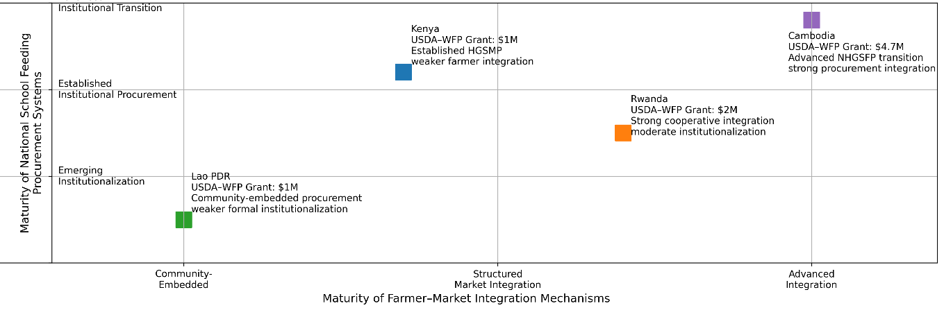

Conclusions/Implications
Procurement effectiveness depended on stakeholder coordination, supplier training, logistics management, and simplified procedures. The evaluations show that process complexity, administrative burdens, and weak synchronization with agricultural production cycles reduce smallholder participation. They provide limited detail regarding systematic farmer mapping and supplier-capacity assessments before implementation but highlight the importance of combining technical training with stronger monitoring, knowledge management, inclusiveness, and risk-sensitive approaches. Given the common conceptual frameworks and instruments, WFP should expand the use of meta-synthesis methodologies (Leary & Walker, 2018) to generate cumulative evidence and strengthen adaptive programming across procurement contexts.

References
Das, M., Sharma, M., Rai, S., & Singh, J. (2020). End line Evaluation of USDA Local Regional Procurement project in Nalae District, Luang Namtha Province in Lao PDR (FY 2016-2019). Decentralized evaluation. WFP Lao PDR. https://www.unevaluation.org/member_publications/end-line-evaluation-usda-local-regional-procurement-project-nalae-district
Dunn, S., & Otsola, J. (2020). Final evaluation of the USA-supported local and regional Procurement (LRP) project in Kenya (FY 2017-2020). Decentralized evaluation. WFP Kenya. https://www.wfp.org/publications/kenya-usda-supported-local-and-regional-procurement-project-2017-2020-evaluation
Food and Agriculture Organization (FAO) & World Food Program (WFP). (2018). Home-grown school feeding. Resource Framework. Technical Document. Rome. 170 p. https://openknowledge.fao.org/server/api/core/bitstreams/d082f20d-a9b4-4a3e-9574-3551ef74043e/content
Fredella, C., Cardani, A., & Zecca, L. (2023). Linking farm and school: a theoretical review. Investigación en la Escuela, 106, 1-17. doi: https://doi.org/10.12795/IE.2023.i106.01
Jantzi, T. (2024). Endline evaluation of USDA local and regional food aid procurement grant (LRP-442-2019-011-00) for WFP school feeding in Cambodia. Decentralized evaluation – Final report. Konterra Group. WFP Cambodia & USDA. https://www.wfp.org/publications/cambodia-usda-local-and-regional-food-aid-procurement-evaluations
Leary, H., & Walker, A. (2018). Meta-analysis and meta-synthesis methodologies: rigorously piecing together research. TechTrends, 62, 525-534.
Management Systems International (MSI). (2012). Local and Regional Procurement Pilot Project: Final evaluation report. USAID Office of Food for Peace & U.S. Department of Agriculture. https://www.fas.usda.gov/sites/default/files/lrp_report_12-03-12_to_print.pdf
Tauranac, M. (2019). Five Models for Local School Food Procurement. https://foodprint.org/blog/five-models-for-local-school-food-procurement
University of Southern California Libraries. (2025). Writing a case study. https://libguides.usc.edu/writingguide/assignments/casestudy
U.S. Department of Agriculture, Foreign Agricultural Service. (2023). Local and regional food aid procurement program: Fiscal year 2022 report to Congress. https://www.fas.usda.gov/newsroom/local-and-regional-food-aid-procurement-program-fy-2022-report-congress
Verguet, S., Limasalle, P., Chakrabarti, A., Husain, A., Burbano, C., Drake, L., & Bundy, D. A. P. (2020). The broader economic value of school feeding Programs in low- and middle-income countries: Estimating the multi-sectoral returns to public health, human capital, social protection, and the local economy. Frontiers in Public Health, 8, 587046.
Visser, M., Steer, L., Midega, E., Mwangi, M., Rurangwa, R. (2020). Evaluation of USDA’s local and regional food aid procurement program (Rwanda 2017-2019). Decentralized evaluation. Endline – final report. WFP Rwanda. https://www.wfp.org/publications/rwanda-local-regional-procurement-project-2017-2019-endline-evaluation
World Food Programme. (2024). State of School Feeding Worldwide 2024. Rome, World Food Programme. https://doi.org/10.71958/wfp130772

