Discursive Signals of AI innovation in Colombian Agrifood Systems: A Case Study on Agricultural Digital Communities

Elizabeth Tabares, Graduate Student
Texas A&M University
600 John Kimbrough Blvd. 2116 TAMU
College Station, TX, 77843
(979) 862-1979
elizabeth.tabaresvil@ag.tamu.edu

Rafael Landaverde, Assistant Professor
Texas A&M University
600 John Kimbrough Blvd. 2116 TAMU
College Station, TX, 77843
(979)321-5764
rafael.q@ag.tamu.edu

Discursive Signals of AI innovation in Colombian Agrifood Systems: A Case Study on Agricultural Digital Communities

Introduction
Social media platforms have become important spaces for public communication, participation, and information exchange across several contexts. Social media can influence policymaking and shape public perceptions, attention, and behavioral intentions through informational and social mechanisms (Battaglini & Patacchini, 2019; Liu et al., 2023; Nekmahmud et al., 2022; Ausat, 2023). In agriculture, social media is used for information exchange (Ramavhale et al., 2024; Balkrishna & Deshmukh, 2017), for information seeking and discussion on agricultural technology (Yadav et al., 2023; Ofori & El-Gayar, 2021) and less for marketing and entrepreneurial activities (Balkrishna & Deshmukh, 2017; Morris & James, 2017).
Colombia has adopted public policies that promote the responsible use of artificial intelligence and big data as key drivers for development (Republic of Colombia, 2023). As AI-related technical and policy initiatives expand, social research is needed to understand how these developments are perceived, interpreted, and discussed within agricultural communities. This case study explores whether social media discussions on AI in Colombia may reveal useful indicators for understanding AI-based agricultural innovation adoption through constructs associated with the Technology Acceptance Model (TAM), particularly regarding perception, social influence, and opinion formation.

Conceptual Framework
We informed our study based on the collective approach on technology adoption proposed by Dissanayake et al. (2022) that integrates prior adoption theories into an agriculture-specific framework. The model argues that agricultural technology adoption is shaped by four broad factor groups: technology-related factors, personal attributes, social/institutional factors, and economic factors, especially the availability of capital sources. The model links these factors to perceived usefulness, perceived ease of use, compatibility, interpersonal influence, external influence, self-efficacy, and facilitating conditions. These then shape attitude, subjective norms, perceived behavioral control, behavioral intention, and behavior. The outcome is not only adoption or non-adoption, but also continued adoption, discontinued adoption, late adoption, or continued non-adoption.

Methods
We adopted an exploratory case study as a research approach to develop a detailed description and analysis of many forms of data (Creswell & Poth 2024). We selected Facebook since it is the most popular social media platform in Colombia. The underlying assumption, informed by the prominence of AI in policy and institutional narratives, was that such enthusiasm would be mirrored in social-level discourse in digital communities. Twenty Facebook groups from academia, general media, specialized media, government, agribusiness, technology developers, and research arena along with ten agricultural communities focused on AI were identified and monitored in March 2026. All available posts related to AI in agriculture were included in the analysis. Inductive content analysis was implemented.

Results
A total of nineteen posts from fifteen groups were identified. None of the producer organizations published content on the use of AI in agriculture. The oldest post was published in 2023. The posts were mainly informational rather than dialogical, consisting of general news, blog-style content, invitations to events, and announcements of AI-related summits, presentations, and training opportunities. Contrary to expectations, discursive engagement was nearly absent. Nine comments were retrieved across all posts, which weakened the original plan, focused on discourse analysis. Figure 1 shows from content analysis that both points of view, critical and supportive, are present in the postures on the technical, social, and political aspects of AI adoption.
Figure 1
Discourse Signals in AI-based Agricultural Innovation on Digital Communities
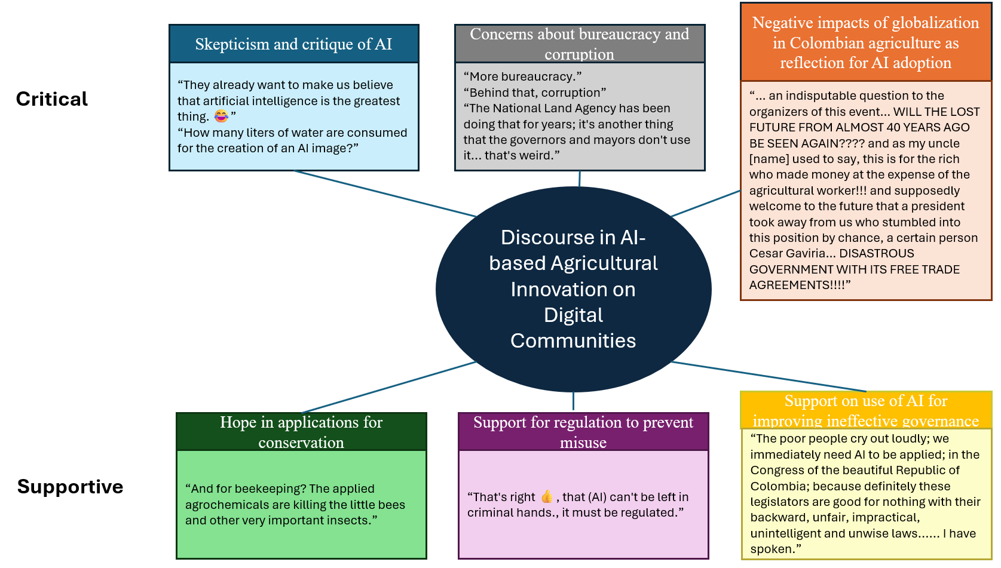

Conclusions/Implications
The discussions on the use of AI in agriculture account not only for social, environmental, and political challenges but also for opportunities for governance and conservation. The study reveals a low-dense and high-heterogeneous level engagement in discourse of AI in Colombian agriculture. The empirical evidence suggests a nascent process of engagement in the discussions. The retrieved comments show rich content that reveals a diversity of positions including skepticism toward technical feasibility and social implications, concerns about bureaucracy and corruption, support for regulation to prevent misuse, AI as a tool to address or exacerbate environmental concerns, optimism about AI improving ineffective governance, and the opportunity to reflect and avoid past mistakes. Monitoring discursive signals for a longer period (2-3 years) and including other digital communities has the potential of providing valuable information to understand the acceptance and adoption of AI-based agricultural from a social perspective.

References
Balkrishna, B. B., & Deshmukh, A. A. (2017). A study on role of social media in agriculture marketing and its scope. International Journal of Management, IT and Engineering, 7(4), 416–423. http://www.ijmra.us
Battaglini, M., & Patacchini, E. (2019). Social networks in policy making. Annual Review of Economics, 11, 473–494. https://doi.org/10.1146/annurev-economics-080218-030419
Creswell, J. W., & Poth, C. N. (2024). Qualitative inquiry & research design: Choosing among five approaches (5th ed). SAGE.
Dissanayake, C. A. K., Jayathilake, W., Wickramasuriya, H. V. A., Dissanayake, U., Kopiyawattage, K. P. P., & Wasala, W. M. C. B. (2022). Theories and models of technology adoption in agricultural sector. Human Behavior and Emerging Technologies, 9258317. https://doi.org/10.1155/2022/9258317
Liu, M., Luo, X., & Lu, W.-Z. (2023). Public perceptions of environmental, social, and governance (ESG) based on social media data: Evidence from China. Journal of Cleaner Production, 387, 135840. https://doi.org/10.1016/j.jclepro.2022.135840
Morris, W., & James, P. (2017). Entrepreneurship and small business management in agriculture: Exploring the role of social media in agricultural enterprises. Journal of Small Business and Enterprise Development, 24(4), 1028–1045. https://www.emerald.com/jsbed/article-pdf/24/4/1028/1698503/jsbed-01-2017-0018.pdf
Nekmahmud, M., Naz, F., Ramkissoon, H., & Fekete-Farkas, M. (2022). Transforming consumers’ intention to purchase green products: Role of social media. Technological Forecasting and Social Change, 185, 122067. https://doi.org/10.1016/j.techfore.2022.122067
Ofori, M., & El-Gayar, O. (2021). Drivers and challenges of precision agriculture: A social media perspective. Precision Agriculture, 22(3), 1019–1044. https://doi.org/10.1007/s11119-020-09760-0
Ramavhale, P. M., Zwane, E. M., & Belete, A. (2024). The benefits of social media platforms used in agriculture for information dissemination. South African Journal of Agricultural Extension, 52(2), 77–90. https://doi.org/10.17159/2413-3221/2024/v52n2a15342
Republic of Colombia. Estrategia Nacional Digital de Colombia 2023-2026.
https://colaboracion.dnp.gov.co/CDT/Desarrollo%20Digital/EVENTOS/END_Colombia_2023_2026.pdf
Yadav, J., Yadav, A., Misra, M., Rana, N. P., & Zhou, J. (2023). Role of social media in technology adoption for sustainable agriculture practices: Evidence from Twitter analytics. Communications of the Association for Information Systems, 52, article 40. https://doi.org/10.17705/1CAIS.05240

